
Please read carefully.
Hello,
We hope this letter finds you well.
Enclosed you will find the latest timetable of activities for May 2025. We will be taking bookings for these activities via phone call or email from 10am on Monday 28th April. Please do not phone us to try booking before this date and time. You will find our contact number and email address on the front page of your timetable.
WEA Courses are now free to all our attendees. We will now only request a national insurance number and a form of ID such as Drivers Licence, Passport or Bus Pass for enrolments.
Can we please remind everyone that if you are feeling unwell, DO NOT attend the Centre. Even if you feel just a little unwell, if you pass that on to someone else more vulnerable, it may impact them far worse. We also have limited staff who all play important roles, and if one of them get sick, it can have a significant impact on the rest of the Centre. Please be mindful and look out for each other and staff. Thank you.
Due to the volume of new referrals coming through. You will only be able to book onto one Social Day (Tuesday or Thursday) and two of Olwyn’s classes per week. This is so we can give new attendees a fair chance of booking onto sessions. (Not including WEA, Bishop college or volunteer led classes).
We please ask that you pay a £1 attendance fee per session. Your attendance fee goes back into the Centre and helps towards cost of materials and use of our tea and coffee facilities situated in our craft room. Your contribution is much appreciated.
Please turn up to your class on time especially if you are already on the premises, unless you have called to say you are running late. Do not eat food or leave to go for a cigarette during classes, this can be very disruptive for other attendees and the instructor. You are all given a 15-minute break halfway through your classes to eat, make a beverage and smoke.
If you are booked onto any class and cannot make it for whatever reason you must call the centre to inform us of this as early as possible, so that we can offer the space to somebody else. You still need to book to attend Social Days as well as regular classes, to guarantee you have a seat.
We look forward to seeing you.


To Book Classes Call: 0191 384 8100 or Email: enquiries@stmargaretscentre.co.uk
(There is an attendance fee of £1 per session)
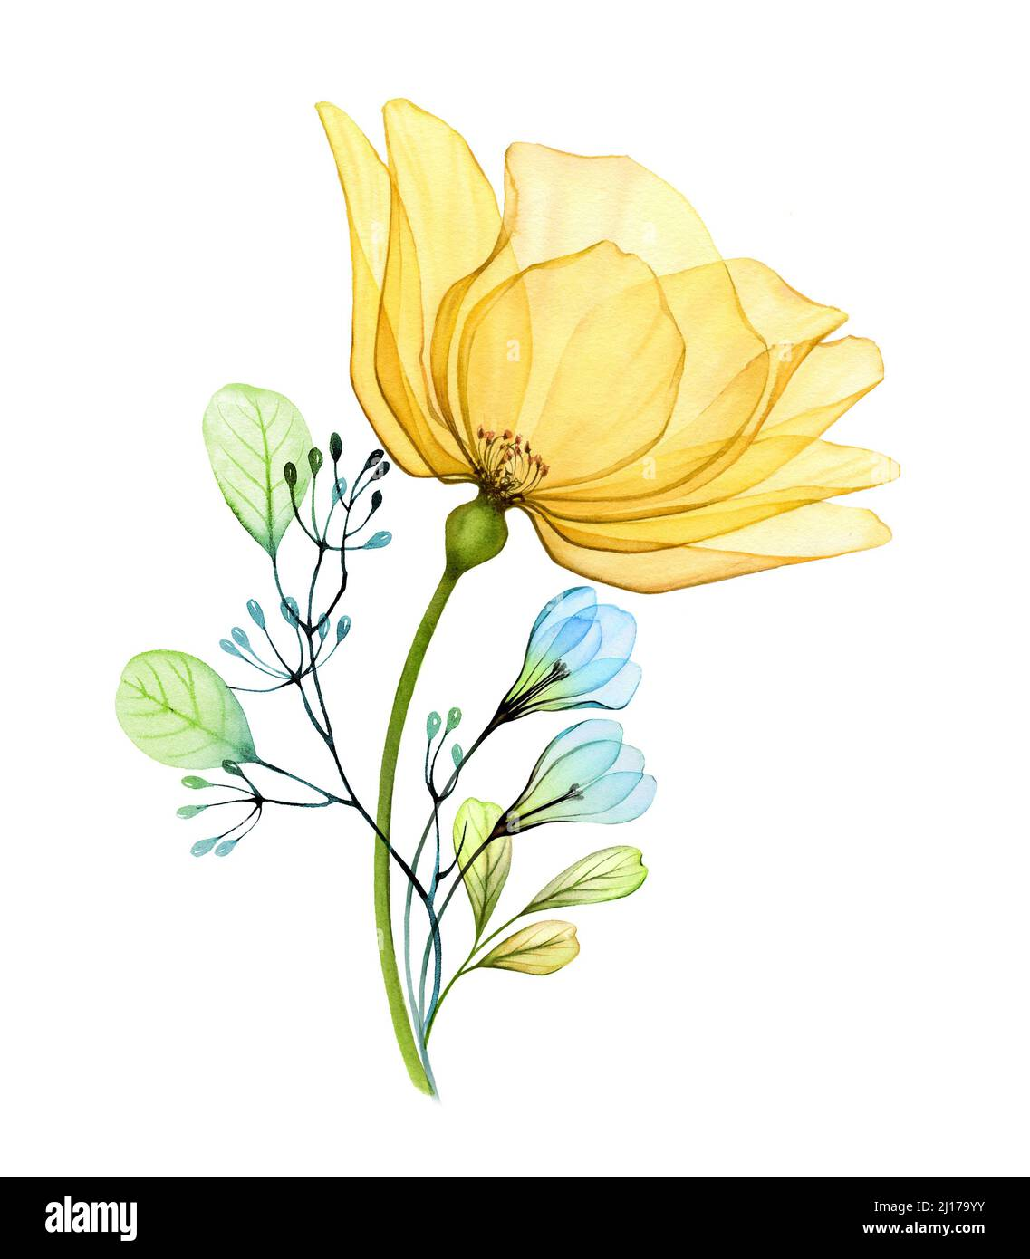

MONDAY 5TH MAY
CENTRE CLOSED - May Bank Holiday
TUESDAY 6TH MAY
Morning -
Social Day - 9.30am - 4pm - (Craft Room. Max. 20ppl)
- A day for social interaction and a safe place to get on with any hobbies you may have e.g., Painting, drawing, writing, jigsaws, crosswords, knitting. Or just enjoy a nice little chin wag with a cuppa. You must still book a slot on any social day you wish to attend, to secure a seat.
Needle Felting Course - 10am - 12pm - Karen - WEA - (Continued - Week 5)
Gardening - 10.30am – 12.30pm - Sandra (Volunteer) - (Meet in Craft Room)
- You will help with a little weeding, potting plants, and bulbs, watering flowers and assisting with the maintenance of our flower beds, lawns, and hedges. Outdoor activities are proven to help with wellbeing and mental health, so come and potter about, breathe in the fresh air and absorb some of that all-important Vitamin D.
Afternoon -
Positive Pathways to Mental Health (10 weeks) - 1.15pm - 3.15pm - Margaret - (Room 2)
- In this course run by the WEA we can choose which pathway we want to travel along - using creative visualization we work with the subconscious mind to visualize how we want to feel, look and live our lives. Discovering Neuroplasticity helps us to understand that our brain can have the ability to change and form new pathways through growth, learning and experiences. Creative visualization and meditation can be powerful tools to enhance better physical and mental health. Using both mindful meditation and moving meditation we can work to promote our positive wellbeing.
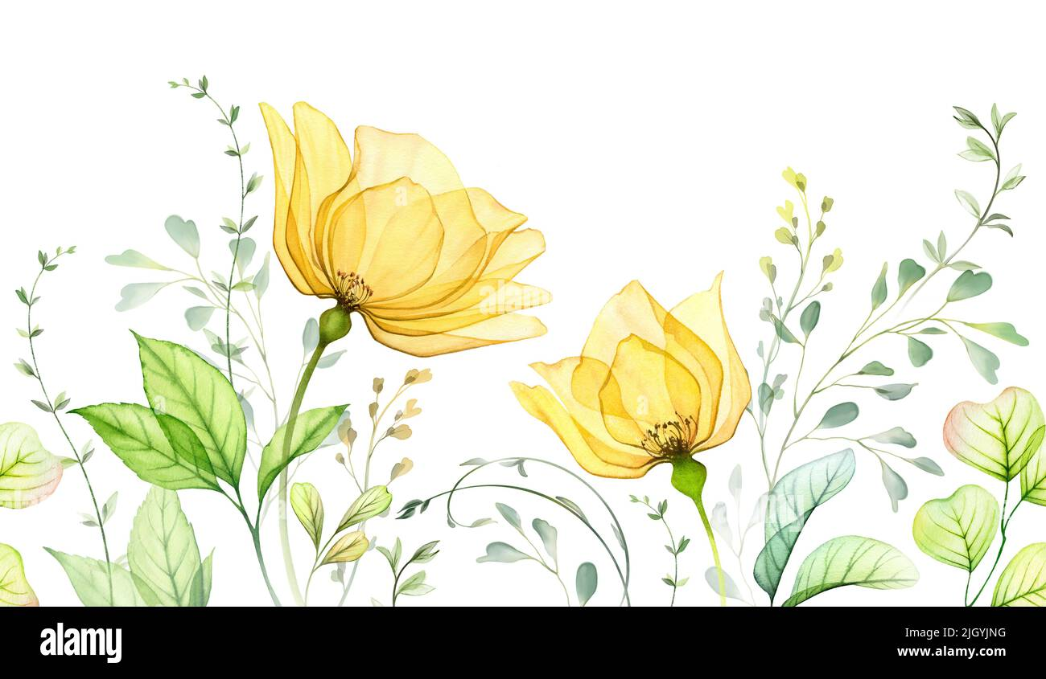
“Knit Happens” Introductory - 1.30pm - 3.30pm - Gail - (Volunteer) - (The Old School Café)
- This simple knitting session is ideal for those who have minimal to no experience in knitting. Our lovely volunteer will gently guide you, showing you the basic of techniques. From here, if you feel confident enough, you can then join onto our following sessions each week to gain more knowledge and knitting skills as you go.
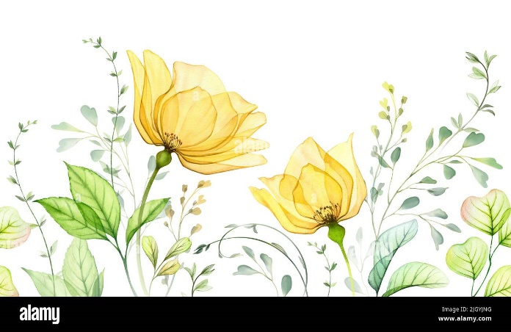


WEDNESDAY 7TH MAY

Morning -
Giant Canvas “A Forest” (3 Weeks) - 10am - 12pm - Olwyn - (Room 2 - Max.6ppl)

- This will be a collaborative art class where we will paint a forest scene with trees, bushes and leafy plants on a very large canvas which will be put up in the centre to add some colour to our walls. The class will be divided into two groups, one group will paint, and the other group will cut out leaf and flower shapes. The groups will then swap over the following week. In the 3rd week, we will bring the whole thing together!

Dance & Wellness - 10.30am - 11.30am - Emily - (Continued - Week 4)
Afternoon -
Lavender Watercolour Pot - 1.15pm - 3.30pm - Olwyn - (Craft Room - Max.14ppl)
- Using Cotton buds dipped in watercolour paint, we will create a pretty pot of purple lavender by gently pressing the cotton tips, to create the buds of the flower. A simple yet effective technique which produces beautiful results.
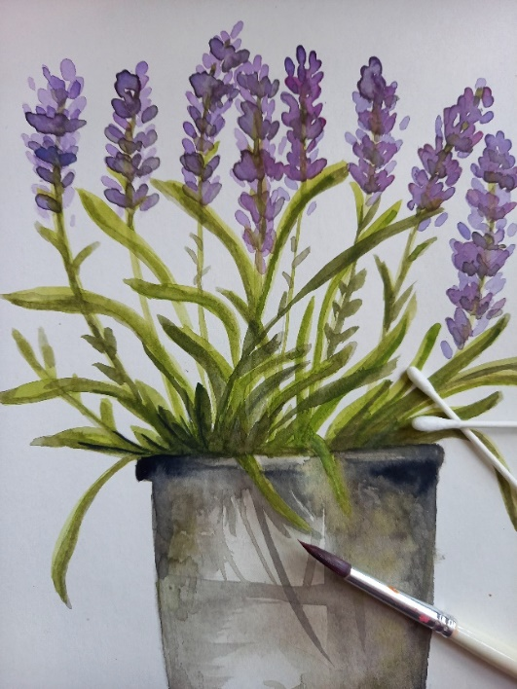


THURSDAY 8TH MAY
(Busy Day)
Morning -
Social Day - 9.30am - 4pm - (Craft Room - Max. 20ppl)
NEW! “Harmonise Your Mind” - 10.30am - 11.30am - Linda (Volunteer) - (Room 2 - Max.9ppl)
- Looking for a fun and uplifting way to brighten your week? Join our Harmonise Your Mind group, where voices come together to create harmony and joy! - For more info, please see the sheet attached to the back of this timetable. This is no longer a course but now one-off weekly sessions , anybody can book onto these sessions each week.

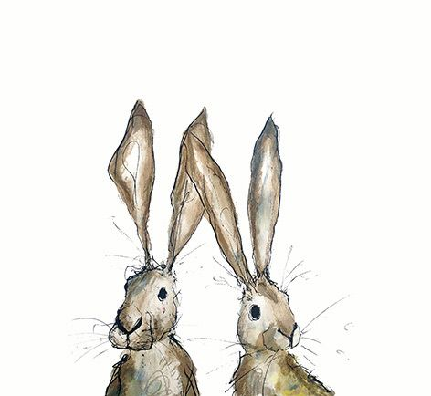
FRIDAY 9TH MAY
(Very busy day)
Morning –
Botanical Drawing - 10am - 12pm - Olwyn - (Craft Room - Max. 14ppl)
- Spring is here! and the buds, petals and leaves are appearing. In this relaxing and immersive class, we will collect some samples from nature, which we will then draw in fineliners and watercolours, with the addition of relaxing forest background sounds.
Cupcake Case Flowers - 10am - 12pm - Sarah & Angela - (Room 2 - Max. 7ppl)
- In this session you will make a beautiful bouquet of flowers using a technique with Cupcake Cases. You will add these to their stalks and some centre detailing with buttons/beads
Afternoon –
Seashells - 1.15pm - 3.30pm - Olwyn - (Craft Room - Max.14ppl)
- Using ‘Prismacolour’ pencils, we will use shading techniques to create the impression of three-dimensional seashells. We will learn about light and shade, and how to give the impression of sunlight falling upon the shells.
Walking Group - 1.30pm - 3pm - Nicola (Meet in The Old School Café - Max.6ppl)
- We will venture out into our wonderful City, exploring the ‘nooks & crannies’ of Durham. This is a nice relaxed paced walk, with only slight inclines and as few stairs as possible (but to be expected in “Hilly” Durham) The walks usually take around 90mins depending on the route and individuals’ mobility. The walks are weather permitted; you will be contacted by lunchtime if the walk has been cancelled due to adverse conditions. Please bring your own water/juice bottle to hydrate or purchase a drink from our Café and wear appropriate footwear and clothing. Waterproofs and umbrellas are good to bring along, in case of a downpour whilst out on the walk or Sunscreen if it is a particularly sunny day. You must book each walking session.

Fridays Class Examples
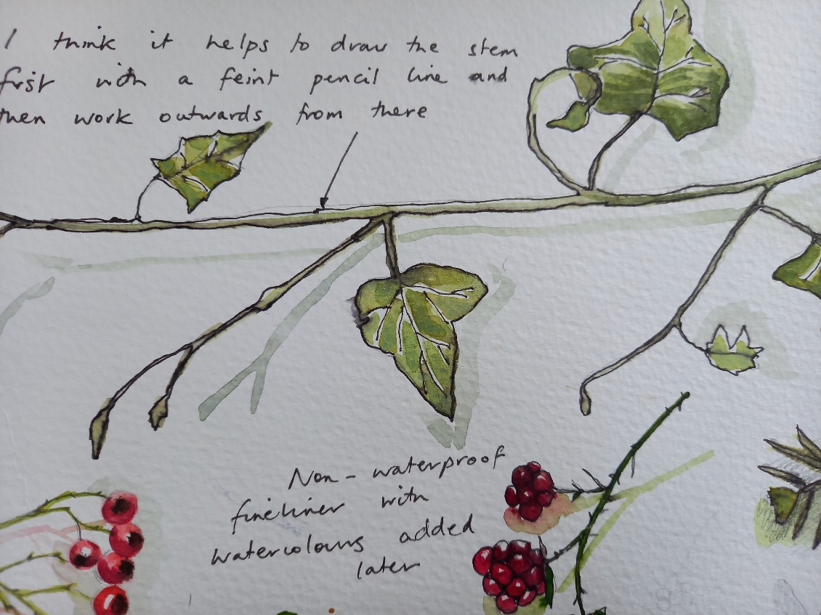
Morning -

“Botanical Drawing” Example

Afternoon –
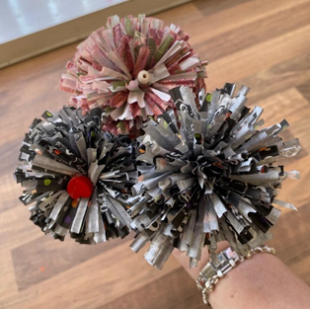
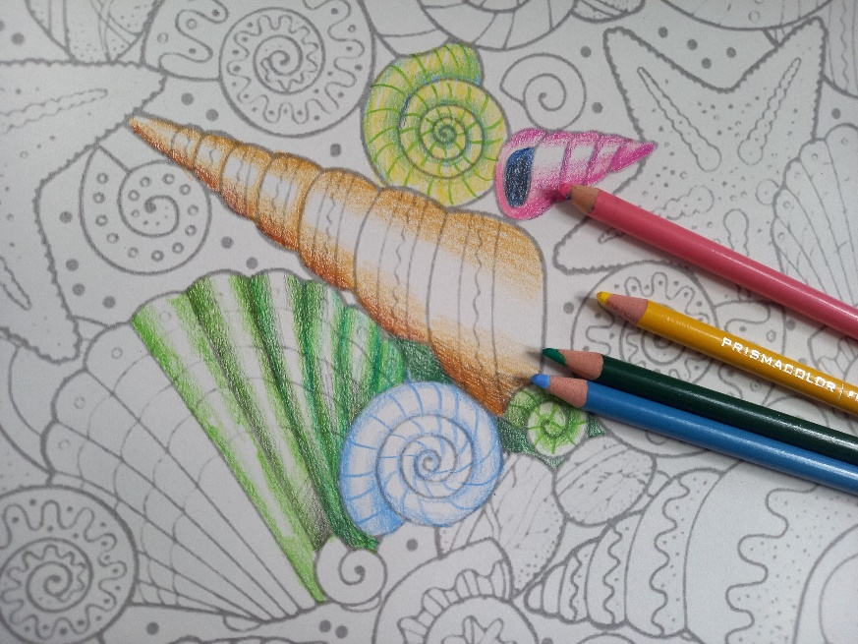

“Seashells” Example “Cupcake Case Flowers” Example
MONDAY 12TH MAY
Afternoon -

Chatty Café Drop In - 1pm - 2pm - John (Volunteer) - (The Old School Café)
Boats & Beach Huts - 1.15pm - 3.30pm - (Craft Room - Max.14ppl)
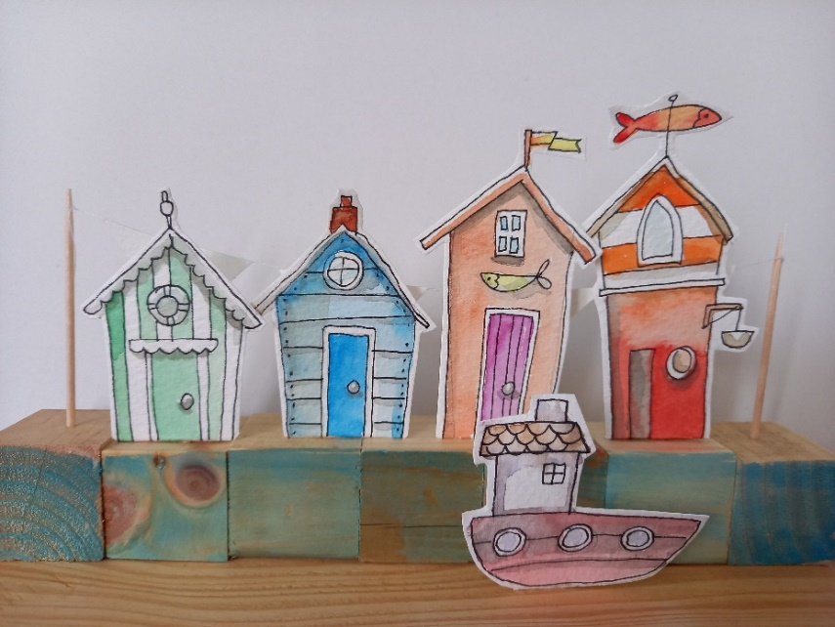
- Using Fineliners and watercolours, we will draw and paint little beach huts and cut them out. They will be assembled in a row on a block of wood with boats in the foreground. You can choose to add other embellishments, whatever seems fitting for your nautical theme.

TUESDAY 13TH MAY
Morning –
Social Day - 9.30am - 4pm - (Craft Room - Max. 20ppl)
Needle Felting Course - 10am - 12pm - Karen - WEA - (Continued - Week 6)
Gardening - 10.30am – 12.30pm - Sandra (Volunteer) - (Meet in Craft Room)
Afternoon –
Positive Pathways to Mental Wellbeing - 1.15pm - 3.15pm - Margaret - (Continued - Week 2)
“Knit Happens” Intermediate - 1.30pm - 3.30pm - Gail (Volunteer) - (The Old School Café)
- Our Intermediate sessions are for experienced knitters or anyone that has completed one or more of our beginners’ sessions. Feel free to bring your own knitting projects or simply turn up without so much as a knitting needle, and our lovely volunteer will get you set away on a project. These sessions will be held every week in our Café situated on the ground floor of our Centre. You will still need to book onto these sessions as there is limited space.
WEDNESDAY 14TH MAY
Morning -
Giant Canvas “A Forest” - 10am - 12pm - Olwyn - (Continued - Week 2)
Horticulture Group - 10am - 12pm - Joy (Volunteer) - (Allotments)
- You will assist in the general upkeep of our allotment, helping with digging, planting
fresh bulbs, weeding, and maintaining the grounds. You will help grow fresh produce
such as fruit, vegetables, and herbs as well as growing flowers, whilst learning new
skills as you go. Outdoor activities are proven to help with wellbeing and mental
health, so come and potter about, breath in the fresh air and absorb some of that all-important Vitamin D
Dance & Wellness - 10.30am - 11.30am - Emily - (Continued - Week 5)
Afternoon –
Plastic Bag Printing - 1.15pm - 3.30pm - Olwyn - (Craft Room - Max. 14ppl)
- Something new and different for us to try, with an effective and interesting technique! We will inflate a sandwich bag and tie a knot in the end and use this like a transfer tool to print flowers in acrylic onto card. The centres of the flowers can be added with a small brush, with the odd leaf here and there. Lots of fun, and a little messy!
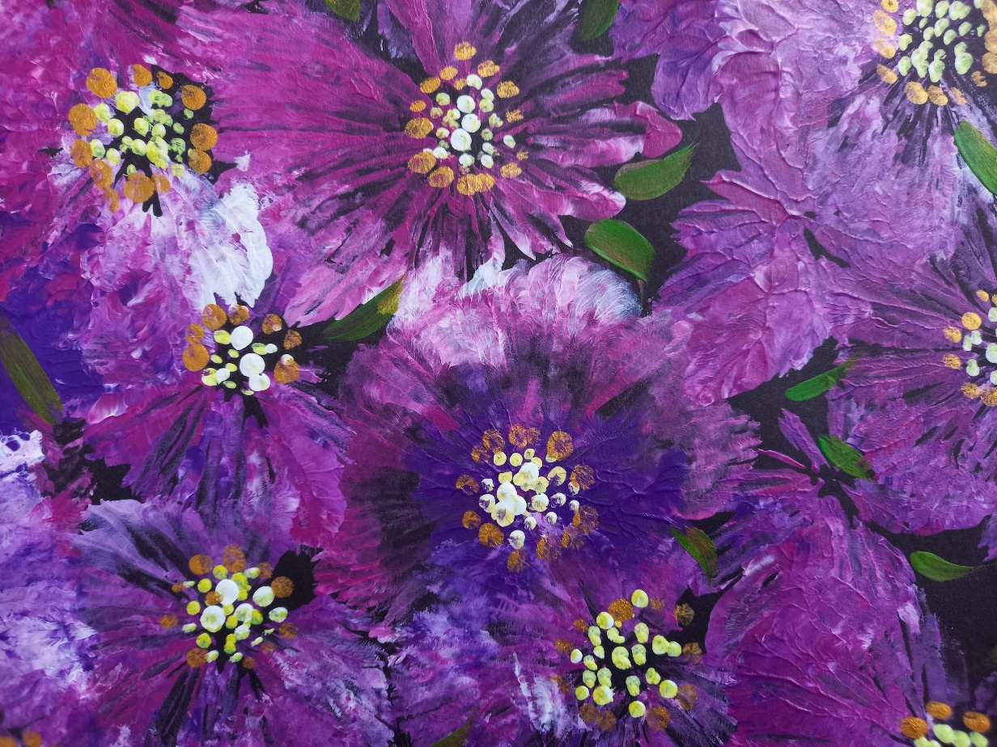

THURSDAY 15TH MAY
(Busy day)
Morning –
Social Day - 9.30am - 4pm - (Craft Room - Max.20ppl)
“Harmonise Your Mind” - 10.30am – 11.30am - Linda (Volunteer) - (Room 2 - Max.9ppl)
FRIDAY 16TH MAY
(Very busy day)
Morning –
Acrylic Painting “Seagulls” - 10am - 12pm - Olwyn - (Craft Room - Max. 14ppl)
- Using acrylic paints, we will paint quirky seagulls wearing stripy jumpers, colourful wellies and hats. This is a slow and deliberate method of painting where we paint blocks of colour, rather than a more impressionistic style.


Afternoon –
Lavender Watercolour Pot - 1.15pm - 3.30pm - Olwyn - (Room 2 - Max. 8ppl)
MONDAY 19TH MAY
Afternoon –
Chatty Café Drop In - 1pm - 2pm - John (Volunteer) - (The Old School Café)
Botanical Drawing - 1.15pm - 3.30pm - Olwyn - (Craft Room - Max.14ppl)

TUESDAY 20TH MAY
Morning –
Social Day - 9.30am - 4pm - (Craft Room - Max.20ppl)
Needle Felting Course - 10am - 12pm - Karen - WEA - (Continued - Final Session)
Gardening - 10.30am - 12.30pm - Sandra (Volunteer) - (Meet in Craft Room)
Afternoon –
Positive Pathways to Mental Health - 1.15pm - 3.15pm - Margaret - (Continued - Week 3)

“Knit Happens” Intermediate - 1.30pm - 3.30pm - Gail (Volunteer) - (The Old School Cafe)
WEDNESDAY 21ST MAY
Morning –
Giant Canvas “A Forest” - 10am - 12pm - Olwyn - (Continued - Final Session)
Horticulture Group - 10am - 12pm - Joy (Volunteer) - (Meet in Craft Room)
Dance & Wellness - 10.30am - 11.30am - Emily - (Continued - Week 6)
Afternoon –
Seashells – 1.15pm – 3.30pm - Olwyn - (Craft Room - Max.14ppl)

THURSDAY 22ND MAY
(Busy day)
Morning –
Social Day - 9.30am - 4pm - (Craft Room - Max. 20ppl)
“Harmonise Your Mind” - 10.30am - 12pm - Linda (Volunteer) - (Room 2 - Max.9ppl)
FRIDAY 23RD MAY
Morning-
Boats & Beach Huts - 10am - 12pm - Olwyn - (Craft Room - Max. 14ppl)
Afternoon –
Desert Island Discs - 1.15pm - 3.30pm - Olwyn - (Craft Room - Max. 14ppl)
- “Sounds of Summer” - In this very popular and uplifting group session, you will have the opportunity to request and listen to songs that remind you of joyful Summertime. Clients may share stories or briefly discuss why they have chosen a specific song, but you are more than welcome to just play a song and listen without sharing anything with the group.

MONDAY 26TH MAY
CENTRE CLOSED - Spring Bank Holiday

TUESDAY 27TH MAY
Morning –
Social Day - 9.30am - 4pm - (Craft Room - Max.20ppl)
Gardening - 10.30am - 12.30pm - Sandra (Volunteer) - (Meet in Craft Room)
Afternoon –
Positive Pathways to Mental Health - 1.15pm - 3.15pm - Margaret - (Continued - Week 4)

“Knit Happens” Intermediate - 1.30pm - 3.30pm - Gail (Volunteer) - (The Old School Cafe)
WEDNESDAY 28TH MAY
Morning –
Acrylic Painting “Seagulls” - 10am - 12pm - Olwyn - (Craft Room - Max. 14ppl)
Horticulture Group - 10am - 12pm - Joy (Volunteer) - (Meet in Craft Room)
Dance & Wellness - 10.30am - 11.30am - Emily - (Continued - Week 7)
Afternoon –
Boats & Beach Huts – 1.15pm – 3.30pm - Olwyn - (Craft Room - Max.14ppl)

THURSDAY 29TH MAY
(Busy day)
Morning –
Social Day - 9.30am - 4pm - (Craft Room - Max. 20ppl)
“Harmonise Your Mind” - 10.30am - 12pm - Linda (Volunteer) - (Room 2 - Max.9ppl)
FRIDAY 30TH MAY
Morning-
Plastic Bag Printing - 12pm - Olwyn - (Craft Room - Max. 14ppl)
Afternoon –
Botanical Drawing - 1.15pm - 3.30pm - Olwyn - (Craft Room - Max. 14ppl)

Decorative Storage Holder - 1.15pm - 3.30pm - Sarah & Angela - (Room 2 - Max.7ppl)

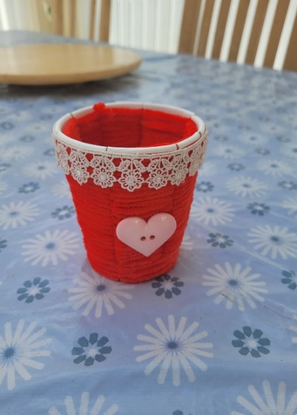
- You will all be given a disposable cup which you will cut slits into down the sides. You will then weave a choice of coloured wool through the cup to create a sturdy fabric exterior. You will then get an array of embellishments for you to decorate your container how you wish.

Walking Group - 1.30pm - 3pm - Nicola (Meet in The Old School Café - Max.6ppl)

Classes with this symbol - are dedicated, quieter sessions. Anybody can join them, but they are designed to be inclusive of neurodivergent individuals who may struggle to access our standard sessions.
(Up to a Maximum of 20ppl in our Craft Room and 8ppl in Room 2)
