**Please read carefully.**

Hello,

We hope this letter finds you well.

Enclosed you will find the latest timetable of activities for April 2025. We will be taking bookings for these activities via phone call or email from **10am** on **Monday 24th March**. Please do not phone us to try booking before this date and time. You will find our contact number and email address on the front page of your timetable.

**WEA Courses are now available and free to any of our attendees. We will now only request a national insurance number and a form of ID for enrolments.**

**Can we please remind everyone that if you are feeling unwell, DO NOT attend the Centre. Even if you feel just a little unwell, if you pass that on to someone else more vulnerable, it may impact them far worse. We also have limited staff who all play important roles, and if one of them get sick, it can have a significant impact on the rest of the Centre. Please be mindful and look out for each other and staff. Thank you.**

Due to the volume of new referrals coming through. You will only be able to book onto **one Social Day** (Tuesday **or** Thursday) and **two of Olwyn’s classes** per week. This is so we can give new attendees a fair chance of booking onto sessions. (Not including WEA, Bishop college or volunteer led classes).

**We please ask that you pay a £1 attendance fee per session.** Your attendance fee goes back into the Centre and helps towards cost of materials and use of our tea and coffee facilities situated in our craft room. Your contribution is much appreciated.

Please turn up to your class **on time** especially if you are already on the premises, unless you have called to say you are running late. **Do not eat food or leave to go for a cigarette during classes**, this can be very disruptive for other attendees and the instructor. You are all given a **15-minute break halfway through your classes** to eat, make a beverage and smoke.

If you are booked onto any class and cannot make it for whatever reason you must call the centre to inform us of this as early as possible, so that we can offer the space to somebody else. **You still need to book to attend Social Days** as well as regular classes, to guarantee you have a seat.

We look forward to seeing you.

**To Book Classes Call: 0191 384 8100 or Email: enquiries@stmargaretscentre.co.uk**

**(**There is an **attendance fee of** **£1 per session)**

**MONDAY 31ST MARCH**

*Afternoon -*

**Chatty Café Drop In - 1pm - 2pm - John (Volunteer) - (The Old School Café)**

* Are you feeling isolated and in need of a little chat and some friendly company? Then we welcome you to pop into The Old School Café, where one of our lovely volunteers will be there waiting. This is not counselling session, but a safe space where you can have a lovely chit chat or play some board games. Hopefully this little drop in will leave you feeling a little brighter.

**Awareness to Pride: The Evolution of Autism Symbols from 1963 to Today****Pastel Drawing “The Rabbit” - 1.15pm - 3.30pm - (Craft Room - Max. 14ppl)**

* Using a simple method, we will learn how to draw a rabbit using 3 circles. We can then move on to the fun part! Using our pastel chalks, we will add colour and detailing to bring our rabbit to life. There will be an inspiring selection of images available to work from, or of course, there’s always your own personal resource – your imagination!

**Mondays Class

*“The rabbit” Example*

**TUESDAY 1ST APRIL**

*Morning -*

**Social Day – 9.30am – 4pm – (Craft Room. Max. 20ppl)**

* A day for social interaction and a safe place to get on with any hobbies you may have e.g., Painting, drawing, writing, jigsaws, crosswords, knitting. Or just enjoy a nice little chin wag with a cuppa. We encourage you to bring your own projects to get on with if you would like to keep yourself busy, or we have an array of arts and crafts materials to get you inspired. ***You must still book a slot on any social day you wish to attend, to secure a seat.***

**Needle Felting Course - 10am - 12pm - Karen - WEA - (Continued - Week 2)**

*Afternoon -*

**Emotional Resilience & Meditation - 1.15pm - 3.15pm - Margaret - (Continued - Week 9)**

**“Knit Happens” Introductory - 1.30pm - 3.30pm - Gail - (Volunteer) - (The Old School Café)**

* This simple knitting session is ideal for those who have minimal to no experience in knitting. Our lovely volunteer will gently guide you, showing you the basic of techniques. From here, if you feel confident enough, you can then join onto our following sessions each week to gain more knowledge and knitting skills as you go. Or you may want to continue doing our monthly Introductory sessions, until you feel ready to progress.

**WEDNESDAY 2ND APRIL**

**Awareness to Pride: The Evolution of Autism Symbols from 1963 to Today***Morning -*

**One Stroke Painting “Bamboo” - 10am - 12pm - Olwyn - (Craft Room - Max.14ppl)**

* **A green bamboo with leaves

  AI-generated content may be incorrect.**One stroke painting is a technique which uses a square ended brush dipped into two or more colours of acrylic paint at the same time, to create brushstrokes with instant highlights. Using the ‘One Stroke’ painting technique, we will paint thick stems of bamboo. We will then attach thinner stalks and leaves to complete this realistic painting.

**Horticulture Group - 10am - 12pm - Joy (Volunteer) - (Allotments)**

* You will assist in the general upkeep of our allotment, helping with digging, planting

fresh bulbs, weeding, and maintaining the grounds. You will help grow fresh produce

such as fruit, vegetables, and herbs as well as growing flowers, whilst learning new

skills as you go. Outdoor activities are proven to help with wellbeing and mental

health, so come and potter about, breath in the fresh air and absorb some of that all-important Vitamin D

**Awareness to Pride: The Evolution of Autism Symbols from 1963 to Today***Afternoon –*

**Clay “Little Cloud” (2 Weeks) - 1.15pm - 3.30pm - Olwyn - (Craft Room - Max.14ppl)**

* In this short course we will create flat cloud shapes using air dried clay, which we will punch in holes along the bottom edge. In week 2, these can be embellished with coloured threads, beads, or smaller decorative clay motifs (If you choose to add decorative clay motifs, remember to make them in the first session, to allow for drying time***) If you book this course, please pop the following week in your diary***

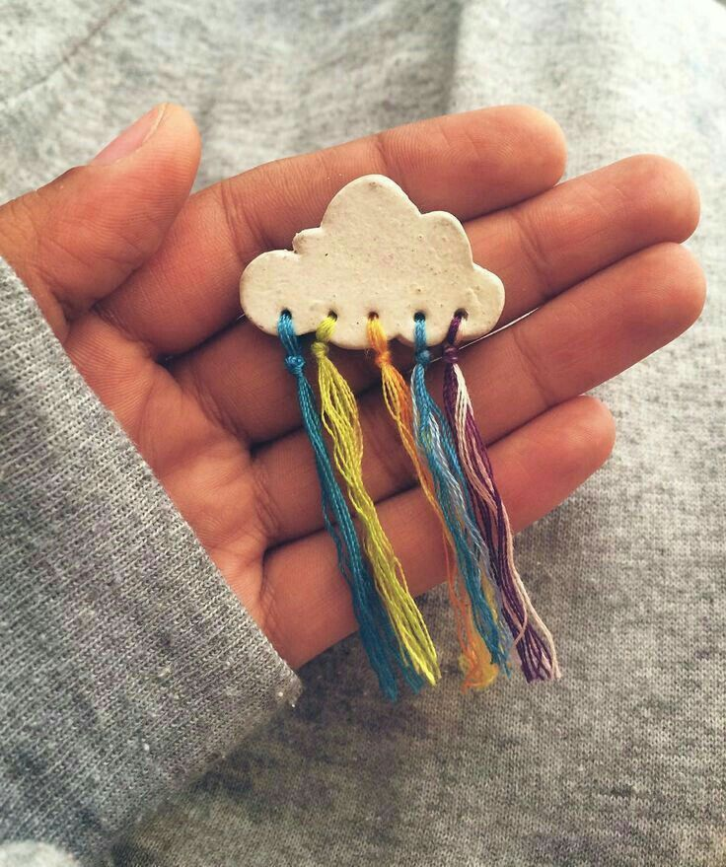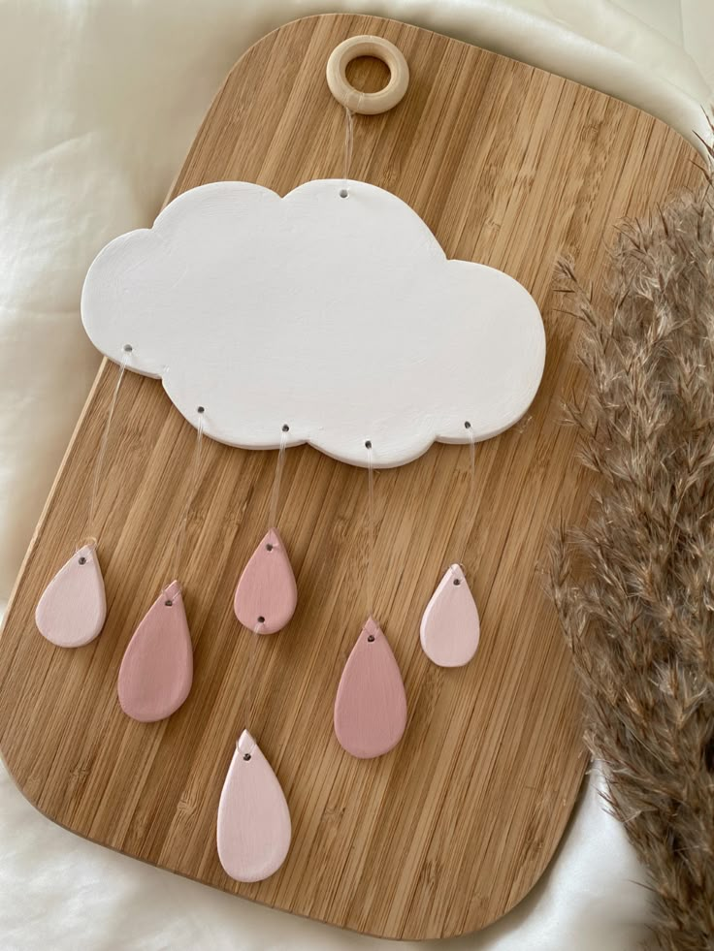

**THURSDAY 3RD APRIL**

**(Busy Day)**

*Morning -*

**Social Day - 9.30am - 4pm - (Craft Room - Max. 20ppl)**

* A day for social interaction and a safe place to get on with any hobbies you may have e.g., Painting, drawing, writing, jigsaws, crosswords, knitting. Or just enjoy a nice little chin wag with a cuppa. We encourage you to bring your own projects to get on with if you would like to keep yourself busy, but we have an array of arts and crafts materials to get you inspired. ***You must still book a slot on any social day you wish to attend, to secure a seat.***

**“Harmonise Your Mind” - 10.30am - 12pm - Linda (Volunteer) - (Continued - Week 5)**

*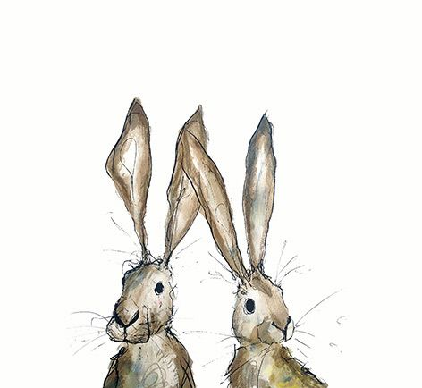***FRIDAY 4TH APRIL**

**(Very busy day)**

*Morning –*

**Mini Egg Gift Box - 10am - 12pm - Olwyn - (Craft Room - Max. 14ppl)**

* In this Easter inspired class you will cut and assemble your own small chocolate gift box. You will learn how to draw cartoon style eyes with different expressions and apply these to our boxes. Please note that this class heavily relies on cutting with scissors, so please be prepared for some intricate cutting.

**Embroidery Skills (4 Weeks) - 10am - 12pm - Meg, Alison & Gail - (Room 2 - Max.8ppl)**

* This basic embroidery course teaches students how to embroider using a needle and thread. Sessions may include instruction on how to prepare fabric, transfer designs, practice different stitch patterns and use a hoop. ***This course is designed for all skill levels. If you book onto this course, please pop the following 3 weeks in your diary.***

*Afternoon –*

**Watercolours “Easter Wreath” -****1.15pm - 3.30pm - Olwyn - (Room 2 - Max.8ppl)**

* A lovely relaxing watercolour class using watercolours to paint a pre-printed image of an easter wreath, featuring foliage, flowers and easter eggs. A nice laid-back session to allow for plenty time to chat.

**Textiles Group “Spring/Easter Decor” (4 weeks) - 1.15pm - 3.30pm - Meg, Alison & Gail (Volunteers) - (Craft Room - Max.10ppl)**

* Using a combination of hand sewing and machine sewing techniques you will create textile decorations based around the theme of spring and easter. ***If you book onto this course, please pop the following 3 weeks in your diary.***

*****Fridays Class Examples*

*****Morning -*

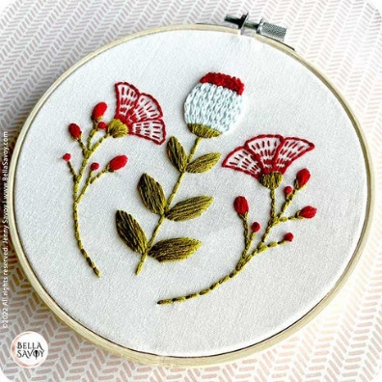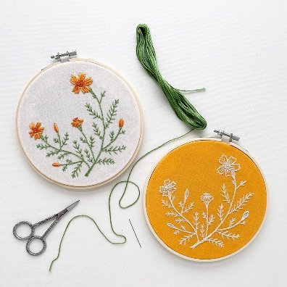

*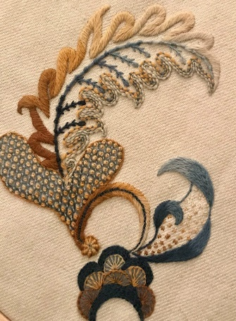***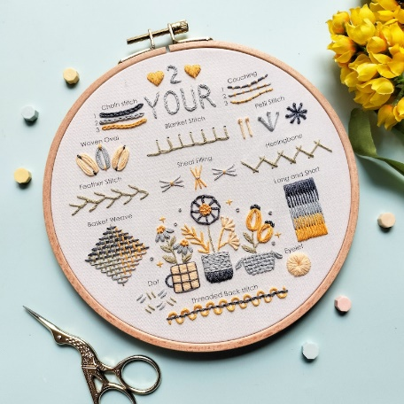**

*“Mini Egg Gift Box” Example “Embroidery Skills” Examples*

*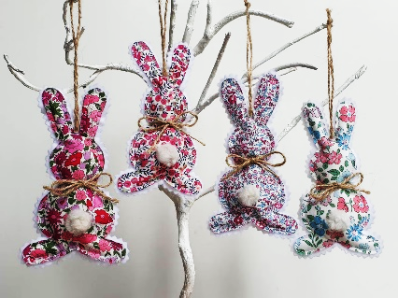Afternoon –*

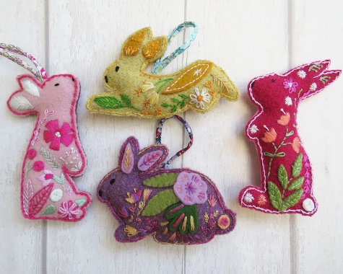

*“Easter Wreath” Example “Textiles Group, Spring/Easter ” Examples*

**MONDAY 7TH APRIL**

*Afternoon -*

**Chatty Café Drop In - 1pm - 2pm - John (Volunteer) - (The Old School Café)**

**One Stroke Painting “Bamboo” - 1.15pm - 3.30pm - (Craft Room - Max.14ppl)**

**TUESDAY 8TH APRIL**

*Morning –*

**Social Day - 9.30am - 4pm - (Craft Room - Max. 20ppl)**

**Needle Felting Course - 10am - 12pm – Karen – WEA – (Continued - Week 3)**

*Afternoon –*

**Emotional Resilience & Meditation - 1.15pm - 3.15pm - Margaret - (Final Session)**

**“Knit Happens” Intermediate - 1.30pm - 3.30pm - Gail (Volunteer) - (The Old School Café)**

* Our Intermediate sessions are for experienced knitters or anyone that has completed one or more of our beginners’ sessions. Feel free to bring your own knitting projects or simply turn up without so much as a knitting needle, and our lovely volunteer will get you set away on a project. These sessions will be held every week in our Café situated on the ground floor of our Centre. ***You will still need to book onto these sessions as there is limited space.***

**WEDNESDAY** **9TH APRIL**

**Awareness to Pride: The Evolution of Autism Symbols from 1963 to Today***Morning -*

**Mini Egg Gift Box - 10am - 12pm - Olwyn - (Craft Room - Max. 14ppl)**

**Horticulture Group - 10am - 12pm - Joy (Volunteer) - (Allotments)**

**Awareness to Pride: The Evolution of Autism Symbols from 1963 to Today***Afternoon –*

**Clay “Little Cloud” - 1.15pm - 3.30pm - Olwyn - (Continued - Final Session)**

**Easter Card Craft - 1.15pm - 3.30pm - Barry (Volunteer) - (Room 2 - Max 6ppl)**

* Come and join our wonderful volunteer in this fun card craft session. You will create your own Easter cards, using an array of easter themed crafts.

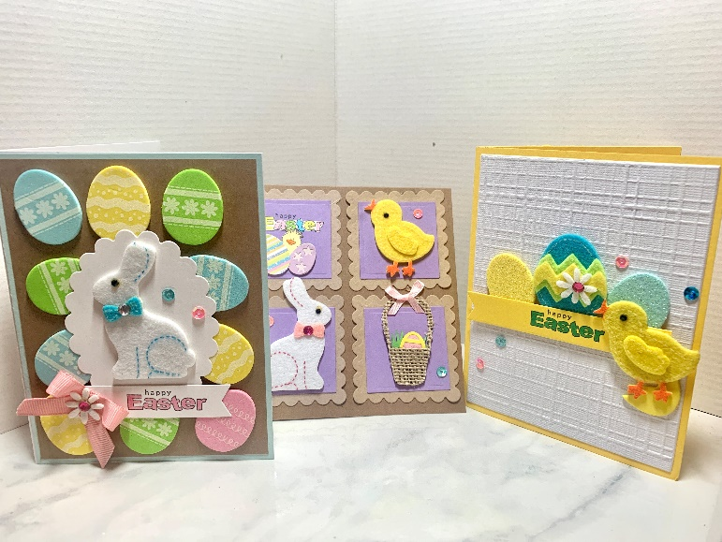

**THURSDAY 10TH APRIL**

**(Busy day)**

*Morning –*

**Social Day - 9.30am - 4pm - (Craft Room - Max.20ppl)**

**“Harmonise Your Mind” - 10.30am - 12pm - Linda (Volunteer) - (Final Session)**

*Afternoon –*

**Cupcake Case Flowers - 1.15pm - 3.30pm - Sarah & Angela (Volunteers) - (Rm.2 -Max.7ppl)**

* **A hand holding a bunch of paper pompoms

  AI-generated content may be incorrect.**In this session you will make a beautiful bouquet of flowers using a technique with Cupcake Cases. You will add these to their stalks and some centre detailing with buttons/beads.

**FRIDAY** **11TH APRIL**

**(Very busy day)**

*Morning –*

**Pastel Drawing “The Rabbit” - 1.15pm - 3.30pm - Olwyn - (Craft Room - Max. 14ppl)**

**Embroidery Skills - 10am - 12pm - Meg, Alison & Gail - (Continued - Week 2)**

*Afternoon –*

**Tea Turtle Coasters - 1.15pm - 3.30pm - Olwyn - (Room 2 - Max. 8ppl)**

* Back with an old favourite. These leather Coasters are made from small scraps of leather which are cut into hexagons to form a shell. These can be attached to a base to make quirky coasters. This is a great gift idea. ***Please be aware this class involves intricate cutting, and it can take a little more effort due to the material being cut.***

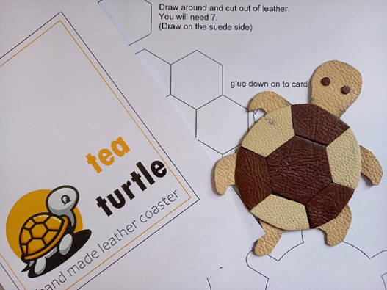

**Textiles Group - 1.15pm - 3.30pm - Meg, Alison, Gail - (Continued - Week 2)**

**MONDAY 14TH APRIL**

*Afternoon –*

**Chatty Café Drop In - 1pm - 2pm - John (Volunteer) - (The Old School Café)**

**NEW! Voices Shared - 1pm - 2pm - Erica (Trustee) - (Room 2 - Max. 8ppl)**

* These sessions have been created to allow attendees voices to be heard. They are in place for you to provide your feedback and any suggestions you may have with regards to the centre. Erica, who is one of the centres trustees, will be available to listen and take note of any ideas that are shared. ***You must still book these sessions as there is limited capacity.***

**Watercolours “Easter Wreath” - 1.15pm - 3.30pm -** **Olwyn - (Craft Room - Max.14ppl)**

**TUESDAY 15TH APRIL**

*Morning –*

**Social Day - 9.30am - 4pm - (Craft Room - Max.20ppl)**

**IT’S BACK! Gardening - 10am - 12pm - Sandra (Volunteer) - (Meet in Craft Room)**

* You will help with a little weeding, potting plants, and bulbs, watering flowers and assisting with the maintenance of our flower beds, lawns, and hedges. Outdoor activities are proven to help with wellbeing and mental health, so come and potter about, breathe in the fresh air and absorb some of that all-important Vitamin D.

**\*No Needle Felting Today, This Course Will Continue on Tuesday 29th April\***

*Afternoon –*

**“Knit Happens” Intermediate - 1.30pm - 3.30pm - Gail (Volunteer) - (The Old School Cafe)**

**WEDNESDAY 16TH APRIL**

**Awareness to Pride: The Evolution of Autism Symbols from 1963 to Today***Morning –*

**Tea Turtle Coasters - 10am - 12pm - Olwyn - (Room 2 - Max. 8ppl)**

**Horticulture Group - 10am - 12pm - Joy (Volunteer) - (Meet in Craft Room)**

**NEW! Dance & Wellness (10 Weeks) - 10.30am - 11.30am - Emily - (Craft Room - Max.8ppl)**

* ***5 Steps to Wellness***:  Through dance and exercise-based sessions learners will gain knowledge about social wellbeing / connecting with others / physical wellbeing / developmental wellbeing / psychological wellbeing and emotional wellbeing. The activities are designed to be challenging but achievable and are very flexible to meet individual learning needs and levels. This session will provide new creative learning and enrichment opportunities to enable them to develop and discover new interests and talents, unlock talent which may have gone unrecognised and celebrate and achieve.

*Afternoon –*

**Watercolour Splatter Cards – 1.15pm – 3.30pm - Olwyn - (Craft Room - Max.14ppl)**

* This is a lovely technique where we splash concentrated watercolours onto paper and then paint flowers with clean water. The surrounding colours will flow into the clean water and create lovely translucent petals

*“Watercolour Splatter Cards” Example*

**THURSDAY 17TH APRIL**

**(Busy day)**

*Morning –*

**Social Day - 9.30am - 4pm - (Craft Room - Max. 20ppl)**

**Music Quiz - 11am - 12.30pm - Kevin (Volunteer) - (Room 2 - Max.8ppl)**

* From Dance Halls to Glitter Balls, Bach to Bad Manners, come and join our host, Kevin for a fun, interactive quiz, and put your music knowledge to the test!

**FRIDAY 18TH APRIL**

**CENTRE CLOSED – Good Friday**

**MONDAY 21ST APRIL**

**CENTRE CLOSED - Easter Monday**

**TUESDAY 22ND APRIL**

*Morning –*

**Social Day - 9.30am - 4pm - (Craft Room - Max. 20.ppl)**

**Gardening - 10am - 12pm - Sandra (Volunteer) - (Meet in Craft Room)**

**\*No Needle Felting Today, This Course Will Continue on Tuesday 29th April\***

*Afternoon –*

**“Knit Happens” Intermediate - 1.30pm - 3.30pm - Gail (Volunteer) - (The Old School Café)**

**WEDNESDAY 23RD APRIL**

*****Morning –*

**Pastel Drawing “The Rabbit” - 10am - 12pm - Olwyn - (Room 2 - Max.8ppl)**

**Horticulture Group - 10am - 12pm - Joy (Volunteer) - (Allotments)**

**Dance & Wellness - 10.30am - 11.30am - Emily - (Continued - Week 2)**

*Afternoon –*

**Desert Island Discs - 1.15pm - 3.30pm - Olwyn - (Craft Room - Max.14ppl)**

* In this very popular and uplifting group session, you will have the opportunity to request and listen to songs that have meaning, or bring you joy. Clients may share stories or briefly discuss why they have chosen a specific song, but you are more than welcome to just play a song and listen without sharing anything with the group.

**THURSDAY 24TH APRIL**

**(Busy day)**

*Morning –*

**Social Day - 9.30am - 4pm - (Craft Room Max.20ppl)**

*Afternoon -*

**“No sew” Heart Cushions - 1.15pm - 3.30pm - Sarah (Volunteer) - (Room 2 - Max.8ppl)**

* 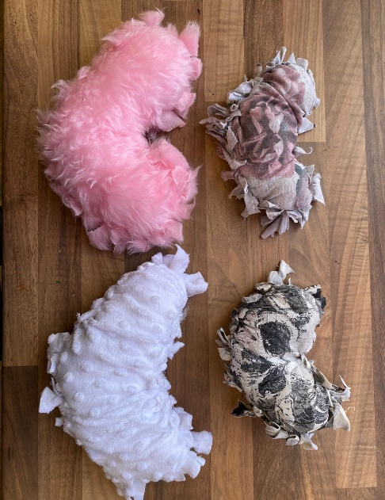In this crafty session you will create a small heart shaped cushion. You will be shown a technique in which you can create your stuffed fabric cushion, without any sewing necessary.

**FRIDAY 25TH APRIL**

**(Very busy day)**

*Morning –*

**Clay “Little Cloud” (2 Weeks) - 10am - 12pm - Olwyn - (Craft Room - Max.14ppl)**

**Embroidery Skills - 10am - 12pm - Meg, Alison & Gail - (Continued - Final Session)**

*Afternoon –*

**One Stroke Painting “Bamboo”- 1.15pm - 3.30pm - Olwyn - (Craft Room - Max. 8ppl)**

**Textiles Group - 1.15pm - 3.30pm - Meg, Alison, Gail - (Continued - Final Session)**

**MONDAY 28TH APRIL**

*Afternoon -*

**Awareness to Pride: The Evolution of Autism Symbols from 1963 to TodayChatty Café Drop In - 1pm - 2pm - John (Volunteer) - (The Old School Café)**

**Watercolour Splatter Cards - 1.15pm - 3.30pm - Olwyn - (Craft Room - Max.14ppl)**

**TUESDAY 29TH APRIL**

*Morning –*

**Social Day - 9.30am - 4pm - (Craft Room - Max. 20.ppl)**

**Gardening – 10am – 12pm – Sandra (Volunteer) – (Meet in Craft Room)**

**Needle Felting Course - 10am - 12pm - Karen - WEA - (Continued - Week 4)**

*Afternoon –*

**“Knit Happens” Intermediate - 1.30pm - 3.30pm - Gail (Volunteer) - (The Old School Café)**

**WEDNESDAY 30TH APRIL**

*****Morning –*

**Watercolours “Springtime Wreath” - 10am - 12pm - Olwyn - (Room 2 - Max.8ppl)**

**Horticulture Group - 10am - 12pm - Joy (Volunteer) - (Allotments)**

**Dance & Wellness - 10.30am - 11.30am - Emily - (Continued - Week 3)**

**Awareness to Pride: The Evolution of Autism Symbols from 1963 to Today***Afternoon –*

**One Stroke Painting “Bamboo” - 1.15pm - 3.30pm - Olwyn - (Craft Room - Max.14ppl)**

**Sound Healing - 2.30pm - 4pm - Ashleigh - (Room 2 - Max. 6ppl)**

* *“The Anam Cara Gong Baths”* It is called a sound ‘bath’ because you are immersed in the vibrations and frequencies of the gongs and other healing instruments – no baths or water involved! You will lie down on a yoga mat or sit on a chair for the duration of the session. Feel free to bring any blankets or pillows – whatever you like to make yourself as comfortable as possible. Ashleigh will take you all through some gentle guided breathwork, and a short meditation, before she plays the gongs. When played, the gongs carry healing sound waves. The frequency of the sound travels through your entire body and helps to facilitate healing on a cellular level. It can move energy blocks, soothe stress and anxiety, lift depression, and even ease physical pain. Please read the leaflet attached to the back of the timetable for more important information regarding this session.

**THURSDAY 1ST MAY**

**(Busy day)**

*Morning –*

**Social Day - 9.30am - 4pm - (Craft Room Max.20ppl)**

**There's a Power in the Music - 11am - 12.30pm - Kevin (Volunteer) - (Room 2 - Max.8ppl)**

* This Session is all about music for positive thinking. You will be exploring the music that raises the spirit.

**FRIDAY 2ND MAY**

**(Very busy day)**

*Morning –*

**Clay “Little Cloud” - 10am - 12pm - Olwyn - (Continued - Final Session)**

*Afternoon –*

**Desert Island Discs - 1.15pm - 3.30pm - (Room 2 - Max.8ppl)**

**IT’S BACK! Walking Group - 1.30pm - 3pm - Nicola (Meet in The Old School Café - Max.6ppl)**

* We will venture out into our wonderful City, exploring the ‘nooks & crannies’ of Durham. This is a nice relaxed paced walk, with only slight inclines and as few stairs as possible (but to be expected in “Hilly” Durham) The walks usually take around 90mins depending on the route and individuals’ mobility. The walks are weather permitted; you will be contacted by lunchtime if the walk has been cancelled due to adverse conditions. Please bring your own water/juice bottle to hydrate or purchase a drink from our Café and wear appropriate footwear and clothing. Waterproofs and umbrellas are good to bring along, in case of a downpour whilst out on the walk or Sunscreen if it is a particularly sunny day.

Awareness to Pride: The Evolution of Autism Symbols from 1963 to TodayClasses with this symbol - are dedicated, quieter sessions. Anybody can join them, but they are designed to be inclusive of neurodivergent individuals who may struggle to access our standard sessions.

(Up to a Maximum of 20ppl in our Craft Room and 8ppl in Room 2)

**Info Sheet**

**The Anam Cara Gong Baths**

***Sound Healing***

Each sound bath lasts around an hour and a half, with around 50 minutes of gong therapy.

After the session I will come around and check in with everyone to make sure they are okay and give them the opportunity to share their experiences. Participants do not have to share anything; it is more of a welfare check in.

During the gong bath participants may experience a range of things, sometimes people don’t experience anything, there is no right or wrong way to experience a gong bath. The healing and stress relief still occurs regardless of the individual experience.

Things you may experience :

- Feel cold or warm

- Feel like you are stuck to or sinking into the floor

- See colours or shapes in your mind’s eye

- Some people have even experienced guides or past loved ones visiting them

- Old memories may resurface

- Visit different events that have occurred in your life

- Feel like you are floating

- Some people experience flying through different landscapes, and go on visual journeys

- Sometimes people fall asleep

- Sometimes people may experience nothing, they just relax and are fully present. Some struggle to quieten their minds, but that is okay. Meditation takes practice, and the healing is still effective. Sometimes difficult emotions can rise to the surface as a way of healing old wounds, it is totally normal, and I recommend to just stay with the breath (Outlined in the meditation beforehand) and ride it out. The emotions are purging old wounds, and it’s a case of 'feel it to heal it'.

You experience something different every time you go to a sound bath. The best way to prepare is to not expect anything and simply relax into the session.

Participants usually sleep very well after a gong bath, as the healing continues a cellular level for days afterwards. Regular sound baths are required to reap the long-term benefits of sound healing.

