**Please read carefully.**

Hello,

We hope this letter finds you well.

Enclosed you will find the latest timetable of activities for March 2025. We will be taking bookings for these activities via phone call or email from **10am** on **Monday 24th February**. Please do not phone us to try booking before this date and time. You will find our contact number and email address on the front page of your timetable.

**WEA Courses are now available and free to any of our attendees. We will now only request a national insurance number and a form of ID for enrolments.**

**Can we please remind everyone that if you are feeling unwell, DO NOT attend the Centre. Even if you feel just a little unwell, if you pass that on to someone else more vulnerable, it may impact them far worse. We also have limited staff who all play important roles, and if one of them get sick, it can have a significant impact on the rest of the Centre. Please be mindful and look out for each other and staff. Thank you.**

Due to the volume of new referrals coming through. You will only be able to book onto **one Social Day** (Tuesday **or** Thursday) and **two of Olwyn’s classes** per week. This is so we can give new attendees a fair chance of booking onto sessions. (Not including WEA, Bishop college or volunteer led classes).

**We please ask that you pay a £1 attendance fee per session.** Your attendance fee goes back into the Centre and helps towards cost of materials and use of our tea and coffee facilities situated in our craft room. Your contribution is much appreciated.

Please turn up to your class **on time** especially if you are already on the premises, unless you have called to say you are running late. **Do not eat food or leave to go for a cigarette during classes**, this can be very disruptive for other attendees and the instructor. You are all given a **15-minute break halfway through your classes** to eat, make a beverage and smoke.

If you are booked onto any class and cannot make it for whatever reason you must call the centre to inform us of this as early as possible, so that we can offer the space to somebody else. **You still need to book to attend Social Days** as well as regular classes, to guarantee you have a seat.

We look forward to seeing you.

**To Book Classes Call: 0191 384 8100 or Email: enquiries@stmargaretscentre.co.uk**

**(**There is an **attendance fee of** **£1 per session)**

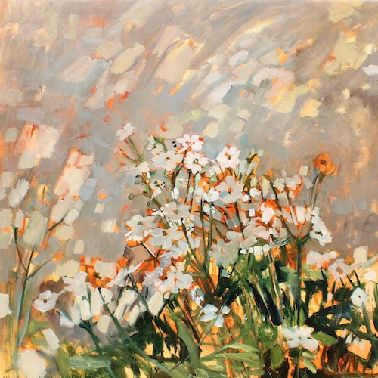

**MONDAY 3RD MARCH**

*Afternoon -*

**Chatty Café Drop In - 1pm - 2pm - John (Volunteer) - (The Old School Café)**

* Are you feeling isolated and in need of a little chat and some friendly company? Then we welcome you to pop into The Old School Café, where one of our lovely volunteers will be there waiting. This is not counselling session, but a safe space where you can have a lovely chit chat or play some board games. Hopefully this little drop in will leave you feeling a little brighter.

**Awareness to Pride: The Evolution of Autism Symbols from 1963 to TodaySound And Vision - 1.15pm - 3.30pm - (Craft Room - Max. 14ppl)**

* Neurographic Art is a free flowing, intuitive form of art which combines science, art, and psychology. It is based on the idea that creating neuron – like lines and shapes can help you to calm and focus the mind. We will use fineliners and coloured pencils to explore this meditative form of art alongside a background of relaxing music.

Mondays Class

“Sound And Vision” Example

**TUESDAY 4TH MARCH**

*Morning -*

**Social Day – 9.30am – 4pm – (Craft Room. Max. 20ppl)**

* A day for social interaction and a safe place to get on with any hobbies you may have e.g., Painting, drawing, writing, jigsaws, crosswords, knitting. Or just enjoy a nice little chin wag with a cuppa. We encourage you to bring your own projects to get on with if you would like to keep yourself busy, or we have an array of arts and crafts materials to get you inspired. You must still book a slot on any social day you wish to attend, to secure a seat.

**Emotional Resilience & Meditation - 1.15pm - 3.15pm - Margaret – (Continued – Week 6)**

**“Knit Happens” Introductory - 1.30pm - 3.30pm - Gail - (Volunteer) - (The Old School Café)**

* This simple knitting session is ideal for those who have minimal to no experience in knitting. Our lovely volunteer will gently guide you, showing you the basic of techniques. From here, if you feel confident enough, you can then join onto our following sessions each week to gain more knowledge and knitting skills as you go. Or you may want to continue doing our monthly Introductory sessions, until you feel ready to progress.

**WEDNESDAY 5TH MARCH**

*Morning -*

**Cat Trinket Tray (2 Weeks) - 10am - 12pm - Olwyn - (Craft Room - Max.14ppl)**

* In this slightly messy, hands-on short course, you make your own cat shaped trinket tray using clay. In the first session you will mould and manipulate your clay into shape and then add any details you may want etching into it. The following week, once dried, you will add paint to your clay to give your cats some character. You do not need any clay/pottery experience; this class is for beginners, so all are welcome.

**Awareness to Pride: The Evolution of Autism Symbols from 1963 to Today***Afternoon –*

**Sparkle doodles (2 Weeks) - 10am - 12pm - Olwyn - (Craft Room - Max.14ppl)**

* Let your creative doodling run wild with this relaxing class, where mandalas meet Zentangle with a few sparkles thrown in! Lots of time to socialise as we doodle and no pressure to draw anything complicated.

**THURSDAY 6TH MARCH**

**(Busy Day)**

*Morning -*

**Social Day - 9.30am - 4pm - (Craft Room - Max. 20ppl)**

* **A group of people standing around a person singing

  AI-generated content may be incorrect.**A day for social interaction and a safe place to get on with any hobbies you may have e.g., Painting, drawing, writing, jigsaws, crosswords, knitting. Or just enjoy a nice little chin wag with a cuppa. We encourage you to bring your own projects to get on with if you would like to keep yourself busy, but we have an array of arts and crafts materials to get you inspired. You must still book a slot on any social day you wish to attend, to secure a seat.

**NEW!** **“Harmonise Your Mind” (6 Weeks) - 10.30am - 12pm - Linda (Volunteer) - (Room 2)**

* This innovative singing group, led by Occupational

Therapist and singer Linda Rae, combines the joy of

music with evidence-based techniques for mental

health and wellbeing. Each 90-minute session is

designed to create a supportive, nurturing

environment where you can explore your voice,

learn valuable self-regulation skills, and experience

the uplifting power of group singing. If you book

this course, please pop the following 5-weeks in

your diary.

*Afternoon –*

**Decoupage “Crafternoon” (4 Weeks) - 12.30pm - 2.30pm - Janet & Pam (Volunteers) - (Room 2 - Max.8ppl)**

* We will revisit the decoupage and dried flower workshops explored earlier to produce 3D work. These results will be applied to your own spring themed garland. You'll also help towards creating one for the centre’s front door.

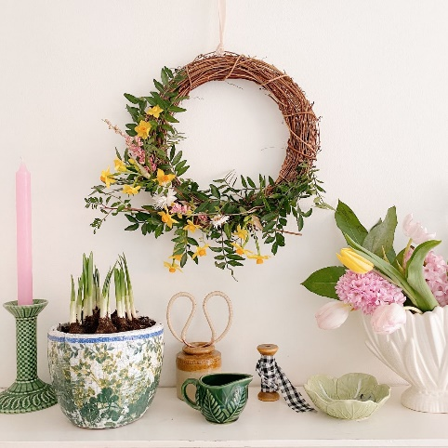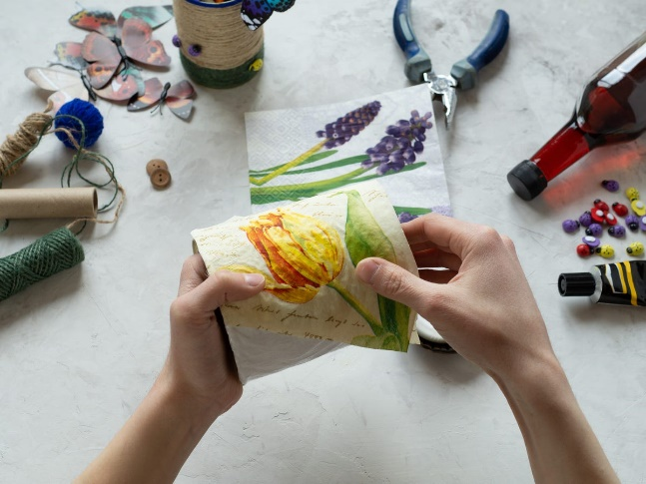

*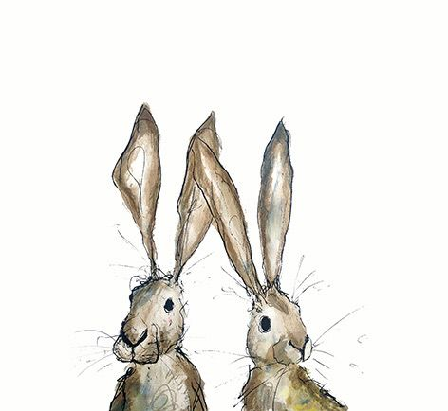***FRIDAY 7TH MARCH**

**(Very busy day)**

*Morning –*

**“Teamwork!” Coloured Tiles - 10am - 12pm - Olwyn - (Craft Room - Max. 14ppl)**

* This is a collaborative group activity, where each participant uses coloured pencils to colour and individual paper tile. These tiles will then fit together at the end of the class to form a large mosaic style design. Working like this in a group setting can help to alleviate social anxieties, build social skills, and boost self-esteem.

**Embroidery Skills (4 Weeks) - 10am - 12pm - Meg, Alison & Gail - (Room 2 - Max.8ppl)**

* This basic embroidery course teaches students how to embroider using a needle and thread. Sessions may include instruction on how to prepare fabric, transfer designs, practice different stitch patterns and use a hoop. This course is designed for all skill levels. If you book onto this course, please pop the following 3 weeks in your diary.

*Afternoon –*

**“Positivi-tea” -****1.15pm - 3.30pm - Olwyn - (Room 2 - Max.8ppl)**

* Taking care of yourself is so important for your own metal well-being and it also helps you to have the energy to be there for others. In this activity, we will cut 9 different teacups from patterned paper and paste them on to an A3 piece of card. We will write a positive affirmation under each one, to remind us to take care of ourselves – remember you cannot pour from an empty cup!

**“Zipped Bags” Textiles Group (4 weeks) - 1.15pm - 3.30pm - Meg, Alison & Gail (Volunteers) - (Craft Room - Max.10ppl)**

* In this course you will hand craft your very own small, boxed shape cosmetic bag. These bags will be made from a choice of fabrics, which you will incorporate a zipper into. You will sew together your materials using a combination of hand sewing and machine sewing techniques. You will If you book onto this course, please pop the following 3 weeks in your diary.

*****Fridays Class Examples*

*Morning -*

**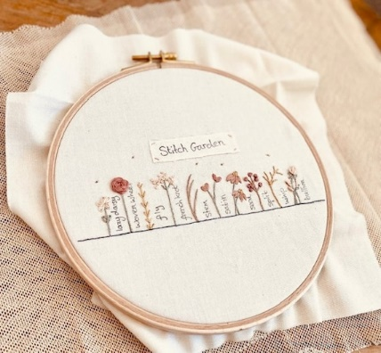****

*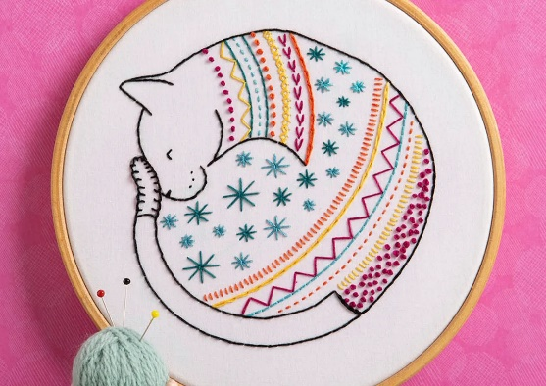***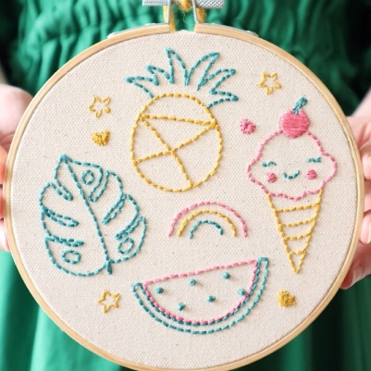**

*“Teamwork - Coloured Tiles” Example “Embroidery Skills” Examples*

* Afternoon –*

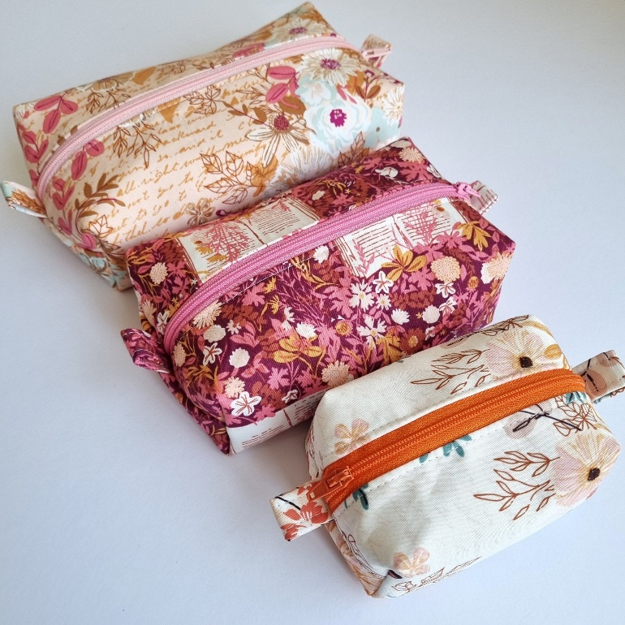

*“Positivi-tea” Example “Textiles Group” Examples*

**MONDAY 10TH MARCH**

*Afternoon -*

**Chatty Café Drop In - 1pm - 2pm - John (Volunteer) - (The Old School Café)**

**Dry Brush Painting - 1.15pm - 3.30pm - (Craft Room - Max.14ppl)**

* In this class you will learn an effective painting technique where small amounts of paint are applied to a brush and gently brushed back and forth across paper, without applying any water at all throughout. This gives an old traditional appearance to your paintings.

*Example by Sandra Shirley*

**TUESDAY 11TH MARCH**

*Morning –*

**Social Day – 9.30am – 4pm – (Craft Room – Max. 20ppl)**

*Afternoon –*

**Emotional Resilience & Meditation - 1.15pm - 3.15pm - Margaret - (Continued – Week 7)**

**“Knit Happens” Intermediate - 1.30pm - 3.30pm - Gail (Volunteer) - (The Old School Café)**

* Our Intermediate sessions are for experienced knitters or anyone that has completed one or more of our beginners’ sessions. Feel free to bring your own knitting projects or simply turn up without so much as a knitting needle, and our lovely volunteer will get you set away on a project. These sessions will be held every week in our Café situated on the ground floor of our Centre. You will still need to book onto these sessions as there is limited space.

**WEDNESDAY** **12TH MARCH**

*Morning -*

**Cat Trinket Tray - 10am - 12pm - Olwyn - (Continued - Final Session)**

**Awareness to Pride: The Evolution of Autism Symbols from 1963 to Today***Afternoon –*

**Sparkle doodles - 10am - 12pm - Olwyn - (Continued - Final Session)**

**THURSDAY 13TH MARCH**

**(Busy day)**

*Morning –*

**Social Day - 9.30am - 4pm - (Craft Room - Max.20ppl)**

**“Harmonise Your Mind” - 10.30am - 12pm – Linda (Volunteer) - (Continued - Week 2)**

*Afternoon –*

**Decoupage “Crafternoon” - 12.30pm - 2.30pm - Janet & Pam - (Continued - Week 2)**

**FRIDAY** **14TH MARCH**

**(Very busy day)**

*Morning –*

**Embroidery Skills - 10am - 12pm - Meg, Alison & Gail - (Continued - Week 2)**

*Afternoon –*

**Crosswords & Cuppas - 1.15pm - 3.30pm - Group Activity - (Room 2 - Max. 9ppl)**

* You will all be given crosswords; you will try and complete the crosswords as a team, reading out questions and sharing answers. This is a fun, and upbeat social activity for all to enjoy. If you’d prefer to do a separate crossword on your own, this is fine, and you will be provided with a different one to complete.

**“Zipped Bags” Textiles Group - 1.15pm - 3.30pm - Meg, Alison, Gail - (Continued - Week 2)**

**MONDAY 17TH MARCH**

*Afternoon –*

**Chatty Café Drop In - 1pm - 2pm - John (Volunteer) - (The Old School Café)**

**Watercolour Illustrations - 1.15pm - 3.30pm - Group Led Session** **(Craft Room - Max.14ppl)**

* There will be no tutor running this class today, this session will be a group led activity. You will be provided with a pre-printed illustration, some watercolours and a Fineliner to create your artwork. All you need to do is add a splash of colour and outline your illustration, no skills necessary! This is a laid-back session, allowing plenty of time to chat amongst yourselves.

**TUESDAY 18TH MARCH**

*Morning –*

**Social Day - 9.30am - 4pm - (Craft Room - Max.20ppl)**

*Afternoon –*

**Emotional Resilience & Meditation - 1.15pm - 3.15pm - Margaret - (Continued - Week 8)**

**“Knit Happens” Intermediate - 1.30pm - 3.30pm - Gail (Volunteer) - (The Old School Cafe)**

**WEDNESDAY 19TH MARCH**

**Awareness to Pride: The Evolution of Autism Symbols from 1963 to Today***Morning –*

**Social Day - 10am - 3.30pm - (Craft Room - Max.20ppl)**

**Button Art - 10am - 12pm - Marie (Volunteer) - (Room 2 - Max. 8ppl)**

* In this playful and uplifting session, you will create various types of art using an array of colourful buttons. This could be wall art, cards, or you may decorate an MDF shape. This class is for all levels, no experience needed.

**THURSDAY 20TH MARCH**

**(Busy day)**

*Morning –*

**Social Day - 9.30am - 4pm - (Craft Room - Max. 20ppl)**

**“Harmonise Your Mind” - 10.30am - 12pm - Linda (Volunteer) - (Continued - Week 3)**

*Afternoon –*

**Decoupage “Crafternoon” - 12.30pm - 2.30pm - Janet & Pam - (Continued - Week 3)**

**FRIDAY 21ST MARCH**

**(Very busy day)**

*Morning –*

**Crosswords & Cuppas - 10am - 12pm - Group Activity - (Craft Room - Max. 14ppl)**

* There will be no tutor present for this session You will all be given a large crossword; you will try and complete the crosswords as a team. If you’d prefer to do a separate crossword on your own, you will be provided with a different one to complete.

**Embroidery Skills - 10am - 12pm - Meg, Alison & Gail - (Continued - Week 3)**

*Afternoon –*

**“Zipped Bags” Textiles Group - 1.15pm - 3.30pm - Meg, Alison, Gail - (Continued - Week 3)**

**MONDAY 24TH MARCH**

*Afternoon -*

**Awareness to Pride: The Evolution of Autism Symbols from 1963 to TodayChatty Café Drop In - 1pm - 2pm - John (Volunteer) - (The Old School Café)**

**Watercolour Illustrations - 1.15pm - 3.30pm - Group Led Session (Craft Room - Max.14ppl)**

**TUESDAY 25TH MARCH**

*Morning –*

**Social Day - 9.30am - 4pm - (Craft Room - Max. 20.ppl)**

**NEW! Needle Felting Course (7 Weeks) - 10am - 12pm - Karen - WEA - (Room 2 - Max.8ppl)**

* Needle felting is a craft that uses specially designed notched needles to sculpt wool into shapes and designs. The notches on the needles tangle the wool fibres, causing them to interlock and form firm structures. This versatile craft allows you to create anything from simple 2D flat pieces to intricate 3D sculptures. Please bring in a form of photo ID, an email address and your National Insurance number at least one week prior to the course starting, these will be used to enrol you onto this course.

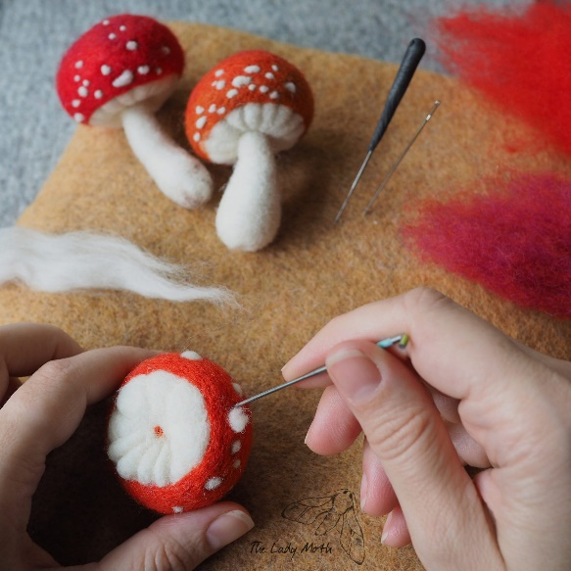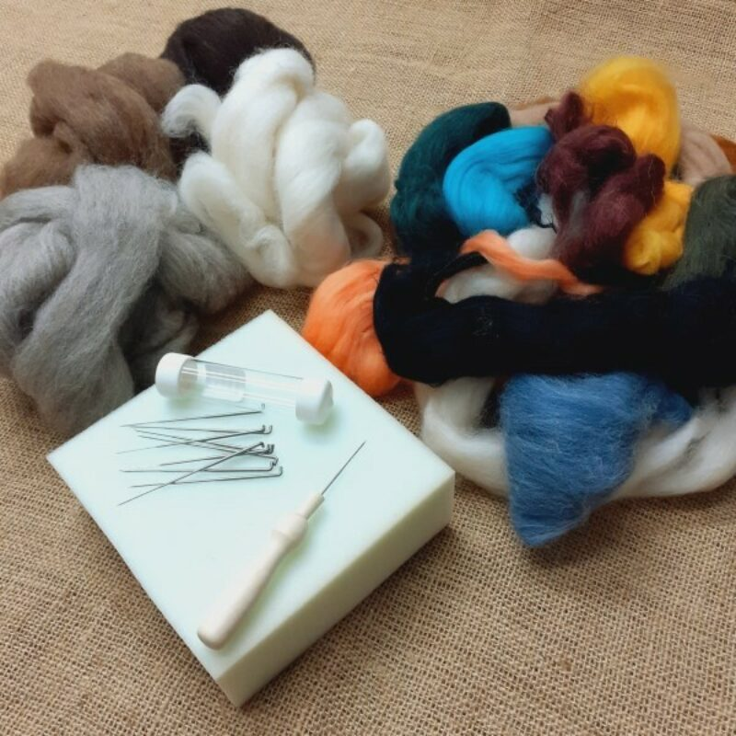

*Afternoon –*

**Emotional Resilience & Meditation - 1.15pm - 3.15pm - Margaret - (Continued - Week 9)**

**“Knit Happens” Intermediate - 1.30pm - 3.30pm - Gail (Volunteer) - (The Old School Café)**

**WEDNESDAY 26TH MARCH**

*****Morning –*

**“Something Fishy” Acrylic Painting - 10am - 12pm - Olwyn - (Craft Room - Max.14ppl)**

* In this class we will use acrylic paint in a contemporary way to create a quirky, bold design using solid blocks of colour, and simple lines.

**IT’S BACK! Horticulture Group - 10am - 12pm - Joy (Volunteer) - (Allotments)**

* You will assist in the general upkeep of our allotment, helping with digging, planting

fresh bulbs, weeding, and maintaining the grounds. You will help grow fresh produce

such as fruit, vegetables, and herbs as well as growing flowers, whilst learning new

skills as you go. Outdoor activities are proven to help with wellbeing and mental

health, so come and potter about, breath in the fresh air and absorb some of that all-important Vitamin D.

*Afternoon –*

**Desert Island Discs - 1.15pm - 3.30pm - Olwyn - (Craft Room - Max.14ppl)**

* In this very popular and uplifting group session, you will have the opportunity to request and listen to songs that have meaning, or bring you joy. Clients may share stories or briefly discuss why they have chosen a specific song, but you are more than welcome to just play a song and listen without sharing anything with the group.

**NEW!** **Sound Healing - 2.30pm - 4pm - Ashleigh - (Room 2 - Max. 6ppl)**

* *“The Anam Cara Gong Baths”* It is called a sound ‘bath’ because you are immersed in the vibrations and frequencies of the gongs and other healing instruments – no baths or water involved! You will lie down on a yoga mat or sit on a chair for the duration of the session. Feel free to bring any blankets or pillows – whatever you like to make yourself as comfortable as possible. Ashleigh will take you all through some gentle guided breathwork, and a short meditation, before she plays the gongs. When played, the gongs carry healing sound waves. The frequency of the sound travels through your entire body and helps to facilitate healing on a cellular level. It can move energy blocks, soothe stress and anxiety, lift depression, and even ease physical pain. Please read the leaflet attached to the back of the timetable for more important information regarding this session.

**THURSDAY 27TH MARCH**

**(Busy day)**

*Morning –*

**Social Day - 9.30am - 4pm - (Craft Room Max.20ppl)**

**“Harmonise Your Mind” - 10.30am - 12pm - Linda (Volunteer) - (Continued - Week 4)**

*Afternoon -*

**Decoupage “Crafternoon” - 12.30pm - 2.30pm - Janet & Pam - (Continued - Final Session)**

**FRIDAY 28TH FEBRUARY**

**(Very busy day)**

*Morning –*

**Dry Brush Painting - 10am - 12pm - Olwyn - (Craft Room - Max. 14ppl)**

**Embroidery Skills - 10am - 12pm - Meg, Alison & Gail - (Continued - Final Session)**

*Afternoon –*

**Sound & Vision - 1.15pm - 3.30pm - Olwyn - (Room 2 - Max. 8ppl)**

**“Zipped Bags” Textiles Group - 1.15pm - 3.30pm - Meg, Alison, Gail - (Continued - Final Session)**

Awareness to Pride: The Evolution of Autism Symbols from 1963 to Today

Classes with this symbol - are dedicated, quieter sessions. Anybody can join them, but they are designed to be inclusive of neurodivergent individuals who may struggle to access our standard sessions.

(Up to a Maximum of 20ppl in our Craft Room and 8ppl in Room 2)

**Info Sheet**

**The Anam Cara Gong Baths**

***Sound Healing***

Each sound bath lasts around an hour and a half, with around 50 minutes of gong therapy.

After the session I will come around and check in with everyone to make sure they are okay and give them the opportunity to share their experiences. Participants do not have to share anything; it is more of a welfare check in.

During the gong bath participants may experience a range of things, sometimes people don’t experience anything, there is no right or wrong way to experience a gong bath. The healing and stress relief still occurs regardless of the individual experience.

Things you may experience :

- Feel cold or warm

- Feel like you are stuck to or sinking into the floor

- See colours or shapes in your mind’s eye

- Some people have even experienced guides or past loved ones visiting them

- Old memories may resurface

- Visit different events that have occurred in your life

- Feel like you are floating

- Some people experience flying through different landscapes, and go on visual journeys

- Sometimes people fall asleep

- Sometimes people may experience nothing, they just relax and are fully present. Some struggle to quieten their minds, but that is okay. Meditation takes practice, and the healing is still effective. Sometimes difficult emotions can rise to the surface as a way of healing old wounds, it is totally normal, and I recommend to just stay with the breath (Outlined in the meditation beforehand) and ride it out. The emotions are purging old wounds, and it’s a case of 'feel it to heal it'.

You experience something different every time you go to a sound bath. The best way to prepare is to not expect anything and simply relax into the session.

Participants usually sleep very well after a gong bath, as the healing continues on a cellular level for days afterwards. Regular sound baths are required to reap the long-term benefits of sound healing.

