**Please read carefully.**

Hello,

We hope this letter finds you well.

Enclosed you will find the latest timetable of activities for February 2025. We will be taking bookings for these activities via phone call or email from **10am** on **Monday 27th January**. Please do not phone us to try booking before this date and time. You will find our contact number and email address on the front page of your timetable.

**WEA Courses are now available and free to any of our attendees. We will now only request a national insurance number and a form of ID for enrolments.**

**Can we please remind everyone that if you are feeling unwell, DO NOT attend the Centre. Even if you feel just a little unwell, if you pass that on to someone else more vulnerable, it may impact them far worse. We also have limited staff who all play important roles, and if one of them get sick, it has a big impact on the rest of the Centre. Please be mindful and look out for each other and staff. Thank you**

Due to the volume of new referrals coming through. You will only be able to book onto **one social day** (Tuesday **or** Thursday) and **two of Olwyn’s classes** per week. This is so we can give new attendees a fair chance of booking onto sessions. (Not including WEA, Bishop college or volunteer led classes).

**We please ask that you pay a £1 attendance fee per session,** your attendance fee goes back into the Centre and helps towards cost of materials and use of our tea and coffee facilities situated in our craft room. Your contribution is much appreciated.

Please turn up to your class **on time** especially if you are already on the premises, unless you have called to say you are running late. **Do not eat food or leave to go for a cigarette during classes**, this can be very disruptive for other attendees and the instructor. You are all given a **15-minute break halfway through your classes** to eat, make a beverage and smoke.

If you are booked onto any class and cannot make it for whatever reason you must call the centre to inform us of this as early as possible, so that we can offer the space to somebody else. **You still need to book to attend Social Days** as well as regular classes, to guarantee you have a seat.

We look forward to seeing you

**To Book Classes Call: 0191 384 8100 or Email: enquiries@stmargaretscentre.co.uk**

**(**There is an **attendance fee of** **£1 per session)**

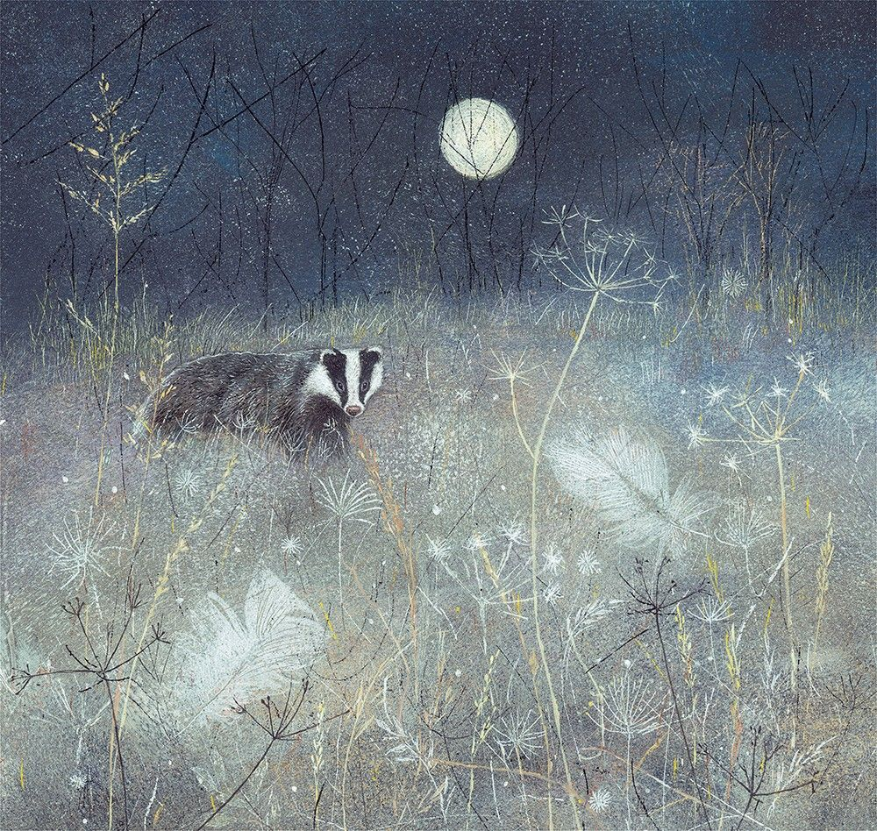

**MONDAY 3RD FEBRUARY**

*Afternoon -*

**Chatty Café Drop In – 1pm – 2pm – John (Volunteer) – (The Old School Café)**

* Are you feeling isolated and in need of a little chat and some friendly company? Then we welcome you to pop into The Old School Café, where one of our lovely volunteers will be there waiting. This is not counselling session, but a safe space where you can have a lovely chit chat or maybe play some board games. Hopefully this little drop in will leave you feeling a little brighter.

**Social Afternoon - 1.15pm - 4pm - (Craft Room - Max.20ppl)**

* An afternoon for social interaction and a safe place to get on with any hobbies you may have e.g., Painting, drawing, writing, jigsaws, crosswords, knitting. Or just enjoy a nice little chin wag with a cuppa. We encourage you to bring your own projects to get on with if you would like to keep yourself busy, but we have an array of arts and crafts materials to get you inspired. You must still book a slot on any social day you wish to attend, to secure a seat.

**TUESDAY 4TH FEBRUARY**

*Morning –*

**Social Day – 9.30am – 4pm – (Craft Room. Max. 20ppl)**

* A day for social interaction and a safe place to get on with any hobbies you may have e.g., Painting, drawing, writing, jigsaws, crosswords, knitting. Or just enjoy a nice little chin wag with a cuppa. We encourage you to bring your own projects to get on with if you would like to keep yourself busy, but we have an array of arts and crafts materials to get you inspired. You must still book a slot on any social day you wish to attend, to secure a seat.

**Emotional Resilience & Meditation - 1.15pm - 3.15pm - Margaret – (Continued – Week 2)**

**“Knit Happens” Introductory - 1.30pm - 3.30pm - Gail - (Volunteer) - (The Old School Café)**

* This simple knitting session is ideal for those who have minimal to no experience in knitting. Our lovely volunteer will gently guide you, showing you the very basic of techniques. From here, if you feel confident enough, you can then join onto our following sessions each week to gain more knowledge and knitting skills as you go. Or you may want to continue doing our monthly Introductory sessions, until you feel ready to progress.

**WEDNESDAY 5TH FEBRUARY**

*All Day -*

**Social Day - 9.30am - 4pm - (Craft Room - Max.14ppl)**

* A day for social interaction and a safe place to get on with any hobbies you may have e.g., Painting, drawing, writing, jigsaws, crosswords, knitting. Or just enjoy a nice little chin wag with a cuppa. We encourage you to bring your own projects to get on with if you would like to keep yourself busy, but we have an array of arts and crafts materials to get you inspired. You must still book a slot on any social day you wish to attend, to secure a seat.

**THURSDAY 6TH FEBRUARY**

**(Busy Day)**

*Morning -*

**Social Day - 9.30am - 4pm - (Craft Room - Max. 20ppl)**

* A day for social interaction and a safe place to get on with any hobbies you may have e.g., Painting, drawing, writing, jigsaws, crosswords, knitting. Or just enjoy a nice little chin wag with a cuppa. We encourage you to bring your own projects to get on with if you would like to keep yourself busy, but we have an array of arts and crafts materials to get you inspired. You must still book a slot on any social day you wish to attend, to secure a seat.

*Afternoon -*

**NEW! “Crafternoon” Wooden Décor (4 Weeks) - 12.30pm - 2.30pm - Janet & Pam (Volunteers) - (Room 2 - Max.8ppl)**

* We will be using a variety of wood surfaces to create decorative items incorporating natural materials. We will use gold and rose gold leaf to complete our work. Suitable for those who have previously done decoupage with us, as we will be using new techniques but also those who are total beginners may join.

*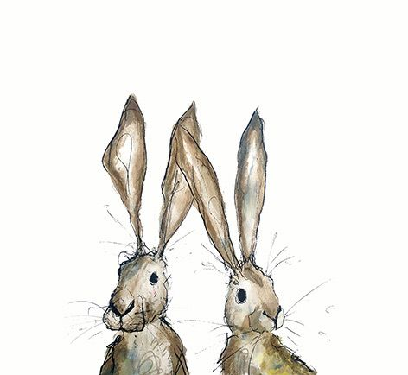***FRIDAY 7TH FEBRUARY**

**(Very busy day)**

*Morning –*

**Flower Mandala - 10am - 12pm - Olwyn - (Craft Room - Max.14ppl)**

* Using a Fineliner we will create an intricate drawing of a flowerhead using concentrate circles as our guides. We will work from the centre outwards drawing simple, repetitive motifs to create our design. Drawing any kind of circular mandala design can be very relaxing, it reduces stress and enhances focus and concentration, providing an inner sense of peace.

**Embroidery Skills (4 Weeks) - 10am - 12pm - Meg, Alison & Gail - (Room 2 - Max.8ppl)**

* This basic embroidery course teaches students how to embroider using a needle and thread. Sessions may include instruction on how to prepare fabric, transfer designs, practice different stitch patterns and use a hoop. This course is designed for all skill levels. If you book onto this course, please pop the following 3 weeks in your diary.

*Afternoon –*

**Fruit Slice Bookmarks -****1.15pm - 3.30pm - Olwyn - (Room 2 - Max.8ppl)**

* This is a fun colouring class where we will use our Prismacolour pencils to shade brightly coloured slices of fruit, which we will cut to form bookmarks. No difficult cutting is required, and plenty of time to relax and socialise

**Textiles Group (4 weeks) - 1.15pm - 3.30pm - Meg, Alison & Gail (Volunteers) - (Craft Room - Max.10ppl)**

* Over the course of 4 weeks, you will create your own decorated picture frame using an array of fabrics and textile accessories. Once this project is complete you will move on to create a small accessories bag which you will add a zip to. You will use a combination of hand sewing and machine sewing skills throughout. If you book onto this course, please pop the following 3 weeks in your diary.

*****Fridays Class Examples*

*****Morning -*

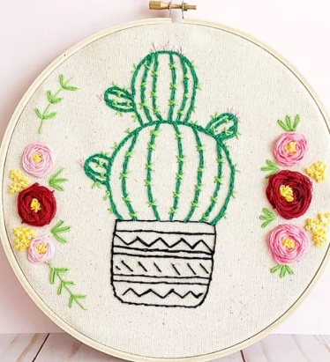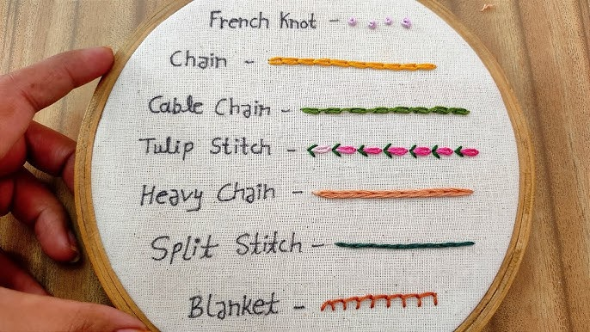

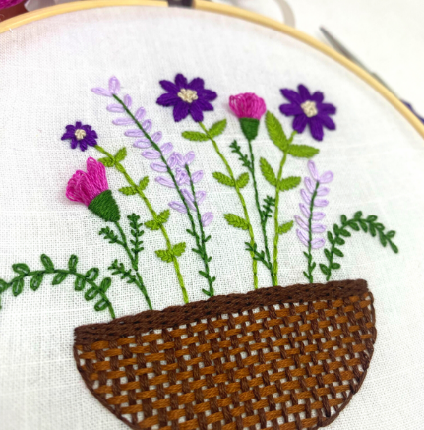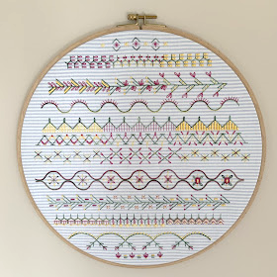

*“Flower Mandala” Example “Embroidery Skills” Examples*

*Afternoon –*

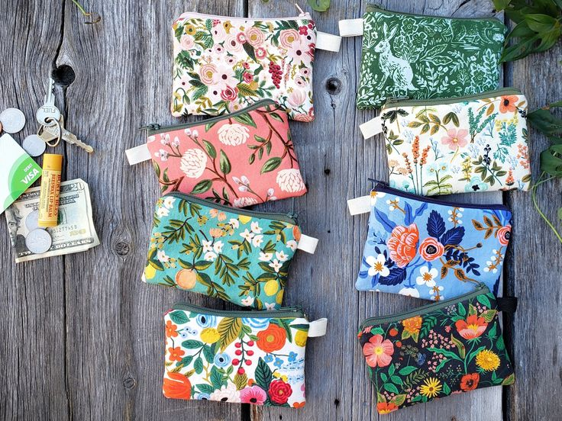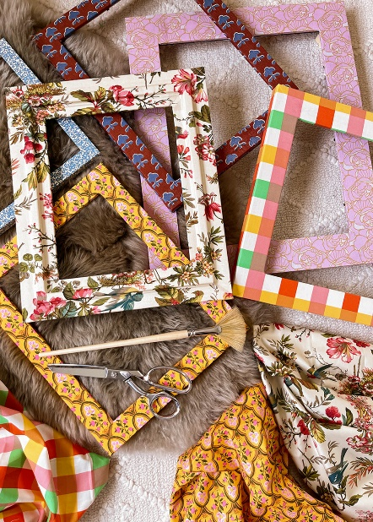

*“Fruit Slice” Example “Textiles Group” Examples*

**MONDAY 10TH FEBRUARY**

*Afternoon -*

**Chatty Café Drop In - 1pm - 2pm - John (Volunteer) - (The Old School Café)**

**Botanical Watercolour Squares (2 weeks) - 1.15pm - 3.30pm - (Craft Room - Max.14ppl)**

* We will start by dividing our card into squares and adding watercolour to each square. Whilst these are drying, we can practise drawing botanical elements which we can add later to complete our designs. A touch of gold or silver, or a little gem here and there can be a lovely finishing touch! If you book up to this course, please pop the following week in your diary.

**TUESDAY 11TH FEBRUARY**

*Morning –*

**Social Day – 9.30am – 4pm – (Craft Room – Max. 20ppl)**

*Afternoon –*

**Emotional Resilience & Meditation - 1.15pm - 3.15pm - Margaret - (Continued – Week 3)**

**“Knit Happens” Intermediate - 1.30pm - 3.30pm - Gail (Volunteer) - (The Old School Café)**

* Our Intermediate sessions are for experienced knitters or anyone that has completed one or more of our beginners’ sessions. Feel free to bring your own knitting projects or simply turn up without so much as a knitting needle, and our lovely volunteer will get you set away on a project. These sessions will be held every week in our Café situated on the ground floor of our Centre. You will still need to book onto these sessions as there is limited space.

**WEDNESDAY** **12TH FEBRUARY**

**Awareness to Pride: The Evolution of Autism Symbols from 1963 to Today***Morning -*

**“Back to Black” - 10am - 12pm - Olwyn (Craft Room - Max.14ppl)**

* The bright colour of Posca paint pens can create stunning

effects against a black background. In this class we will draw

vertical lines which burst into colour as they reach the top –

A topical subject, as we prepare to leave the dark days of

Winter and enjoy the colours of spring.

*Afternoon –*

**Desert Island Discs “Love Songs” - 1.15pm - 3.30pm - Olwyn – (Craft Room – Max.14ppl)**

* We will choose tracks which bring us happy memories and inspire. This session will be inspired by Valentines Day, so think about your soppiest or up lifting love songs. We will all listen to each person’s song, whilst they share why these tracks are so positive and joyful to them. If you would rather just have your song played and not discuss anything, that is up to you.

**THURSDAY 13TH FEBRUARY**

**(Busy day)**

*Morning –*

**Social Day - 9.30am - 4pm - (Craft Room - Max.20ppl)**

**NEW! Self-Care Salon “Hair” - 10am – 12pm – Angela (Volunteer) – (Room 2 – Max. 4ppl)**

* We have the pleasure of introducing you to one of our wonderfully talented volunteers Angela, who will be running a couple of Self-care sessions each month. In this session she will be trimming, cutting or shearing hair to give you that fresh feeling. Self-care is essential to one’s mental health; it can boost your mood, reduce stress and anxiety, and boost your confidence and self-esteem. When you book you will be allocated a 30-minute slot, depending on what is available.

*Afternoon –*

**“Crafternoon” Wooden Décor - 1pm - 3pm - Janet & Pam - (Continued - Week 2)**

**FRIDAY** **14TH FEBRUARY**

**(Very busy day)**

*Morning –*

**Watercolour Wellness Poster - 10am - 12pm - Olwyn - (Craft Room - Max. 14ppl)**

* A drawing of a cup of tea and a pen

  Description automatically generatedA relaxing class where we will learn about the benefits of healthy foods and how they can improve our mood and reduce anxiety. We will create our own wellness poster using a combination of Fineliners and watercolours upon a pre-printed A3 poster.

**Embroidery Skills - 10am - 12pm - Meg, Alison & Gail - (Continued - Week 2)**

*Afternoon –*

**Zentangle – 1.15pm – 3.30pm – Olwyn – (Room 2 - Max.8ppl)**

* The art of ‘zentangle’ is designed to focus the mind

on repetitive patterns in a similar manner to mindfulness

meditation. The participant can create quite intricate

designs by breaking then down into smaller areas and

filling them with patterns called tangles. These patterns

can be very simple, or very complicated, making it an

enjoyable and inclusive class for everyone.

**Textiles Group - 1.15pm - 3.30pm - Meg, Alison, Gail - (Continued - Week 2)**

**MONDAY 17TH FEBRUARY**

*Afternoon –*

**Awareness to Pride: The Evolution of Autism Symbols from 1963 to TodayAwareness to Pride: The Evolution of Autism Symbols from 1963 to TodayChatty Café Drop In – 1pm – 2pm – John (Volunteer) – (The Old School Café)**

**Botanical Watercolour Squares -1.15pm - 3.30pm - Olwyn - (Continued – Final session)**

**TUESDAY 18TH FEBRUARY**

*Morning –*

**Social Day - 9.30am - 4pm - (Craft Room - Max.20ppl)**

*Afternoon –*

**Emotional Resilience & Meditation - 1.15pm - 3.15pm - Margaret - (Continued – Week 4)**

**“Knit Happens” Intermediate - 1.30pm - 3.30pm - Gail (Volunteer) - (The Old School Cafe)**

**WEDNESDAY 19TH FEBRUARY**

**Awareness to Pride: The Evolution of Autism Symbols from 1963 to Today***Morning –*

**Pop-up Hug Cards – 10am – 12pm – Olwyn – (Craft Room - Max.14ppl)**

* This is a fun class with minimal folding and cutting. The front of the card can be coloured as you wish, and the pop-up centre can be personalised to suit your taste. This laid-back session allows lots of time to enjoy a chat with your classmates.

*Afternoon –*

**Pastel Drawing – 1.15pm – 3.30pm - Olwyn (Craft Room - Max.14ppl)**

* Learn how to create perspective within an image using coloured pastels. You will be provided with examples for your inspiration.

*Wednesdays Class Examples*

*Morning - Afternoon -*

*“Pop-up Hug Card” Example “Pastel Drawing” Example*

**THURSDAY 20TH FEBRUARY**

**(Busy day)**

*Morning –*

**Social Day - 9.30am - 4pm - (Craft Room - Max. 20ppl)**

*Afternoon –*

**“Crafternoon” Wooden Décor - 1pm - 3pm - Janet & Pam - (Continued - Week 3)**

**FRIDAY 21ST FEBRUARY**

**(Very busy day)**

*Morning –*

**Watercolour Squares (2 Weeks) - 10am - 12pm - Olwyn - (Craft Room – Max. 14ppl)**

**Embroidery Skills - 10am - 12pm - Meg, Alison & Gail - (Continued - Week 3)**

*Afternoon –*

**Flower Mandala - 1.15pm - 3.30pm - Olwyn - (Room 2 - Max.8ppl)**

**Textiles Group - 1.15pm - 3.30pm - Meg, Alison, Gail - (Continued - Week 3)**

**MONDAY 24TH FEBRUARY**

*Afternoon -*

**Awareness to Pride: The Evolution of Autism Symbols from 1963 to TodayChatty Café Drop In - 1pm - 2pm - John (Volunteer) - (The Old School Café)**

**Pop-up Hug Card - 1.15pm - 3.30pm - Olwyn – (Craft Room - Max. 14ppl)**

**TUESDAY 25TH FEBRUARY**

*Morning –*

**Social Day - 9.30am - 4pm - (Craft Room - Max. 20.ppl)**

*Afternoon –*

**Emotional Resilience & Meditation - 1.15pm - 3.15pm - Margaret - (Continued – Week 5)**

**“Knit Happens” intermediate - 1.30pm - 3.30pm - Gail (Volunteer) - (The Old School Café)**

**WEDNESDAY 26TH FEBRUARY**

*Morning –*

**Watercolour Wellness Poster - 10am - 12pm - Olwyn - (Craft Room - Max.14ppl)**

*****Afternoon –*

**Fruit Slice Bookmarks – 1.15pm – 3.30pm – Olwyn – (Craft Room – Max.14ppl)**

**NEW!** **Sound Healing – 2.30pm – 4pm – Ashleigh – (Room 2 – Max. 6ppl)**

* *“The Anam Cara Gong Baths”* It is called a sound ‘bath’ because you are immersed in the vibrations and frequencies of the gongs and other healing instruments – no baths or water involved! You will lie down on a yoga mat or sit on a chair for the duration of the session. Feel free to bring any blankets or pillows – whatever you like to make yourself as comfortable as possible. Ashleigh will take you all through some gentle guided breathwork, and a short meditation, before she plays the gongs. When played, the gongs carry healing sound waves. The frequency of the sound travels through your entire body and helps to facilitate healing on a cellular level. It can move energy blocks, soothe stress and anxiety, lift depression, and even ease physical pain. Please read the leaflet attached to the back of the timetable for more important information regarding this session.

**THURSDAY 27TH FEBRUARY**

**(Busy day)**

*Morning –*

**Social Day - 9.30am - 4pm - (Craft Room – Max.20ppl)**

**NEW! Self-Care Salon “Nails” – 10am – 12pm – Angela – (Room 2 – Max. 4ppl)**

* In this Session, Angela will be giving manicures and/or painting nails to bring a pop of colour to your hands. Self-care is essential to one’s mental health; it can boost your mood, reduce stress and anxiety, and boost your confidence and self-esteem.

*Afternoon -*

**“Crafternoon” Wooden Decor - 1pm - 3pm - Janet & Pam - (Continued - Final Session)**

**FRIDAY 28TH FEBRUARY**

**(Very busy day)**

*Morning –*

**Watercolour Squares – 10am – 12pm – Olwyn – (Continued – Final Session)**

**Embroidery Skills - 10am - 12pm - Meg, Alison & Gail - (Continued - Final Session)**

*Afternoon –*

**Pastel Drawing - 1.15pm - 3.30pm - Olwyn - (Room 2 - Max.8ppl)**

**Textiles Group - 1.15pm - 3.30pm - Meg, Alison, Gail - (Continued - Final Session)**

Awareness to Pride: The Evolution of Autism Symbols from 1963 to Today

Classes with this symbol - are dedicated, quieter sessions. Anybody can join them, but they are designed to be inclusive of neurodivergent individuals who may struggle to access our standard sessions.

(Up to a Maximum of 20ppl in our Craft Room and 8ppl in Room 2)

**Info Sheet**

**The Anam Cara Gong Baths**

***Sound Healing***

Each sound bath lasts around an hour and a half, with around 50 minutes of gong therapy.

After the session I will come around and check in with everyone to make sure they are okay and give them the opportunity to share their experiences. Participants do not have to share anything; it is more of a welfare check in.

During the gong bath participants may experience a range of things, sometimes people don’t experience anything, there is no right or wrong way to experience a gong bath. The healing and stress relief still occurs regardless of the individual experience.

Things you may experience :

- Feel cold or warm

- Feel like you are stuck to or sinking into the floor

- See colours or shapes in your mind’s eye

- Some people have even experienced guides or past loved ones visiting them

- Old memories may resurface

- Visit different events that have occurred in your life

- Feel like you are floating

- Some people experience flying through different landscapes, and go on visual journeys

- Sometimes people fall asleep

- Sometimes people may experience nothing, they just relax and are fully present. Some struggle to quieten their minds, but that is okay. Meditation takes practice, and the healing is still effective. Sometimes difficult emotions can rise to the surface as a way of healing old wounds, it is totally normal, and I recommend to just stay with the breath (Outlined in the meditation beforehand) and ride it out. The emotions are purging old wounds, and it’s a case of 'feel it to heal it'.

You experience something different every time you go to a sound bath. The best way to prepare is to not expect anything and simply relax into the session.

Participants usually sleep very well after a gong bath, as the healing continues on a cellular level for days afterwards. Regular sound baths are required to reap the long-term benefits of sound healing.

