
Please read carefully.
Hello,
We hope this letter finds you well.
Enclosed you will find the latest timetable of activities for January 2025. We will be taking bookings for these activities via phone call or email from 10am on Monday 16th December. Please do not phone us to try booking before this date and time. You will find our contact number and email address on the front page of your timetable.
THE CENTRE WILL BE CLOSED FROM FRIDAY 20TH OF DECEMBER AND WILL RE-OPEN ON THURSDAY 2ND OF JANUARY
Can we please remind everyone that if you are feeling unwell, DO NOT attend the Centre. Even if you feel just a little unwell, if you pass that on to someone else more vulnerable, it may impact them far worse. We also have limited staff who all play important roles, and if one of them get sick, it has a big impact on the rest of the Centre. Please be mindful and look out for each other and staff. Thank you
Due to the volume of new referrals coming through. You will now only be able to book onto one social day (Tuesday or Thursday) and two of Olwyn’s classes per week. This is so we can give new attendees a fair chance of booking onto sessions. (Not including WEA, Bishop college, walking groups or volunteer led classes).
We please ask that you pay a £1 attendance fee per session, your attendance fee goes back into the Centre and helps towards cost of materials and use of our tea and coffee facilities situated in our craft room. Your contribution is much appreciated.
Please turn up to your class on time especially if you are already on the premises, unless you have called to say you are running late. Do not eat food or leave to go for a cigarette during classes, this can be very disruptive for other attendees and the instructor. You are all given a 15-minute break halfway through your classes to eat, make a beverage and smoke.
If you are booked onto any class and cannot make it for whatever reason you must call the centre to inform us of this as early as possible, so that we can offer the space to somebody else. You still need to book to attend Social Days as well as regular classes, to guarantee you have a seat.
We look forward to seeing you.
From all the staff, we wish you all a MERRY CHRISTMAS AND A HAPPY NEW YEAR!

To Book Classes Call: 0191 384 8100 or Email: enquiries@stmargaretscentre.co.uk
(There is an attendance fee of £1 per session)



MONDAY 6TH JANUARY
Afternoon -
Chatty Café Drop In – 1pm – 2pm – John (Volunteer) – (The Old School Café)
- Are you feeling isolated and in need of a little chat and some friendly company? Then we welcome you to pop into The Old School Café, where one of our lovely volunteers will be there waiting. This is not counselling session, but a safe space where you can have a lovely chit chat or maybe play some board games. Hopefully this little drop in will leave you feeling a little brighter.
Dry Brush Painting “Fur” - 1.15pm - 3.30pm – Olwyn - (Craft Room - Max.14ppl)
- We will use a dry brush painting technique to create wispy, furry brushstrokes, taking care to notice the direction of the fur to achieve the most realistic results.

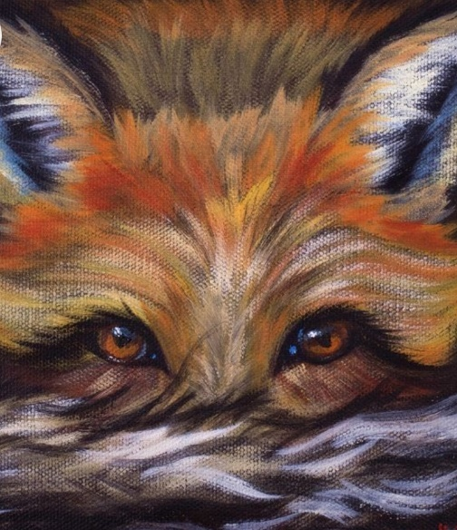

“Dry Brush Painting “Fur” Example
TUESDAY 7TH JANUARY
Morning –
Social Day – 9.30am – 4pm – (Craft Room. Max. 20ppl)
- A day for social interaction and a safe place to get on with any hobbies you may have e.g., Painting, drawing, writing, jigsaws, crosswords, knitting. Or just enjoy a nice little chin wag with a cuppa. We encourage you to bring your own projects to get on with if you would like to keep yourself busy, but we have an array of arts and crafts materials to get you inspired. You must still book a slot on any social day you wish to attend, to secure a seat.
“Knit Happens” Introductory - 1.30pm - 3.30pm - Gail - (Volunteer) - (The Old School Café)
- This simple knitting session is ideal for those who have minimal to no experience in knitting. Our lovely volunteer will gently guide you, showing you the very basic of techniques. From here, if you feel confident enough, you can then join onto our following sessions each week to gain more knowledge and knitting skills as you go. Or you may want to continue doing our monthly Introductory sessions, until you feel ready to progress.


WEDNESDAY 8TH JANUARY

Morning –
Embellished Greetings Card - 10am - 12pm - Olwyn - (Craft Room - Max.14ppl)
- In this class we will create beautiful handmade cards. Firstly, we will prepare some water-coloured stars, then we will cut out and assemble our stars in a circle with a positive sentiment of your choice in the centre. A lovely card to send to anyone who puts a little sparkle in your life.
Afternoon -
“Light” With Pastels - 1.15pm - 3.30pm - Olwyn - (Craft Room – Max.14ppl)
- Magical effects can be created by adding a touch of luminous yellow pastel chalk to a drawing. It can give the appearance of warm glow which may have come from a window, lamp or even a star!

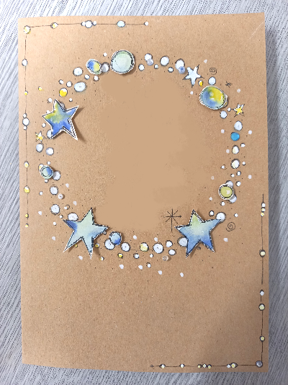
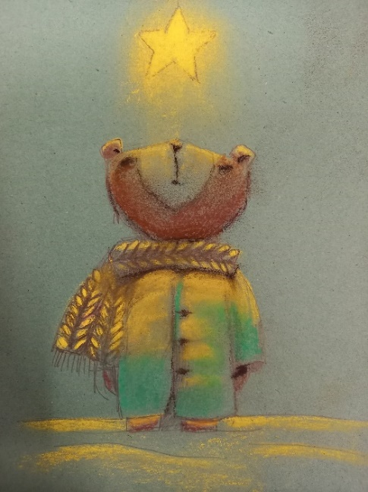

Good Luck
In your New
Job

“Embellished Card” Example “Light” Example


THURSDAY 9TH JANUARY
(Busy Day)
Morning -
Social Day - 9.30am - 4pm - (Craft Room - Max. 20ppl)
- A day for social interaction and a safe place to get on with any hobbies you may have e.g., Painting, drawing, writing, jigsaws, crosswords, knitting. Or just enjoy a nice little chin wag with a cuppa. We encourage you to bring your own projects to get on with if you would like to keep yourself busy, but we have an array of arts and crafts materials to get you inspired. You must still book a slot on any social day you wish to attend, to secure a seat.
Afternoon -
NEW! “Crafternoon” Paper Making Course (4 Weeks) - 1pm - 3pm - Janet & Pam (Volunteers) - (Room 2 - Max.8ppl)
- Over the next four weeks you will be exploring paper making using cotton wool and wallpaper paste. It’s a relatively simple process and the results are lovely! Once the process is understood, you’ll be helped to develop your own ideas.
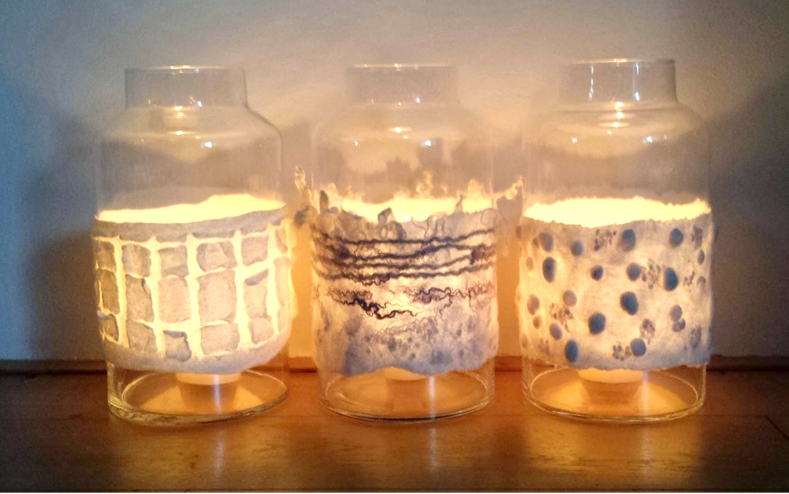
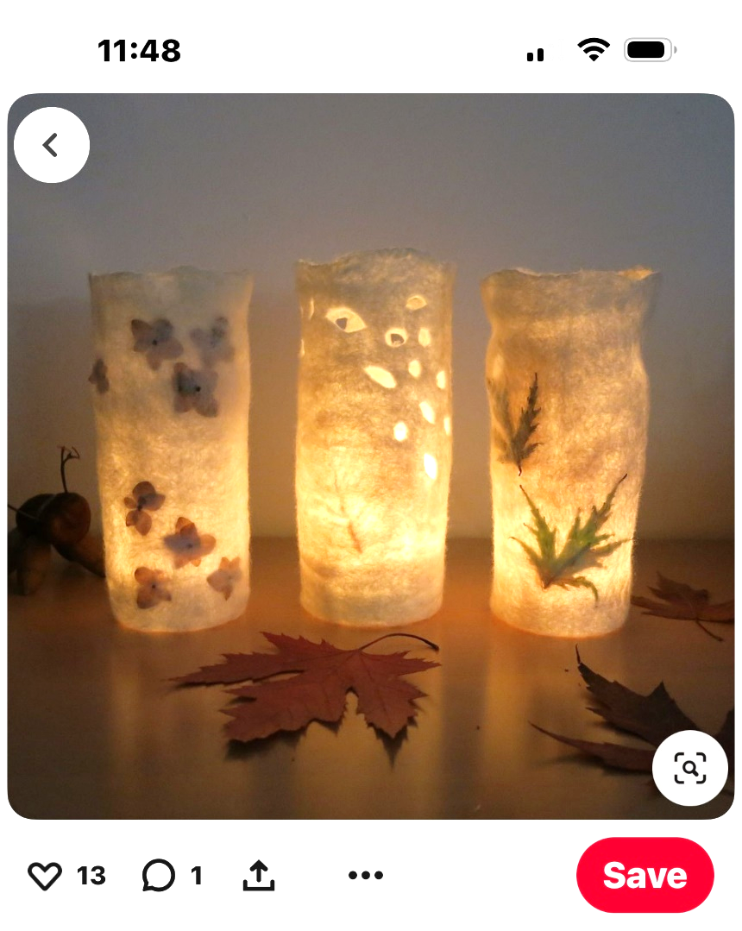

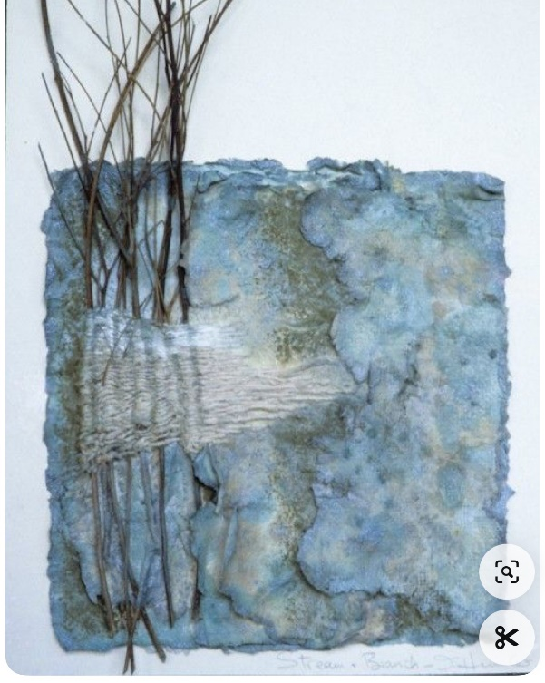
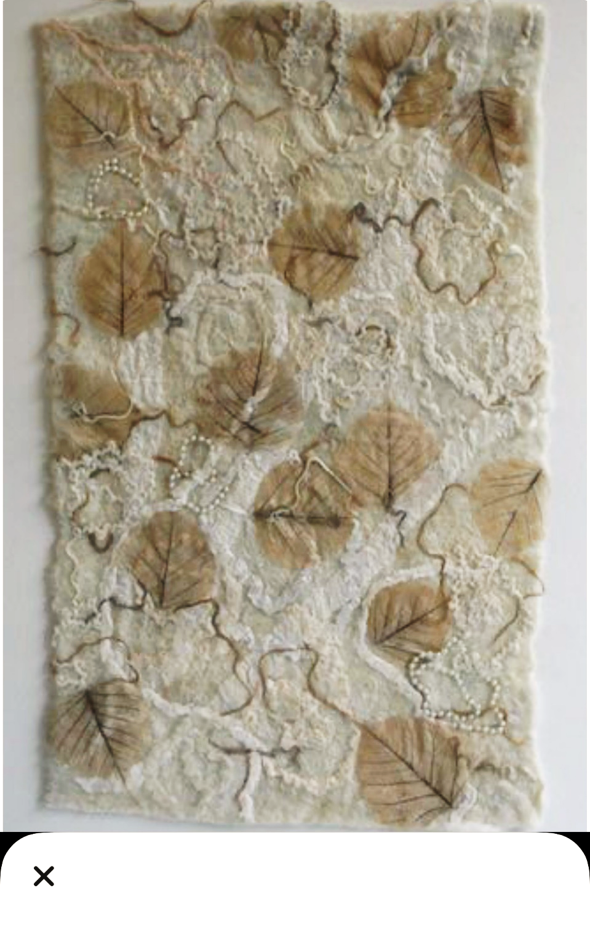

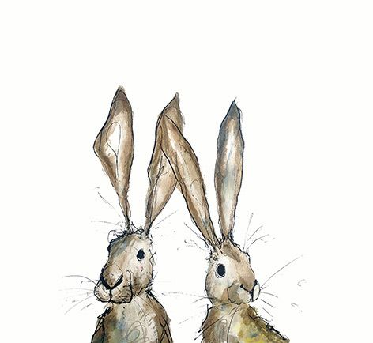
FRIDAY 10TH JANUARY
(Very busy day)
Morning –
Calligraphy Course (4 weeks) - 10am - 12pm - Olwyn - (Craft Room - Max.10ppl)
- Copperplate calligraphy is a style of writing that uses a pointed nib to create fine hairlines and rounded, swirling lines. It's known for its beauty and fluidity, and is often used for social correspondence, invitations, and other elegant communications. In this course you will learn the basics of copperplate calligraphy, where you will progress each week. In your final week you will hopefully have the confidence to write your own sentiment which can be put inside a greetings card.
Embroidery Skills (4 Weeks) - 10am - 12pm - Meg, Alison & Gail - (Room 2 - Max.8ppl)
- Learn the basics of embroidery. This course is designed for all skill levels
Afternoon –
3D Secret Message Flowers - 1.15pm - 3.30pm - Olwyn - (Room 2 - Max.8ppl)
- This is a hexagonal folding flower shape that opens in a unique way to reveal your personal message. This class involves a little paper folding and some colouring, but nothing too tricky, just a nice relaxing session.
Hanging Birds Garland & Patchwork Tote Bag (4 weeks) - 1.15pm - 3.30pm - Meg, Alison & Gail (Volunteers) - (Craft Room - Max.10ppl)
- In this course you will be creating your own hanging bird garland, where you will create small plushie birds using patterned fabrics, stuffed with teddy filling. You will then create a patchwork applique which you will apply to a tote bag. A combination of hand and machine sewing techniques will be used. *Please note that beginners, or anyone who is struggling with this course, may be given a slightly different project from the proposed one, to help build and develop skills. If you book onto this course, you must be able to attend all the following 3 sessions.


Fridays Class Examples
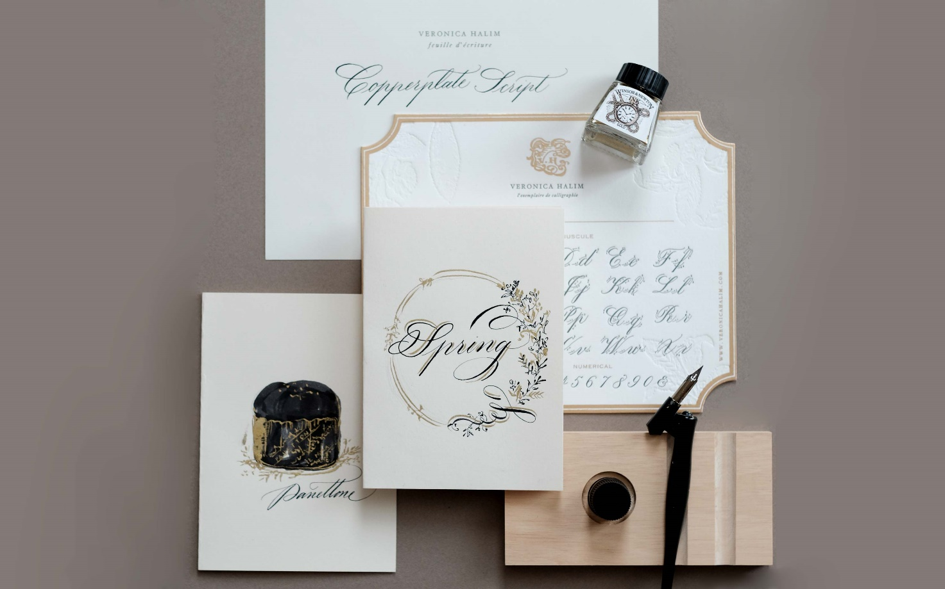
Morning -

“Copperplate Calligraphy” Example
Afternoon –
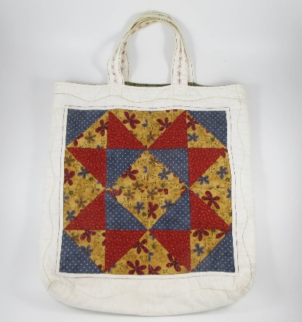
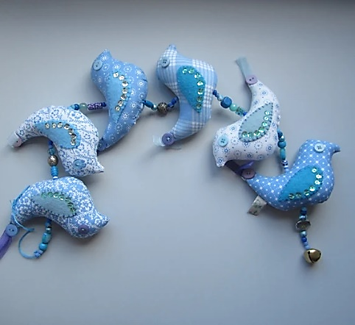
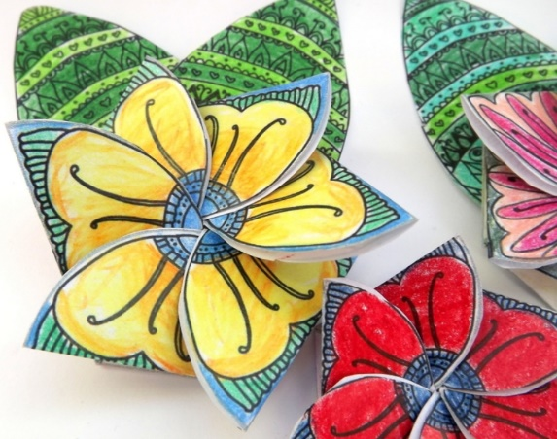

“3D Secret Message Flower” Example “Bird Garland & Tote bag” Examples

MONDAY 13TH JANUARY
Afternoon -
Chatty Café Drop In – 1pm – 2pm – John (Volunteer) – (The Old School Café)
Watercolour Zendoodles – 1.15pm – 3.30pm - (Craft Room - Max.14ppl)
- This is a relaxing class where no drawing skills are required. We will first create a background of watercolours blended loosely. When the background is dry, we will follow the edges with a Fineliner to create abstract patters. We will do it alongside a relaxing soundtrack of forest sounds and gentle streams.
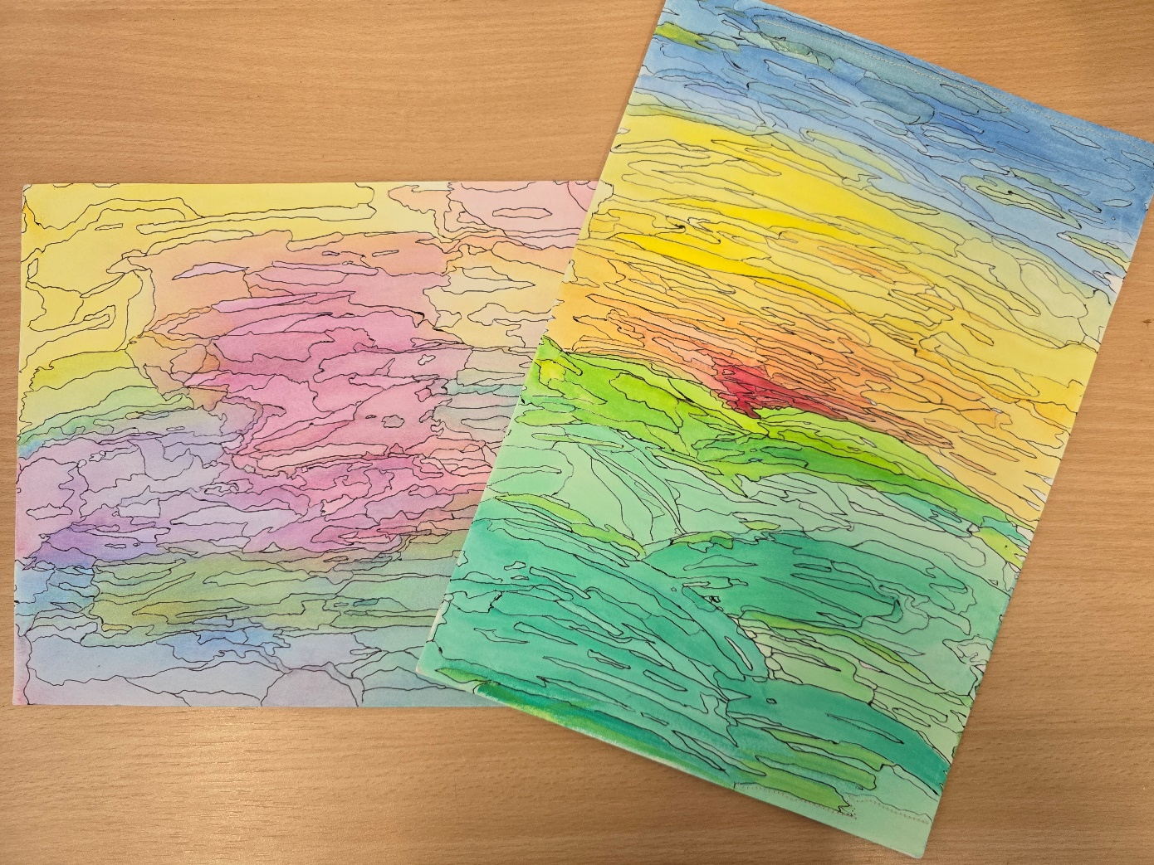

Example by Kelly Dorling
TUESDAY 14TH JANUARY
Morning –
Social Day – 9.30am – 4pm – (Craft Room – Max. 20ppl)
Afternoon –
“Knit Happens” Intermediate - 1.30pm - 3.30pm - Gail (Volunteer) - (The Old School Café)
- Our Intermediate sessions are for experienced knitters or anyone that has completed one or more of our beginners’ sessions. Feel free to bring your own knitting projects or simply turn up without so much as a knitting needle, and our lovely volunteer will get you set away on a project. These sessions will be held every week in our Café situated on the ground floor of our Centre. You will still need to book onto these sessions as there is limited space.

WEDNESDAY 15TH JANUARY
Morning -
Bubble Wrap Painting - 10am - 12pm - Olwyn (Craft Room - Max.14ppl)
- A fun class where we apply acrylic paint to bubble wrap cut into various shapes, these are then dipped in paint and gently stamped onto black card to create a lovely textured image.
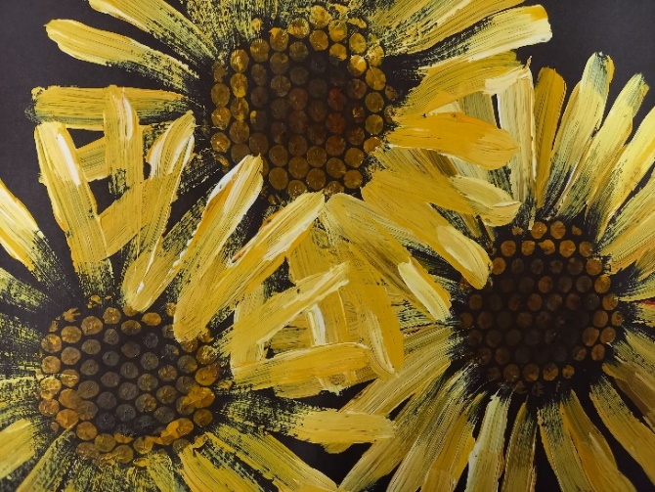

Afternoon –
Whimsical Gift Wrap - 1.15pm - 3.30pm - Olwyn – (Craft Room – Max.14ppl)
- “Happy Birthday to Ewe” Using Posca Paint pens we will decorate a sheet of plain wrapping paper with fun and playful characters. This gift wrap can then be used to wrap that special someone’s present.
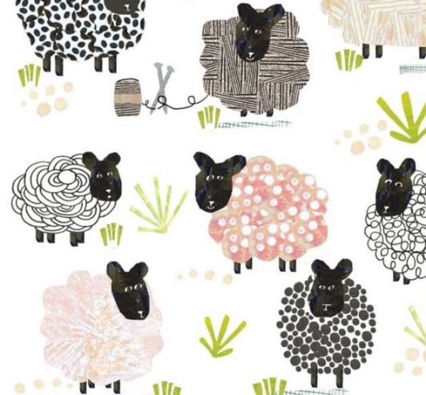

THURSDAY 16TH JANUARY
(Busy day)
All Day –
Social Day - 9.30am - 4pm - (Craft Room - Max.20ppl)
Afternoon –
“Crafternoon” Paper Making - 1pm - 3pm - Janet & Pam - (Continued - Week 2)

FRIDAY 17TH JANUARY
(Very busy day)
Morning –
Calligraphy Course - 10am - 12pm – Olwyn - (Continued - Week 2)
Embroidery Skills - 10am - 12pm - Meg, Alison & Gail - (Continued - Week 2)
Afternoon –

Teabag Folding – 1.15pm – 3.30pm – Olwyn – (Room 2 - Max.8ppl)
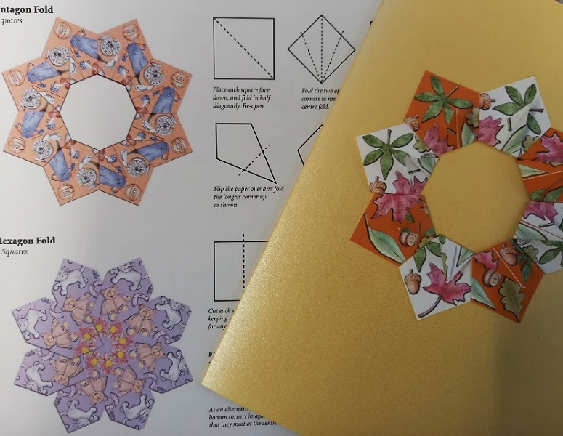
- Teabag folding began in the Netherlands, and was originally done with tea bag wrappers, hence the name. This simple form of origami uses small squares of colourful patterned paper to create ‘mandala’ type patterns which are great for decorating a greetings card in a unique and appealing way. No intricate cutting is required, but you need to be able to fold accurately.

Bird Garland & Tote Bag - 1.15pm - 3.30pm - Meg, Alison, Gail - (Continued - Week 2)
MONDAY 20TH JANUARY
Afternoon –
Chatty Café Drop In – 1pm – 2pm – John (Volunteer) – (The Old School Café)
Multi-Media “Jar of Snowdrops”-1.15pm - 3.30pm - Olwyn - (Craft Room - Max.14ppl)
- In this class we will choose a piece of patterned paper and draw on top using Fineliners, coloured pencils and posca pens, to create a beautiful Illustration. We will add a sentiment to our artwork and learn how to write faux calligraphy style.
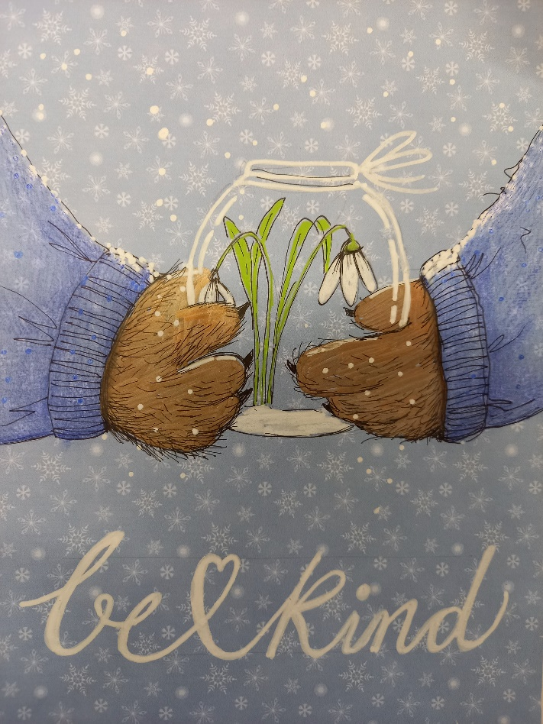

TUESDAY 21ST JANUARY
Morning –
Social Day - 9.30am - 4pm - (Craft Room - Max.20ppl)
Afternoon –
“Knit Happens” Intermediate - 1.30pm - 3.30pm - Gail (Volunteer) - (The Old School Cafe)

WEDNESDAY 22ND JANUARY
Morning –
3D Secret Message Flowers – 10am – 12pm – Olwyn – (Craft Room - Max.14ppl)
Afternoon –
Desert Island Discs – 1.15pm – 3.30pm - Olwyn (Craft Room - Max.14ppl)
- Back with our ever-popular class, where we will choose tracks which bring us happy memories and inspire. We will all listen to each person’s song, whilst they share why these tracks are so positive and joyful to them. If you would rather just have your song played and not discuss anything, that is up to you.

THURSDAY 23RD JANUARY
(Busy day)
Morning –
Social Day - 9.30am - 4pm - (Craft Room - Max. 20ppl)
Embroidery Skills - 10am - 12pm - Meg, Alison & Gail - (Continued - Week 3)
Afternoon –
“Crafternoon” Paper Making - 1pm - 3pm - Janet & Pam - (Continued - Week 3)

FRIDAY 24TH JANUARY
(Very busy day)
Morning –
Calligraphy Course - 10am - 12pm - Olwyn - (Continued - Week 3)
Embroidery Skills - 10am - 12pm - Meg, Alison & Gail - (Continued - Week 3)
Afternoon –
Whimsical Gift Wrap – 1.15pm – 3.30pm - Olwyn - (Room 2 - Max.8ppl)
Bird Garland & Tote Bag - 1.15pm - 3.30pm - Meg, Alison, Gail - (Continued - Week 3)

MONDAY 27TH JANUARY
Afternoon -
Chatty Café Drop In – 1pm – 2pm – John (Volunteer) – (The Old School Café)
“Light” With Pastels - 1.15pm - 3.30pm - Olwyn – (Craft Room - Max. 14ppl)

TUESDAY 28TH JANUARY
Morning –
Social Day - 9.30am - 4pm - (Craft Room - Max. 20.ppl)
Afternoon –
NEW! Emotional Resilience & Meditation Course (10 weeks) - 1.15pm - 3.15pm - Margaret – WEA - (Room 2 - Max.9ppl)
- This course is designed to help you to understand how emotions evolve and how to develop coping strategies for stress. We look at the psychological mind and emotions and the principles of “The Three Brains”. By the end of the course, you will be able to practice moving meditation and mindfulness to help build better emotional resilience. You will need to be enrolled onto this course as it is run by an external tutor from the WEA. Please have your national insurance number and email address ready when you book this course.
“Knit Happens” intermediate - 1.30pm - 3.30pm - Gail (Volunteer) - (The Old School Café)

WEDNESDAY 29TH JANUARY
Morning –
Watercolour Zendoodles - 10am - 12pm - Olwyn - (Craft Room - Max.14ppl)
Afternoon –
Dry Brush Painting “Fur” – 1.15pm – 3.30pm – Olwyn – (Craft Room – Max.14ppl)

THURSDAY 30TH JANUARY
(Busy day)
Morning –
Social Day - 9.30am - 4pm - Olwyn (Craft Room)
Afternoon -
“Crafternoon” Paper Making - 1pm - 3pm - Janet & Pam - (Continued - Final Session)

FRIDAY 31ST JANUARY
(Very busy day)
Morning –
Calligraphy Course – 10am – 12pm – Olwyn – (Continued - Final Session)
Embroidery Skills - 10am - 12pm - Meg, Alison & Gail - (Continued - Final Session)
Afternoon –
Multi - Media “Jar of Snowdrops” - 1.15pm - 3.30pm - Olwyn - (Room 2 - Max.8ppl)

Bird Garland & Tote Bag - 1.15pm - 3.30pm - Meg, Alison, Gail - (Continued - Final Session)

Classes with this symbol - are dedicated, quieter sessions. Anybody can join them, but they are designed to be inclusive of neurodivergent individuals who may struggle to access our standard sessions.
(Up to a Maximum of 20ppl in our Craft Room and 8ppl in Room 2)

