
Please read carefully.
Hello,
We hope this letter finds you well.
Enclosed you will find the latest timetable of activities for November 2024. We will be taking bookings for these activities via phone call or email from 10am on Monday 28th October. Please do not phone us to try booking before this date and time. You will find our contact number and email address on the front page of your timetable.
Our Gardening/Horticulture groups are now finished for the winter. They will return in spring 2025.
Can we please remind everyone that if you are feeling unwell, DO NOT attend the Centre. Even if you feel just a “little unwell”, if you pass that on to someone else more vulnerable, it may impact them far worse. We also have limited staff who all play important roles, and if one of them get sick, it has a big impact on the rest of the Centre. Please be mindful and look out for each other and staff. Thank you
Due to the volume of new referrals coming through. You will now only be able to book onto one social day (Tuesday or Thursday) and two classes per week (Not including WEA, Bishop college, Walking groups or external tutors). This is so we can give new attendees a fair chance of booking onto sessions.
We please ask that you pay a £1 attendance fee per session, your attendance fee goes back into the Centre and helps towards cost of materials and use of our tea and coffee facilities situated in our craft room. Your contribution is much appreciated.
Please turn up to your class on time especially if you are already on the premises, unless you have called to say you are running late. Do not eat food or leave to go for a cigarette during classes, this can be very disruptive for other attendees and the instructor. You are all given a 15-minute break halfway through your classes to eat, make a beverage and smoke.
If you are booked onto any class and cannot make it for whatever reason you must call the centre to inform us of this as early as possible, so that we can offer the space to somebody else. You still need to book to attend Social Days as well as regular craft classes, to guarantee you have a seat.
We look forward to seeing you.
Warmest wishes from all the staff at St. Margarets Centre.

To Book Classes Call: 0191 384 8100 or Email: enquiries@stmargaretscentre.co.uk
(There is an attendance fee of £1 per session)



MONDAY 4TH NOVEMBER
Afternoon -
Chatty Café Drop In – 1pm – 2pm – John (Volunteer) – (The Old School Café)
- Are you feeling isolated and in need of a little chat and some friendly company? Then we welcome you to pop into The Old School Café, where one of our lovely volunteers will be there waiting. This is not counselling session, but a safe space where you can have a lovely chit chat or maybe play some board games. Hopefully this little drop in will leave you feeling a little brighter.

Leaf Wreath – 1.15pm – 3.30pm – Olwyn – (Craft Room – Max. 14ppl)
- We will create a collage using leaves which we will decorate with Posca pens or even just a touch of gold or silver metallics. They will be arranged in a wreath shape and glued down.

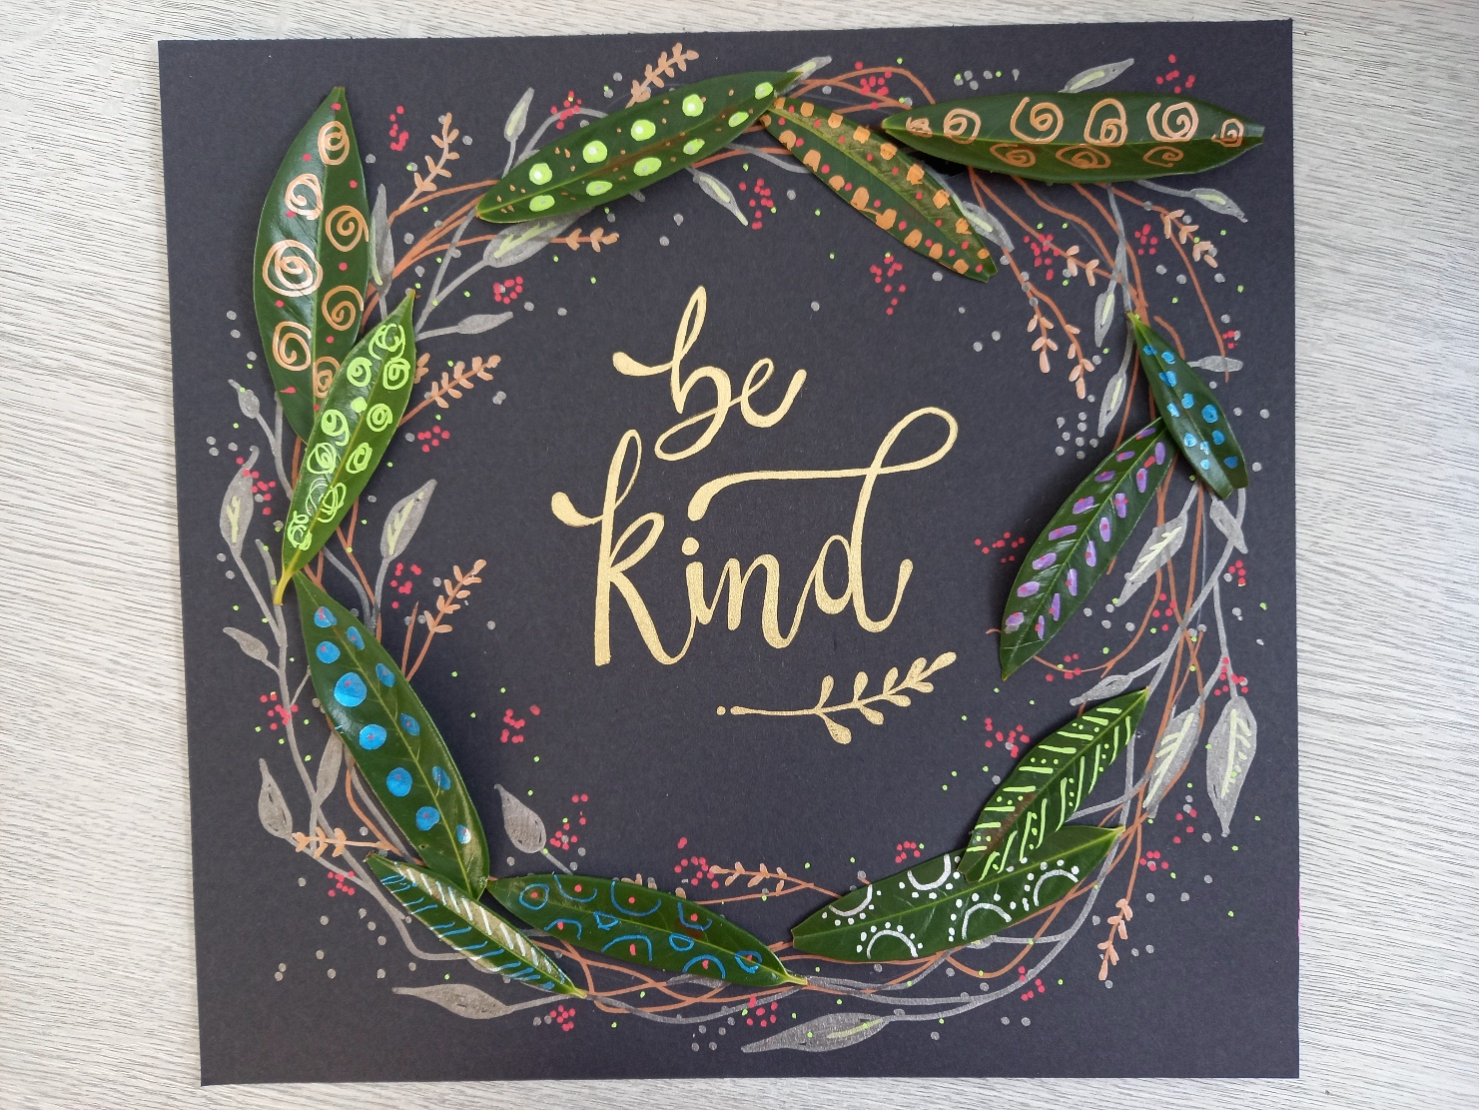

“Leaf Wreath” Example
TUESDAY 5TH NOVEMBER
Morning –
Social Day – 9.30am – 4pm – (Craft Room. Max. 20ppl)
- A day for social interaction and a safe place to get on with any hobbies you may have e.g., Painting, drawing, writing, jigsaws, crosswords, knitting. Or just enjoy a nice little chin wag with a cuppa. We encourage you to bring your own projects to get on with if you would like to keep yourself busy, but we have an array of arts and crafts materials to get you inspired. You must still book a slot on any social day you wish to attend, to secure a seat.
“Knit Happens” Introductory - 1.30pm - 3.30pm - Gail - (Volunteer) - (The Old School Café)
- This simple knitting session is ideal for those who have minimal to no experience in knitting. Our lovely volunteer will gently guide you, showing you the very basics of techniques. From here, if you feel confident enough, you can then join onto our following sessions each week to gain more knowledge and knitting skills as you go. Or you may want to continue doing our monthly Introductory sessions, until you feel ready to progress.
WEDNESDAY 6TH NOVEMBER

Morning –
Dry Brush Painting - 10am - 12pm - Olwyn - (Craft Room - Max. 14ppl)

- In this class you will learn an effective painting technique where small amounts of paint are applied to a brush and gently brushed back and forth across paper, without applying any water at all throughout. This gives an old traditional appearance to your paintings. This class will be inspired by Christmas, these paintings always scan in very well and make beautiful Christmas cards. We often re-print these and sell them as cards at our craft fairs.

Afternoon -
Through Thick and Thin (2 Weeks) - 1.15pm - 3.30pm - Olwyn - (Craft Room – Max. 14ppl)
- This is a relaxing course where we will outline stacked up Christmas trees in a combination of thick and thin lines, adding watercolours to bring a pop of colour! This is an easy, slow-paced course, giving everyone a chance to chat whilst having fun doodling and painting. If you book this course, please pop the following week in your diary.

NEW! Christmas Clay (2 weeks) - 1:15pm - 3:30pm - Marie (Volunteer) - (Rm.2 - Max. 7ppl)
- To celebrate the festive season, we will make clay Gonks, Gnomes and snowmen to decorate your home. The air-dry clay can be painted in the second week once it has dried." If you book this course, please pop the following week in your diary. You must be able to attend both sessions as there is drying time between sessions.

Wednesday Afternoon Class Examples

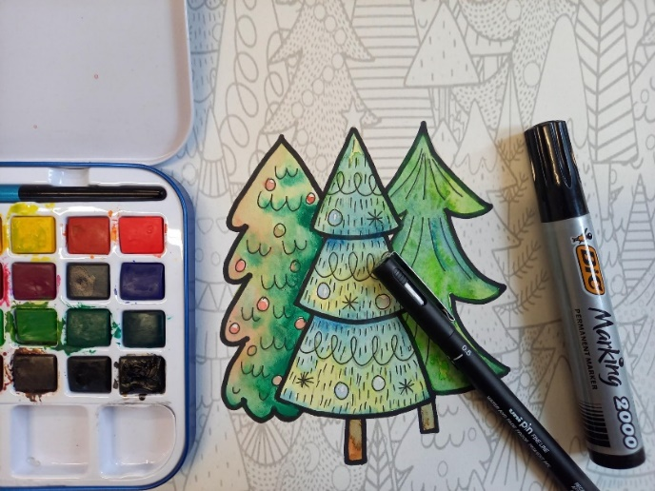


“Through Thick and Thin” Example Christmas Clay Examples

THURSDAY 7TH NOVEMBER
(Busy Day)
Morning –
Social Day – 9.30am – 4pm – (Craft Room – Max. 20ppl)
- A day for social interaction and a safe place to get on with any hobbies you may have e.g., Painting, drawing, writing, jigsaws, crosswords, knitting. Or just enjoy a nice little chin wag with a cuppa. We encourage you to bring your own projects to get on with if you would like to keep yourself busy, but we have an array of arts and crafts materials to get you inspired. You must still book a slot on any social day you wish to attend, to secure a seat.
Afternoon –
Makaton Course - 1.15pm - 3.15pm - Maria - WEA - (Continued – Week 5)

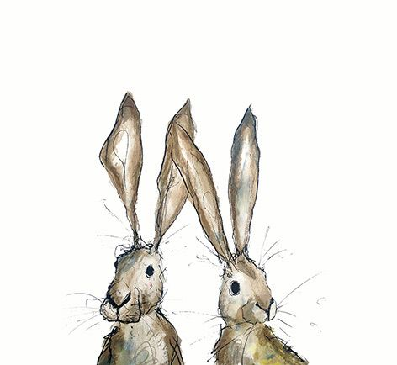
FRIDAY 8TH NOVEMBER
(Very busy day)
Morning –
Go To Bed Ted Card - 10am - 12pm – Olwyn - (Craft Room - Max. 14ppl)
- You will create a little felt quilt cover filled with wadding, you will tuck a small illustration of a teddy bear behind as if he were snuggled up for bed. Suitable for various occasions, this card can be adapted to suit your needs. There will be some intricate cutting required for this project.

Hand Sewing & Embroidery Techniques - 10am - 12pm – Meg, Alison & Gail (Volunteers) - (Continued – Week 6)
Afternoon –
Acorn Garland - 1.15pm - 3.30pm - Olwyn - (Room 2 - Max. 8ppl)
- Make yourself a rustic, autumnal garland to decorate your home, using patterned paper and twine. This involves cutting out shapes, but not too complicated.

Textiles Group “Felt Poppies” - 1.15pm - 3.30pm - Meg, Alison & Gail (Volunteers) - (Craft Room - Max.10ppl)
- You will create wearable felt poppies. Poppies represent remembrance on Remembrance Day as a symbol of hope for a peaceful future and to honour those who have served and sacrificed in the Armed Forces.

Walking Group – 1.30pm – 3pm – Nicola (Meet in The Old School Café – Max. 6ppl)
- We will adventure out into our wonderful City, exploring the ‘nooks & crannies’ of Durham. This is a nice relaxed paced walk, with only slight inclines and as few stairs as possible (but to be expected in “Hilly” Durham) The walks are weather permitted, you will be contacted by lunchtime if the walk has been cancelled due to adverse conditions. Please bring your own water/juice bottle to hydrate or purchase a drink from our Café and wear appropriate footwear and clothing. Waterproofs and umbrellas are good to bring along, in case of a downpour whilst out on the walk or Sunscreen if it is a warm, sunny day.


Fridays Class Examples
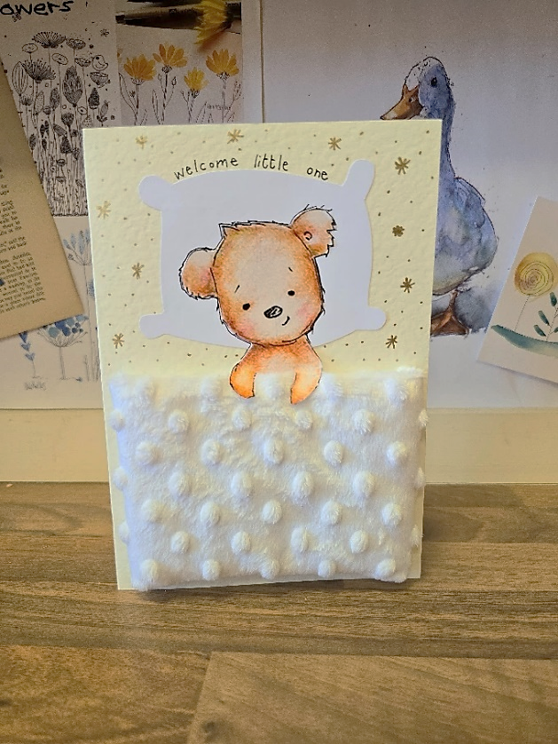
Morning -

“Go To Bed Ted” Example

Afternoon –
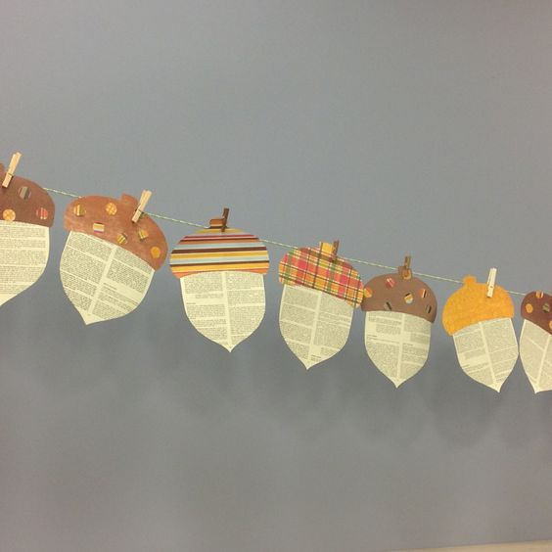
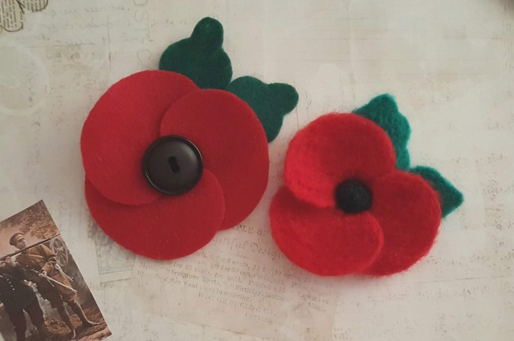

Acorn Garland Example Felt Poppies Examples

MONDAY 11TH NOVEMBER
Afternoon -
Chatty Café Drop In – 1pm – 2pm – John (Volunteer) – (The Old School Café)
“Dachshund Through the Snow” – 1.15pm – 3.30pm - (Craft Room - Max. 14ppl)
- We will create collage style Christmas cards by decorating dachshunds wearing winter inspired outfits. You will be cutting out individual dog jumpers and winter hats from a choice of patterned paper, these will then be applied to your dachshund Illustrations. Then we will draw a string of fairy lights and embellish them with glistening gems



TUESDAY 12TH NOVEMBER
Morning –
Social Day – 9.30am – 4pm – (Craft Room – Max. 20ppl)
Afternoon –
“Knit Happens” Intermediate - 1.30pm - 3.30pm - Gail (Volunteer) - (The Old School Café)
- Our Intermediate sessions are for experienced knitters or anyone that has completed one or more of our beginners’ sessions. Feel free to bring your own knitting projects or simply turn up without so much as a knitting needle, and our lovely volunteer will get you set away on a project. These sessions will be held every week in our Café situated on the ground floor of our Centre. You will still need to book onto these sessions as there is limited space.
WEDNESDAY 13TH NOVEMBER
Morning -
Desert Island Discs - 10am - 12pm - Olwyn (Craft Room – Max. 14ppl)
- Back with our ever-popular class, where we will choose tracks which bring us happy memories and inspire. We will all listen to each person’s song, whilst they share why these tracks are so positive and joyful to them. If you would rather just have your song played and not discuss anything, that is up to you.
Afternoon –
Christmas Clay - 1:15pm - 3:30pm - Marie (Volunteer) - (Continued - Final Session)
Christmas Pastel Drawing - 1.15pm - 3.30pm - Olwyn – (Craft Room – Max. 14ppl)
- Pastel chalks are perfect for Christmas themed images, blending to make soft glowing lights and creating a cosy ambience. Let’s relax and enjoy this sensory class.


THURSDAY 14TH NOVEMBER
(Busy day)
Morning –
Social Day - 9.30am - 4pm - (Craft Room - Max. 20ppl)
Afternoon –
Makaton Course – 1.15pm – 3.15pm – Maria – WEA – (Continued – Week 6)
FRIDAY 15TH NOVEMBER
(Very busy day)
Morning –
Go To Bed Ted Cards - 10am - 12pm – Olwyn - (Craft Room - Max. 14ppl)
Hand Sewing & Embroidery – 10am – 12pm – Meg, Alison & Gail – (Continued - Week 7)
Afternoon –
Leaf Wreath - 1.15pm - 3.30pm – Olwyn - (Room 2 - Max. 8ppl)
Walking Group – 1.30pm – 3pm – Nicola – (Meet in The Old School Café - Max. 6ppl)
NEW! Textiles Group (3 Weeks) - 1.15pm - 3.30pm - Meg, Alison, Gail (Craft Room - 10ppl)
- In this course you will create textile-based Christmas gifts using hand sewing and machine sewing techniques, as well as some basic crafting skills. The gifts you create will include Bottle bags, decorated picture frame, tissue holder, gift bags etc. If you book onto this course, please pop the following 2 weeks in your diary.


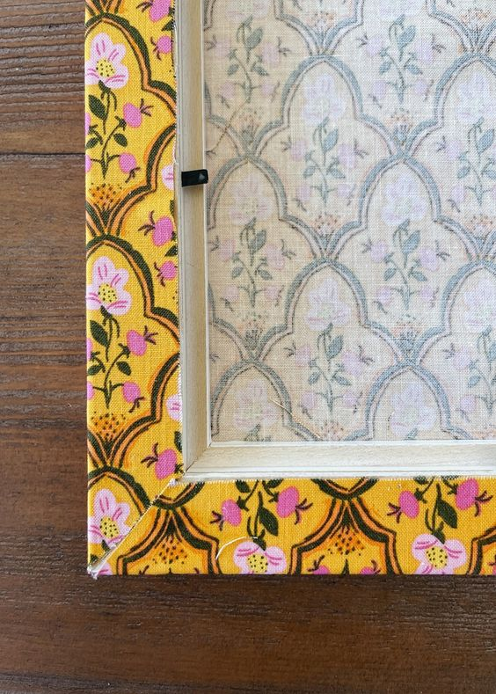


MONDAY 18TH NOVEMBER
Afternoon –
Chatty Café Drop In – 1pm – 2pm – John (Volunteer) – (The Old School Café)
Dry Brush Painting - 1.15pm - 3.30pm - Olwyn – (Craft Room – Max. 14ppl)
TUESDAY 19TH NOVEMBER
Morning –
Social Day – 9.30am – 4pm – (Craft Room – Max. 20ppl)
Afternoon –
“Knit Happens” Intermediate – 1.30pm – 3.30pm – Gail (Volunteer) - (The Old School Cafe)
WEDNESDAY 20TH NOVEMBER
Morning –
“Dachshund Through the Snow” – 10am – 12pm – Olwyn – (Craft Room – Max.14ppl)
Afternoon –
NEW! Christmas Clay (2 weeks) - 1.15pm - 3.30pm - Marie (Volunteer) - (Rm.2 - Max. 7ppl)
Glistening Christmas Cards – 1.15pm – 3.30pm – Olwyn – (Craft Room – Max. 14ppl)
- In this therapeutic and relaxing session, you will bring some joy to pre-printed Christmas illustrations by bedazzling them with glistening gems and shiny beads.



THURSDAY 21ST NOVEMBER
(Busy day)
Morning –
Social Day - 9.30am - 4pm - (Craft Room - Max. 20ppl)
Afternoon –
Makaton Course – 1.15pm – 3.15pm - WEA - (Continue - Week 7)
FRIDAY 22ND NOVEMBER
(Very busy day)
Morning –
“2B Or Not 2B” – 10am - 12pm - Olwyn - (Craft Room - Max. 14ppl)
- This class will demonstrate how to turn a humble colouring page into a 3D work of art using only a pencil! Designed to focus the mind, it can be very relaxing to use one pencil, rather than interchange colours whilst drawing.
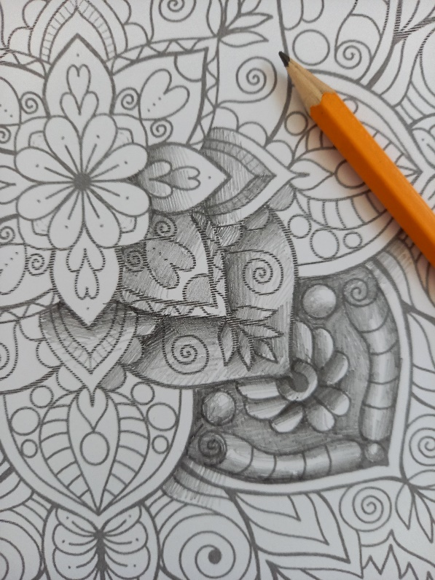

Hand Sewing & Embroidery - 10am - 12pm - Meg, Alison & Gail (Continued - Week 8)
Afternoon –
Through Thick and Thin (2 Weeks) – 1.15pm – 3.30pm - Olwyn - (Craft Room - Max. 14ppl)
Textiles Group - 1.15pm - 3.30pm – Meg, Alison, Gail - (Continued - Week 2)
MONDAY 25TH NOVEMBER
Afternoon -
Chatty Café Drop In – 1pm – 2pm – John (Volunteer) – (The Old School Café)
Glistening Christmas Cards - 1.15pm - 3.30pm - Olwyn – (Craft Room – Max. 14ppl)

TUESDAY 26TH NOVEMBER
Morning –
Social Day – 9.30am – 4pm – (Craft Room – Max. 20.ppl)
Afternoon –
“Knit Happens” – 1.30pm – 3.30pm – Gail (volunteer) - (The Old School Café)

WEDNESDAY 27TH NOVEMBER
Morning –
Positivity Alphabet - 10am - 12pm - Olwyn - (Craft Room - Max. 14ppl)
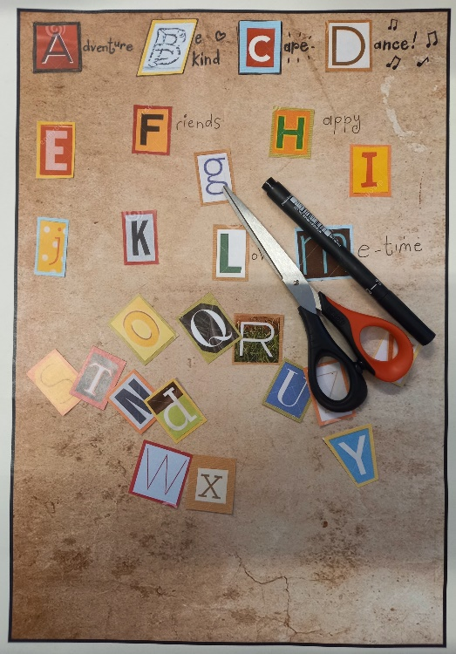
- A fun collage exercise where we will create positive affirmations, one for each letter of the alphabet. A sociable and interactive class.

Afternoon –
Christmas Clay - 1:15pm - 3:30pm - Marie (Volunteer) - (Continued – Final Session)
2B Or Not 2B – 1.15pm – 3.30pm – Olwyn – (Craft Room – Max – 14ppl)
THURSDAY 28TH NOVEMBER
(Busy day)
Morning –
Social Day - 9.30am - 4pm – Olwyn (Craft Room)
Afternoon –
Makaton Course – 1.15pm – 3.15pm – WEA - (Continue - Week 4)
FRIDAY 29TH NOVEMBER
(Very busy day)
Morning –
Christmas Pastel Drawings – 10am – 12pm – Olwyn – (Craft Room – Max. 14ppl)
Hand Sewing & Embroidery - 10am - 12pm - Meg, Alison & Gail (Continued - Final session)
Afternoon –
Through Thick and Thin - 1.15pm - 3.30pm - Olwyn - (Continued – Final Session)

Textiles Group - 1.15pm - 3.30pm - Meg, Alison, Gail - (Continued – Final Session)

Walking Group – 1.30pm – 3pm – Nicola – (Meet in The Old School Café - Max. 6ppl)

Classes with this symbol - are dedicated, quieter sessions. Anybody can join them, but they are designed to be inclusive of neurodivergent individuals who may struggle to access our standard sessions.
(Up to a Maximum of 20ppl in our Craft Room and 8ppl in Room 2)

