**Please read carefully.**

Hello,

We hope this letter finds you well.

Enclosed you will find the latest timetable of activities for October 2024. We will be taking bookings for these activities via phone call or email from **10am** on **Monday 23rd September**. Please do not phone us to try booking before this date and time. You will find our contact number and email address on the front page of your timetable.

**Can we please remind everyone that if you are feeling unwell DO NOT attend the Centre. Even if you feel just a “little unwell”, if you pass that on to someone else more vulnerable, it may impact them far worse. We also have limited staff who all play important roles, and if one of them are off sick it has a big impact on the rest of the Centre. Please be mindful and look out for each other and staff. Thank you**

Due to the volume of new referrals coming through. You will now only be able to book onto one social day (Tuesday or Thursday) and **two classes** per week (Not including WEA, Bishop college, Walking groups or external tutors). This is so we can give new attendees a fair chance of booking onto sessions.

**We please ask that you pay a £1 attendance fee per session,** your attendance fee goes back into the Centre and helps towards cost of materials and use of our tea and coffee facilities situated in our craft room. Your contribution is much appreciated.

Please turn up to your class **on time** especially if you are already on the premises, unless you have called to say you are running late. **Do not eat food or leave to go for a cigarette during classes**, this can be very disruptive for other attendees and the instructor. You are all given a **15-minute break halfway through your classes** to eat, make a beverage and smoke.

If you are booked onto any class and cannot make it for whatever reason you must call the centre to inform us of this as early as possible, so that we can offer the space to somebody else. **You still need to book to attend Social Days** as well as regular craft classes, to guarantee you have a seat.

We look forward to seeing you.

Warmest wishes from all the staff at St. Margarets Centre.

**To Book Classes Call: 0191 384 8100 or Email: enquiries@stmargaretscentre.co.uk**

**(**There is an **attendance fee of** **£1 per session)**

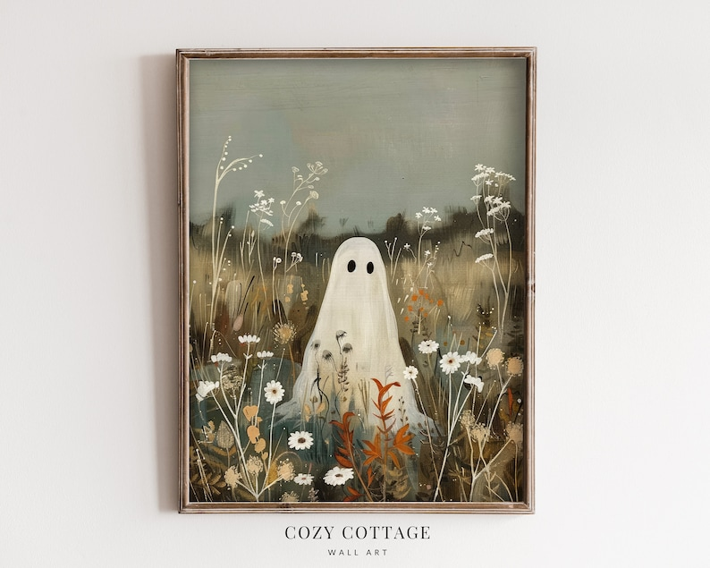

**MONDAY 30TH SEPTEMBER**

*Morning –*

**Chatty Café Drop In – 1pm – 2pm – John (Volunteer) – (The Old School Café)**

* Are you feeling isolated and in need of a little chat and some friendly company? Then we welcome you to pop into The Old School Café, where one of our lovely volunteers will be there waiting. This is not counselling session, but a safe space where you can have a lovely chit chat or maybe play some board games. Hopefully this little drop in will leave you feeling a little brighter.

**Gardening Group – 10am – 12pm – Sandra (Volunteer) – (Meet in Craft Room)**

*****Afternoon -*

**“Make it Clear” – 1.15pm – 3.30pm – Olwyn – (Craft Room – Max. 14ppl)**

* In this class we will trace a black outline with fineliners on the front of the acetate, then paint on the reverse. A separate sheet of patterned paper can be added at the back to create a multi – layered piece of artwork, with a glossy finish.

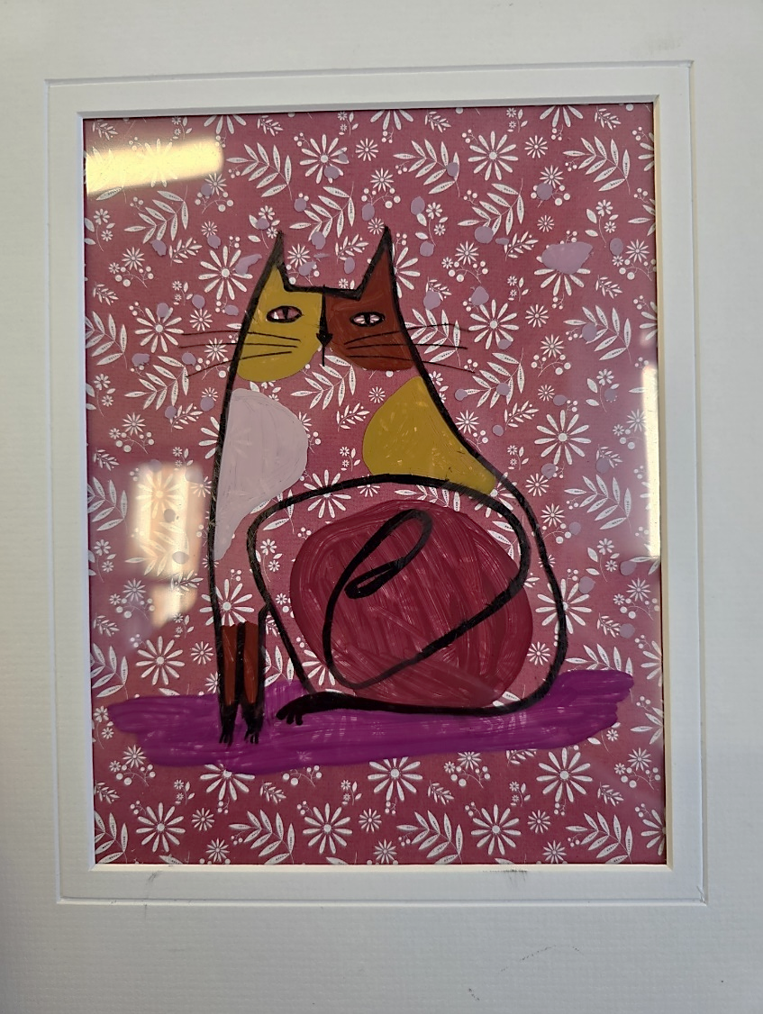

“Make it Clear” Example

**TUESDAY 1ST OCTOBER**

*Morning –*

**Social Day – 9.30am – 4pm – (Craft Room. Max. 20ppl)**

* A day for social interaction and a safe place to get on with any hobbies you may have e.g., Painting, drawing, writing, jigsaws, crosswords, knitting. Or just enjoy a nice little chin wag with a cuppa. We encourage you to bring your own projects to get on with if you would like to keep yourself busy, but we have an array of arts and crafts materials to get you inspired. You must still book a slot on any social day you wish to attend, to secure a seat.

**Mind Management Course – 1.15pm – 3.15pm – Margaret – WEA (Continued – Week 4)**

**“Knit Happens” Introductory - 1.30pm - 3.30pm - Gail - (Volunteer) - (The Old School Café)**

* This simple knitting session is ideal for those who have minimal to no experience in knitting. Our lovely volunteer will gently guide you, showing you the very basics of techniques. From here, if you feel confident enough, you can then join onto our following sessions each week to gain more knowledge and knitting skills as you go. Or you may want to continue doing our monthly Introductory sessions, until you feel ready to progress.

**WEDNESDAY 2ND OCTOBER**

**Awareness to Pride: The Evolution of Autism Symbols from 1963 to Today***Morning –*

**“Cute” Illustrations - 10am - 12pm - Olwyn - (Craft Room - Max. 14ppl)**

* 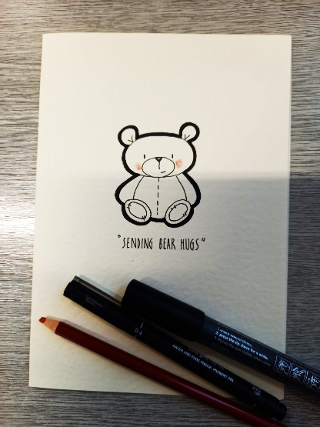Get professional looking results by drawing with a combination of thick and thin lines. This is a classic technique that many cartoonists use. We will draw our own cute characters from scratch, using simple guidelines and transfer them onto a greetings card.

**Horticulture Group - 10am – 12pm – Joy - (Volunteer) - (Allotments – Max. 6ppl)**

* You will assist in the general upkeep of our allotment, helping with digging, planting fresh bulbs, weeding, and maintaining the grounds. You will help grow fresh produce such as fruit, vegetables, and herbs as well as growing flowers, whilst learning new skills as you go. Outdoor activities are proven to help with wellbeing and mental health, so come and potter about, breathe in the fresh air and absorb some of that all-important Vitamin D.

*Afternoon -*

**“Creepy Clay” (2 Weeks) - 1.15pm - 3.30pm – Olwyn - (Craft Room – Max. 14ppl)**

* **A small pumpkin with a hat

  Description automatically generated**To celebrate the spooky season, we will make clay ghosts and pumpkins to decorate your home. The air – dry clay can be painted in the second week once it has dried. **(Do not book this course if you cannot attend both sessions, as it is a two-week process with drying time in between)**

**THURSDAY 3RD OCTOBER**

**(Busy Day)**

*Morning –*

**Social Day – 9.30am – 4pm – (Craft Room – Max. 20ppl)**

* A day for social interaction and a safe place to get on with any hobbies you may have e.g., Painting, drawing, writing, jigsaws, crosswords, knitting. Or just enjoy a nice little chin wag with a cuppa. We encourage you to bring your own projects to get on with if you would like to keep yourself busy, but we have an array of arts and crafts materials to get you inspired. You must still book a slot on any social day you wish to attend, to secure a seat.

**Horticulture Group - 10am – 12pm – Therese - (Volunteer) - (Allotment – Max. 6ppl)**

*Afternoon –*

**NEW! Makaton Course (11 Weeks) - 1.15pm - 3.15pm - Maria - WEA - (Room 2 - Max. 9ppl)**

* 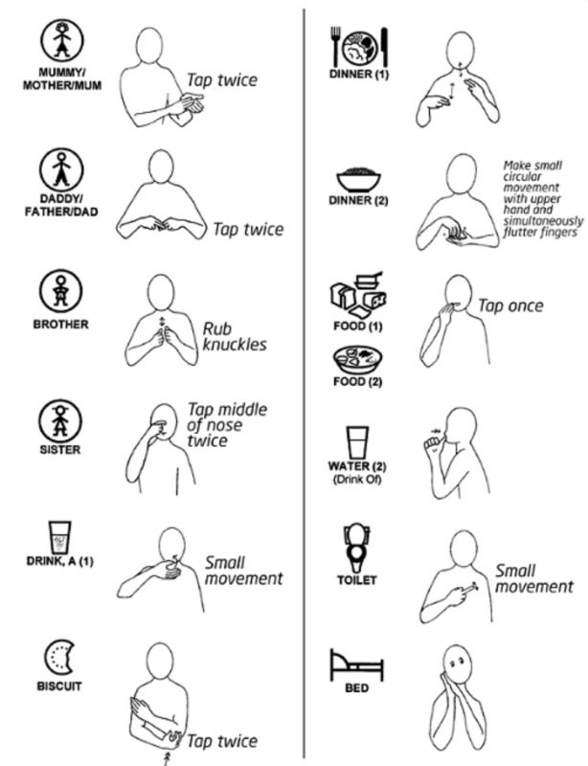Makaton is a simpler and more direct form of sign language used along with speech. It is the UK's leading programme for adults and children with learning or communication difficulties. It is a language programme that combine signs, symbols and speech to give different options for people to communicate. Using signs can help people who do not use speech to communicate. **(There is only 1 space left on this course) This course is free to those on benefits. Please have your national insurance number ready when booking and once booked, send a scan or clear photograph of a benefits letter from either PIP, UC OR ESA with your name and address clearly on the front to** [**smcnicola@outlook.com**](mailto:smcnicola@outlook.com)

*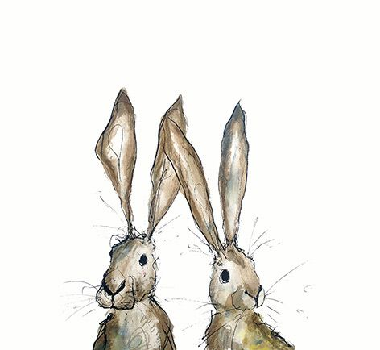***FRIDAY 4TH OCTOBER**

**(Very busy day)**

*Morning –*

**Halloween Colouring - 10am - 12pm – Olwyn - (Craft Room - Max. 14ppl)**

* Learn some spooky shading techniques with our professional “Prismacolour” soft coloured pencils. Tips will be given on how to blend colours together to achieve professional results. No drawing skills needed.

**NEW! Hand Sewing & Embroidery Techniques (9-Weeks) - 10am - 12pm – Meg, Alison & Gail (Volunteers) - (Room 2 - Max. 8ppl)**

* In this course you will develop Hand Sewing and Embroidery techniques using traditional threads, progressing to ribbon work and bead work. This course is suitable for beginners and advanced sewers alike. No sewing experience is needed, our talented volunteers will guide and support you, allowing you to progress and build your skills each session.

*Afternoon –*

**Dry Brush Painting -****1.15pm - 3.30pm - Olwyn - (Room 2 - Max. 8ppl)**

* In this class you will learn an effective painting technique where small amounts of paint are applied to a brush and gently brushed back and forth across paper, without applying any water at all throughout. This gives an old traditional appearance to your paintings.

**NEW! Textiles Group “Applique Decorations” (5-Weeks) - 1.15pm - 3.30pm - Meg, Alison & Gail (Volunteers) - (Craft Room - Max.10ppl)**

* Using a combination of hand stitching and machine sewing skills, you will create your own decorative appliques, which you will apply to tote bags and cushions. To get into the spooky season, you will also be making some halloween decorations. **(There is a £1.00 fee to purchase a tote bag, if you’d like one)**

*****Fridays Class Examples*

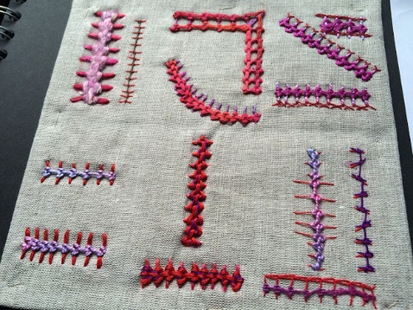**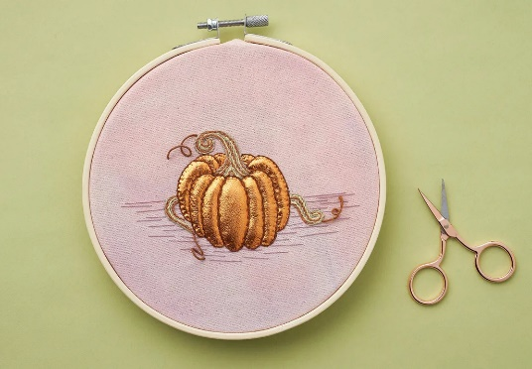***Morning -*

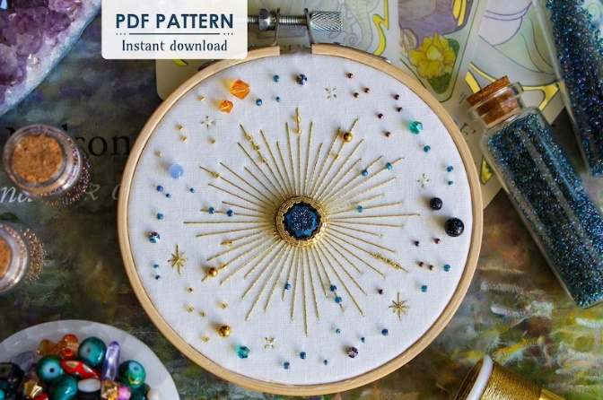

*Halloween Colouring Example Hand sewing and Embroidery Examples*

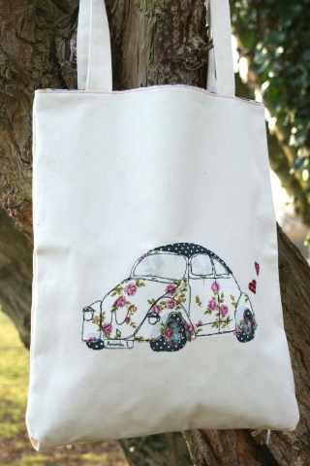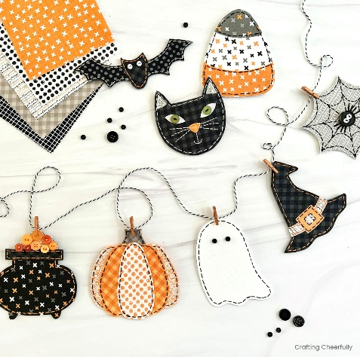*Afternoon -*

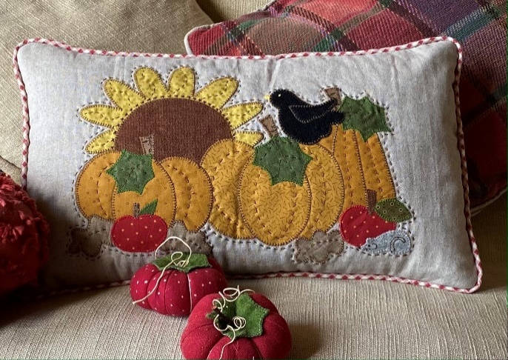

*Dry Brush Painting Example Applique Decoration Examples*

**MONDAY 7TH OCTOBER**

*Morning -*

**Gardening Group – 10am – 12pm – Sandra (Volunteer) – (Meet in Craft Room)**

*Afternoon -*

**Chatty Café Drop In – 1pm – 2pm – John (Volunteer) – (The Old School Café)**

**3D Paper Pumpkins – 1.15pm – 3.30pm - (Craft Room - Max. 14ppl)**

* 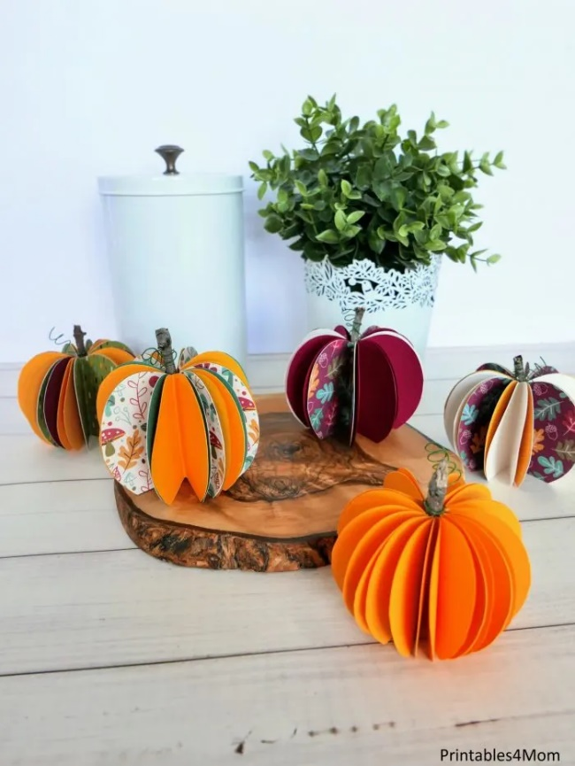This is a simple but effective technique which involves cutting small circles of coloured card and assembling to form a pumpkin. A group of 3 pumpkins would make an effective display, or smaller versions could be attached to a string to form a seasonal garland. There is a bit of tricky scissor work involved, so please keep this in mind when booking.

**TUESDAY 8TH OCTOBER**

*Morning –*

**Social Day – 9.30am – 4pm – (Craft Room – Max. 20ppl)**

*Afternoon –*

**Mind Management Course - 1.15pm - 3.15pm - Margaret - WEA - (Continued – Week 5)**

**“Knit Happens” Intermediate - 1.30pm - 3.30pm - Gail (Volunteer) - (The Old School Café)**

* Our Intermediate sessions are for experienced knitters or anyone that has completed one or more of our beginners’ sessions. Feel free to bring your own knitting projects or simply turn up without so much as a knitting needle, and our lovely volunteer will get you set away on a project. These sessions will be held every week in our Café situated on the ground floor of our Centre. You will still need to book onto these sessions as there is limited space.

**WEDNESDAY** **9TH OCTOBER**

*Morning -*

**Group Mandala - 10am - 12pm - Olwyn (Craft Room – Max. 14ppl)**

* A quilt with different colors of circles

  Description automatically generated with medium confidenceOn a square piece of black card, each participant will use pastel chalks to create their own colourful mandala design. This will then be cut into 4 equal pieces and re-assembled alongside the other creations, to form a completely new and very large piece of art.

**Horticulture Group - 10am - 12pm - Joy - (Volunteer) - (Allotments)**

*Afternoon –*

**“Creepy Clay” - 1.15pm - 3.30pm - Olwyn - (Continued – Final Session)**

**THURSDAY 10TH OCTOBER**

**(Busy day)**

*Morning –*

**Social Day - 9.30am - 4pm - (Craft Room - Max. 20ppl)**

**Horticulture Group – 10am – 12pm – Therese (Volunteer) – (Allotment – Max. 6ppl)**

*Afternoon –*

**Makaton Course – 1.15pm – 3.15pm – Maria – WEA – (Continued – Week 2)**

**FRIDAY** **11TH OCTOBER**

**(Very busy day)**

*Morning –*

**“Cute” Illustrations - 10am - 12pm – Olwyn - (Craft Room - Max. 14ppl)**

**Hand Sewing & Embroidery – 10am – 12pm – Meg, Alison & Gail – (Continued - Week 2)**

*Afternoon –*

**Ornate Watercolour Frame - 1.15pm - 3.30pm – Olwyn - (Room 2 - Max. 8ppl)**

* You will be given a blank white frame made of solid card. You will decorate your frame using a combination of wispy organic lines, using fineliners, and delicate watercolour application to form a beautifully classical looking ornate frame.

*Example*

**Textile Applique Decorations - 1.15pm - 3.30pm - Meg, Alison & Gail -(Continued - Week 2)**

**MONDAY 14TH OCTOBER**

*Morning-*

**Gardening Group – 10am – 12pm – Sandra (Volunteer) – (Meet in Craft Room)**

*Afternoon –*

**Awareness to Pride: The Evolution of Autism Symbols from 1963 to TodayAwareness to Pride: The Evolution of Autism Symbols from 1963 to TodayChatty Café Drop In – 1pm – 2pm – John (Volunteer) – (The Old School Café)**

**Ornate Watercolour Frame - 1.15pm - 3.30pm - Olwyn – (Craft Room – Max. 14ppl)**

**TUESDAY 15TH OCTOBER**

*Morning –*

**Social Day – 9.30am – 4pm – (Craft Room – Max. 20ppl)**

*Afternoon –*

**Mind Management – 1.15pm – 3.15pm – Margaret – WEA (Continued – Week 6)**

**“Knit Happens” – 1.30pm – 3.30pm – Gail (Volunteer) - (The Old School Cafe)**

**WEDNESDAY 16TH OCTOBER**

**Centre Closed – Staff Training**

**THURSDAY 17TH OCTOBER**

**(Busy day)**

*Morning –*

**Social Day - 9.30am - 4pm - (Craft Room – Max. 20ppl)**

**Horticulture Group - 10am – 12pm – Therese - (Volunteer) - (Allotment - Max. 6ppl)**

*Afternoon –*

**Makaton Course – 11am – 12pm – WEA - (Continue - Week 3)**

**FRIDAY 18TH OCTOBER**

**(Very busy day)**

*Morning –*

**“Creepy Clay” Figurines (2-Weeks) - 10am - 12pm - Olwyn (Craft Room - Max. 14ppl)**

**Hand Sewing & Embroidery – 10am – 12pm – Meg, Alison & Gail (Continued – Week 3)**

*Afternoon –*

**3D Pumpkins -****1.15pm - 3.30pm - Olwyn (Room 2 – Max. 8ppl)**

**Textile Applique Decorations - 1.15pm - 3.30pm – Meg, Alison, Gail - (Continued - Week 3)**

**MONDAY 21ST OCTOBER**

*Morning -*

**Gardening Group – 10am – 12pm – Sandra (Volunteer) – (Meet in Craft Room)**

*Afternoon -*

**Awareness to Pride: The Evolution of Autism Symbols from 1963 to TodayAwareness to Pride: The Evolution of Autism Symbols from 1963 to TodayChatty Café Drop In – 1pm – 2pm – John (Volunteer) – (The Old School Café)**

**Group Mandala with Pastels - 1.15pm - 3.30pm - Olwyn – (Craft Room – Max. 14ppl)**

**TUESDAY 22ND OCTOBER**

*Morning –*

**Social Day – 9.30am – 4pm – (Craft Room – Max. 20.ppl)**

*Afternoon –*

**Mind Management – 1.15pm – 3.15pm – Margaret – WEA (Continued – Week 7)**

**“Knit Happens” – 1.30pm – 3.30pm – Gail (volunteer) - (The Old School Café)**

**WEDNESDAY 23RD OCTOBER**

**Awareness to Pride: The Evolution of Autism Symbols from 1963 to Today***Morning –*

**3D Paper Pumpkins – 10am – 12pm – Olwyn – (Craft Room – Max. 14ppl)**

**Horticulture Group – 10am – 12pm – Joy - (Volunteer) - (Allotments)**

*Afternoon –*

**Pumpkin Carving (£3 fee) – 1.15pm – 3.30pm – Nicola – (Room 2 – Max. 8ppl)**

**Spooky Island Discs - 1.15pm - 3.30pm - Olwyn - (Craft Room – Max. 14ppl)**

* In this fun and sociable group activity, you will all think of a spooky Halloween themed song, which will then be played to the group. You are all free to tell a little story, if you have any good memories attached to your song.

**THURSDAY 24TH OCTOBER**

**(Busy day)**

*Morning –*

**Social Day - 9.30am - 4pm – Olwyn (Craft Room)**

**Horticulture Group - 10am – 12pm – Therese - (Volunteer) - (Allotments)**

*Afternoon –*

**Makaton Course – 11am – 12pm – WEA - (Continue - Week 4)**

**FRIDAY 25TH OCTOBER**

**(Very busy day)**

*Morning –*

**“Creepy Clay” Figurines – 10am – 12pm – Olwyn - (Continued – Final Session)**

**Hand Sewing & Embroidery – 10am – 12pm – Meg, Alison & Gail (Continued – Week 4)**

*Afternoon –*

**“Make It Clear” - 1.15pm - 3.30pm - Olwyn - (Room 2 - Max. 8ppl)**

**Textile Applique Decorations - 1.15pm - 3.30pm - Meg, Alison, Gail - (Continued - Week 4)**

**MONDAY 28TH OCTOBER**

*Morning -*

**Gardening Group – 10am – 12pm – Sandra (Volunteer) – (Meet in Craft Room)**

*Afternoon -*

**Awareness to Pride: The Evolution of Autism Symbols from 1963 to TodayAwareness to Pride: The Evolution of Autism Symbols from 1963 to TodayChatty Café Drop In – 1pm – 2pm – John (Volunteer) – (The Old School Café)**

**“Cute” Illustrations - 1.15pm - 3.30pm - Olwyn – (Craft Room – Max. 14ppl)**

**TUESDAY 29TH OCTOBER**

*Morning –*

**Social Day – 9.30am – 4pm – (Craft Room – Max. 20.ppl)**

*Afternoon –*

**Mind Management – 1.15pm – 3.15pm – Margaret – WEA - (Continued – Final Session)**

**“Knit Happens” – 1.30pm – 3.30pm – Gail (volunteer) - (The Old School Café)**

**WEDNESDAY 30TH OCTOBER**

**Awareness to Pride: The Evolution of Autism Symbols from 1963 to Today***Morning –*

**Dry Brush Painting – 10am – 12pm – Olwyn – (Craft Room – Max. 14ppl)**

**Horticulture Group – 10am – 12pm – Joy - (Volunteer) - (Allotments)**

*Afternoon –*

**Pumpkin Carving (£3 fee) – 1.15pm – 3.30pm – Nicola – (Room 2 – Max. 8ppl)**

**Halloween Colouring - 1.15pm - 3.30pm - Olwyn - (Craft Room – Max. 14ppl)**

**THURSDAY 31ST OCTOBER - HAPPY HALLOWEEN!**

**(Busy day)**

*Morning –*

**Social Day - 9.30am - 4pm – Olwyn (Craft Room)**

**Horticulture Group - 10am – 12pm – Therese - (Volunteer) - (Allotments)**

**FRIDAY 1ST NOVEMBER**

**(Very busy day)**

*Morning –*

**Group Mandala – 10am – 12pm – Olwyn - (Continued - Final Session)**

**Hand Sewing & Embroidery – 10am – 12pm – Meg, Alison & Gail (Continued-Final Session)**

*Afternoon –*

**Ornate Watercolour Frame - 1.15pm - 3.30pm - Olwyn - (Room 2 - Max. 8ppl)**

**Applique Decorations - 1.15pm - 3.30pm - Meg, Alison, Gail - (Continued - Final Session)**

Awareness to Pride: The Evolution of Autism Symbols from 1963 to Today

Classes with this symbol - are dedicated, quieter sessions. Anybody can join them, but they are designed to be inclusive of neurodivergent individuals who may struggle to access our standard sessions.

(Up to a Maximum of 20ppl in our Craft Room and 8ppl in Room 2)