**Please read carefully.**

Hello,

We hope this letter finds you well.

Enclosed you will find the latest timetable of activities for September 2024. We will be taking bookings for these activities via phone call or email from **10am** on **Tuesday 27th August**. Please do not phone us to try booking before this date and time. You will find our contact number and email address on the front page of your timetable.

**On Monday 2nd and Tuesday 3rd of September our lift is getting replaced, due to the amount of disruption this will cause, the centre will be CLOSED. The lift will be out of use for a further 3 days on Wed 4th/Thurs 5th/Fri 6th and classes will only be accessible via the stairs, please take this into consideration when booking classes.**

**Due to the volume of new referrals coming through. You will now only be able to book onto one social day (Tuesday or Thursday) and two classes per week (Not including WEA, Bishop college, Walking groups or external tutors). This is so we can give new attendees a fair chance of booking onto sessions.**

**We please ask that you pay a £1 attendance fee per session,** your attendance fee goes back into the Centre and helps towards cost of materials and use of our tea and coffee facilities situated in our craft room. Your contribution is much appreciated.

Please turn up to your class **on time** especially if you are already on the premises, unless you have called to say you are running late. **Do not eat food or leave to go for a cigarette during classes**, this can be very disruptive for other attendees and the instructor. You are all given a **15-minute break halfway through your classes** to eat, make a beverage and smoke.

If you are booked onto any class and cannot make it for whatever reason you must call the centre to inform us of this as early as possible, so that we can offer the space to somebody else. **You still need to book to attend Social Days** as well as regular craft classes, to guarantee you have a seat.

We look forward to seeing you.

Warmest wishes from all the staff at St. Margarets Centre.

**To Book Classes Call: 0191 384 8100 or Email: enquiries@stmargaretscentre.co.uk**

**(**There is an **attendance fee of** **£1 per session)**

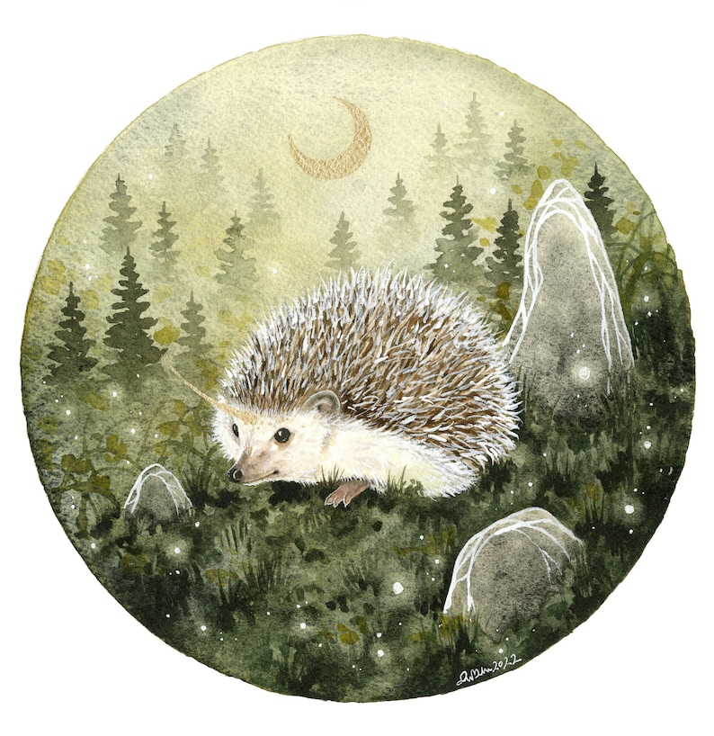

**MONDAY 2ND SEPTEMBER**

**CENTRE CLOSED DUE TO MAJOR REPAIRS ON OUR LIFT**

**TUESDAY 3RD SEPTEMBER**

**CENTRE CLOSED DUE TO MAJOR REPAIRS ON OUR LIFT**

**LIMITED ACCESS TO CLASSES AS LIFT WILL NOT BE IN OPERATION, ACCESS VIA STAIRS ONLY. SORRY FOR ANY INCONVENIENCE.**

**WEDNESDAY 4TH SEPTEMBER**

**Awareness to Pride: The Evolution of Autism Symbols from 1963 to Today***Morning –*

**One Word Watercolours - 10am – 12pm – Olwyn – (Craft Room – Max. 14ppl)**

* On a small piece of card, we will transform a word into a flower stem and finish with a watercolour flower head. These can then be mounted on to some co-ordinating patterned paper to create a border. Ribbon can be attached if desired. You may turn these pieces into a bookmark or a large gift tag.

**Horticulture Group - 10am – 12pm – Joy - (Volunteer) - (Allotments)**

* You will assist in the general upkeep of our allotment, helping with digging, planting fresh bulbs, weeding, and maintaining the grounds. You will help grow fresh produce such as fruit, vegetables, and herbs as well as growing flowers, whilst learning new skills as you go. Outdoor activities are proven to help with wellbeing and mental health, so come and potter about, breathe in the fresh air and absorb some of that all-important Vitamin D.

**“Go To Bed Ted” Cards - 1.15pm - 3.30pm - Olwyn (Craft Room – Max. 14ppl)**

* You will create a little felt quilt cover filled with wadding, you will tuck a small illustration of a teddy bear behind as if he were snuggled up for bed. Suitable for various occasions, this card can be adapted to suit your needs. There will be some intricate cutting required for this project.

**“*One-word Watercolours” “Go To Bed Ted Cards”***

**LIMITED ACCESS TO CLASSES AS LIFT WILL NOT BE IN OPERATION, ACCESS VIA STAIRS ONLY.**

**THURSDAY 5TH SEPTEMBER**

**(Busy Day)**

*Morning –*

**Social Day – 9.30am – 4pm – (Craft Room – Max. 20ppl)**

* A day for social interaction and a safe place to get on with any hobbies you may have e.g., Painting, drawing, writing, jigsaws, crosswords, knitting. Or just enjoy a nice little chin wag with a cuppa. We encourage you to bring your own projects to get on with if you would like to keep yourself busy, but we have an array of arts and crafts materials to get you inspired. You must still book a slot on any social day you wish to attend, to secure a seat.

**Horticulture Group - 10am – 12pm – Therese - (Volunteer) - (Allotments – Max. 6ppl)**

*Afternoon -*

**“Crafternoon” DIY Suncatcher - 1pm - 3pm - Sarah (Volunteer) - (Rm 2. Max 7ppl)**

* In this one-off session, you will be using Jewellery wire/chains and an array of glistening beads and charms. With these materials you will create a beautiful and unique suncatcher to display in a window.

***“DIY Suncatcher”***

**LIMITED ACCESS TO CLASSES AS LIFT WILL NOT BE IN OPERATION, ACCESS VIA STAIRS ONLY. SORRY FOR ANY INCONVENIENCE.**

*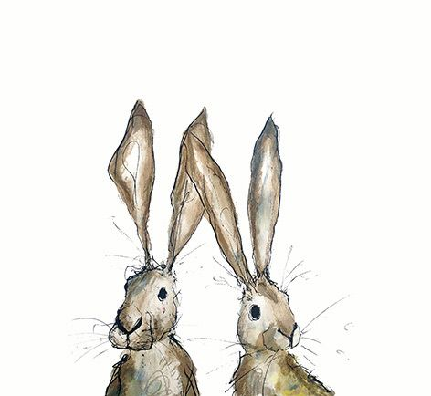***FRIDAY 6TH SEPTEMBER**

**(Very busy day)**

*Morning –*

**Crosswords and Cuppas - 10am - 12pm - Group led - (Craft Room - Max. 14ppl)**

* In this laid-back social session, as a group you will come together to put your general knowledge to the test and complete crosswords as a team. All whilst enjoying a nice cuppa!

*Afternoon –*

**Watercolour Florals -****1.15pm - 3.30pm – Group led - (Room 2 - Max. 8ppl)**

* A group of flowers and butterflies

  Description automatically generatedIn this relaxing and simple session, you will be given a selection of small intricate floral illustrations, which you will bring to life using watercolours by adding a delicate wash of colour. There is no instructor throughout this session, so a little creative initiative is beneficial. However, you will be given a quick tutorial at the beginning.

**NEW! Textiles Group (4-Weeks) - 1.15pm - 3.30pm - Meg, Alison & Gail (Volunteers) - (Craft Room - Max.10ppl)**

* 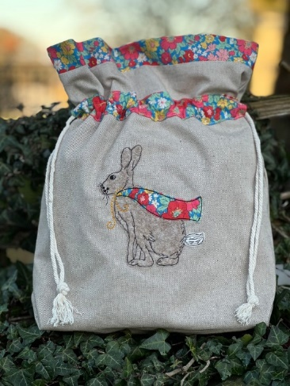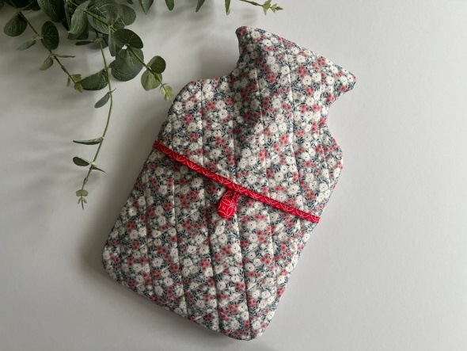Using prequilted material, we are making  a hot water bottle cover, a pyjama case and a clothes protector for wardrobe storage. The course will be using hand and machine sewing and cutting out from a paper pattern. Some experience of using a sewing machine would be useful. If you book onto this course, pop the following 3 Fridays in your diary.

*Example Example*

**MONDAY 9TH SEPTEMBER**

*Afternoon -*

**Chatty Café Drop In – 1pm – 2pm – John (Volunteer) – (The Old School Café)**

* Are you feeling isolated and in need of a little chat and some friendly company? Then we welcome you to pop into The Old School Café, where one of our lovely volunteers will be there waiting. This is not counselling session, but a safe space where you can have a lovely chit chat or maybe play some board games. Hopefully this little drop in will leave you feeling a little brighter.

**Afternoon Social - 1pm - 4pm - (Craft Room – Max. 20ppl)**

* An afternoon for social interaction and a safe place to get on with any hobbies you may have e.g., Painting, drawing, writing, jigsaws, crosswords, knitting. Or just enjoy a nice little chin wag with a cuppa. We encourage you to bring your own projects to get on with if you would like to keep yourself busy, but we have an array of arts and crafts materials to get you inspired. You must still book a slot on any social day you wish to attend, to secure a seat.

**TUESDAY 10TH SEPTEMBER**

*Morning –*

**Social Day – 9.30am – 4pm – (Craft Room – Max. 20ppl)**

**Gardening Group – 10am – 12pm – Sandra (Volunteer) - (Meet in Craft Room)**

*Afternoon –*

**Mind Management (8-Weeks) – 1.15pm – 3.15pm – Margaret – WEA (Room 2 Max.9ppl)**

* **(Course information on the last sheet of the timetable, please read)**

**“Knit Happens” – 1.30pm – 3.30pm – Gail (Volunteer) – (The Old School Café – Max. 8ppl)**

* Our “Knit Happens” sessions are for new and experienced knitters alike. Feel free to bring your own knitting projects or simply turn up without so much as a knitting needle where we will help you to begin knitting squares to make into a blanket. No experience is required to join, and equally, accomplished Knitters are welcome too. These sessions will be held every week in our Café situated on the ground floor of our Centre. You will still need to book onto these sessions as there is limited space.

**WEDNESDAY** **11TH SEPTEMBER**

*Morning -*

**Crosswords & Cuppas - 10am - 3.30pm - (Craft Room – Max. 14ppl)**

**Horticulture Group - 10am - 12pm - Joy - (Volunteer) - (Allotments)**

*Afternoon –*

**NEW! Beginners Phone Photography Course (3-Weeks) - 1.15pm – 3.30pm – Nicola - (Room 2 - Max. 8ppl)**

* In this beginner course, you will learn the basics of photography and editing through your mobile phone camera. We will first learn about popular professional photography styles such as composition, perspective and vantage point. We will then go over basic photo editing techniques, these are often built into your phone camera app, such as saturation, brightness, contrast, hue. Each week we will take our phones outside and go for a short walk whilst taking photographs. We will then head back to the centre and use editing techniques to enhance and tweak our photographs. At the end of the course, you will get to choose your favourite photograph to be printed and displayed to the group, which you will get to keep. You do not need to know how to use your phone camera, this course is designed to help support you with that.

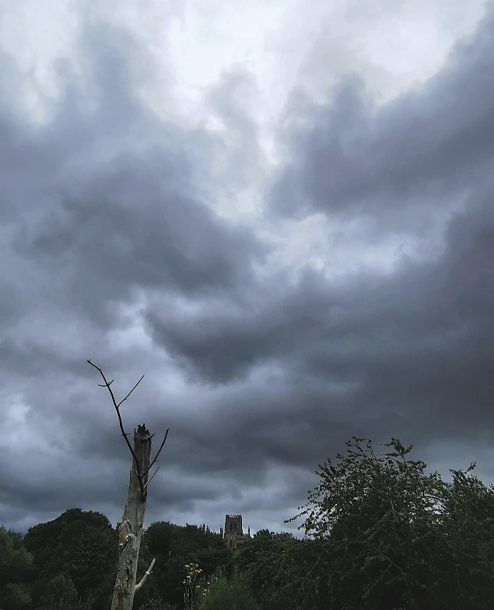

**THURSDAY 12TH SEPTEMBER**

**(Busy day)**

*Morning –*

**Social Day - 9.30am - 4pm - (Craft Room - Max. 20ppl)**

*Afternoon –*

**“Crafternoon” Memory Wire Bracelets - 1pm - 3pm - Sarah (Volunteers) - (Rm 2. Max 7ppl)**

* In this one-off session, using jewellery making tools you will create your own unique bracelet using memory wire, along with an array of colourful beads and charms. This would make a lovely personal gift for a loved one.



*Example*

**FRIDAY 1****3TH SEPTEMBER**

**(Very busy day)**

*Morning –*

**Crosswords and Cuppas - 10am - 12pm - Group led - (Craft Room - Max. 14ppl)**

*Afternoon –*

**Magic Fineliner Shading - 1.15pm - 3.30pm - Group Led - (Room 2 - Max. 8ppl)**

* Using non-waterproof Fineliners, you will trace over the lines of a pre-printed illustration. You will then create shading by adding water with a brush. The ink bleeds into the water, which you can then manipulate and move with your brush to create definition. This will be a relaxing class with plenty of time to chat amongst the group. There is no instructor available throughout this session, so a little creative initiative is beneficial. However, you will be given a little tutorial before you start.

*Example*

**Textile Group - 1.15pm - 3.30pm - Meg, Alison & Gail - (Continued - Week 2)**

**MONDAY 16TH SEPTEMBER**

*Afternoon –*

**Awareness to Pride: The Evolution of Autism Symbols from 1963 to TodayAwareness to Pride: The Evolution of Autism Symbols from 1963 to TodayChatty Café Drop In – 1pm – 2pm – John (Volunteer) – (The Old School Café)**

**Vintage Music Paper Watercolour - 1.15pm - 3.30pm - Olwyn – (Craft Room – Max. 14ppl)**

* A painting of a bird on a sheet of music

  Description automatically generatedIn this class we will create our own artwork by tracing the outline of a songbird onto music paper using fineliners. We will finish with a subtle touch of colour, almost as if it were re-touching an old photograph, and bringing it to life!

*Example*

**TUESDAY 17TH SEPTEMBER**

*Morning –*

**Social Day – 9.30am – 4pm – (Craft Room – Max. 20ppl)**

**Gardening Group – 10am – 12pm – Sandra (Volunteer) – (Meet in Craft Room)**

*Afternoon –*

**Mind Management – 1.15pm – 3.15pm – Margaret – WEA (Continued – Week 2)**

**“Knit Happens” – 1.30pm – 3.30pm – Gail (Volunteer) - (The Old School Café – Max. 8ppl)**

**WEDNESDAY 18TH SEPTEMBER**

**Awareness to Pride: The Evolution of Autism Symbols from 1963 to Today***Morning –*

**“Bless This House” Wooden Cube – 10am – 12pm – Olwyn – (Craft Room – Max. 14ppl)**

* A cute miniature model of a picturesque home, made from strong paper and decorated with fineliners and watercolours, all built up upon a small wooden cube. The perfect small gift or something quirky and fun for your own home**. This is quite a fiddly craft with small cuttings and assembling, so please make sure you are up for the intricate task before you sign up.**

**Horticulture Group – 10am – 12pm – Joy (Volunteer) - (Allotments)**

*Afternoon –*

**Pastel Drawing “Burning Flame”- 1.15pm - 3.30pm - Olwyn - (Craft Room – Max. 14ppl)**

* In this session we will learn how to draw a burning match using the perfect medium for blending – pastel chalks. A newly extinguished flame is also an interesting thing to try, as it creates wispy smoke which spirals across the page. Demonstrations will be given, and alternative images will be offered if you struggle.

**Beginners Phone Photography Course - 1.15pm – 3.30pm – Nicola - (Continued – Week 2)**

*“ Bless This House” Example “Burning Flame” Example*

**THURSDAY 19TH SEPTEMBER**

**(Busy day)**

*Morning –*

**Social Day - 9.30am - 4pm - (Craft Room – Max. 20ppl)**

**Horticulture Group - 10am – 12pm – Therese - (Volunteer) - (Allotments)**

**Makaton Enrolments – 11am – 12pm – WEA (Room 2 – Max.9ppl)**

* You must attend this session if you intend to book onto the Makaton Course which starts in October, information for this course is on a separate sheet on the back on this timetable.

*Afternoon –*

**“Crafternoon” Crystal & Driftwood Hangers (2-Weeks) – 1pm – 3pm – Janet & Pam (Volunteers) - (Room 2 – Max. 6ppl)**

* In this short course you will be creating your own DIY “boho” style wall hangings, using a combination of driftwood, crystals and charms. If you book onto this course, please pop the following week in your diary.

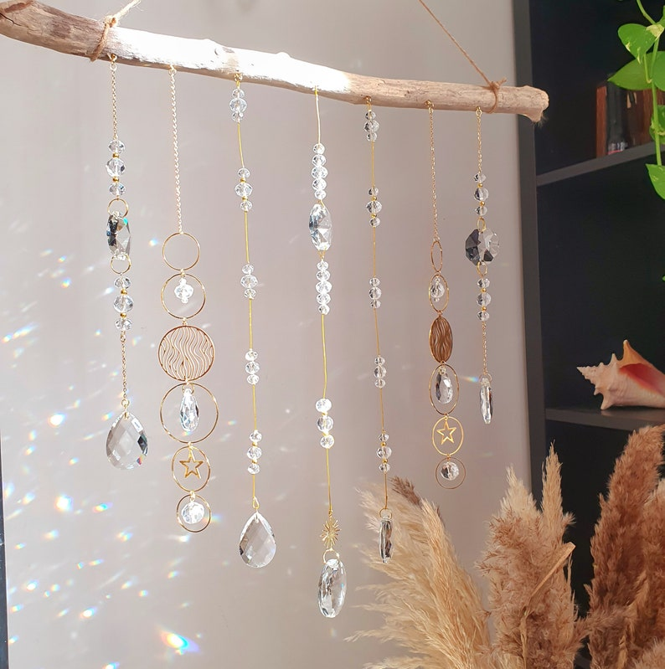

*Example*

**FRIDAY 20TH SEPTEMBER**

**(Very busy day)**

*Morning –*

**One Word Watercolour Bookmarks - 10am - 12pm - Olwyn (Craft Room - Max. 14ppl)**

*Afternoon –*

**Desert Island Discs -****1.15pm - 3.30pm - Olwyn (Room 2 – Max. 8ppl)**

* Back with our ever-popular class, where we will choose tracks which bring us happy memories and inspire. We will all listen to each person’s song, whilst they share why these tracks are so positive and joyful to them. If you would rather just have your song played and not discuss anything, that is fine.

**Textiles Group - 1.15pm - 3.30pm – Meg, Alison, Gail - (Continued - Week 3)**

**MONDAY 23RD SEPTEMBER**

*Afternoon –*

**Awareness to Pride: The Evolution of Autism Symbols from 1963 to TodayAwareness to Pride: The Evolution of Autism Symbols from 1963 to TodayChatty Café Drop In – 1pm – 2pm – John (Volunteer) – (The Old School Café)**

**“Bless This House” Wooden Cube - 1.15pm - 3.30pm - Olwyn – (Craft Room – Max. 14ppl)**

**TUESDAY 24TH SEPTEMBER**

*Morning –*

**Social Day – 9.30am – 4pm – (Craft Room – Max. 20.ppl)**

**Gardening Group – 10am – 12pm – Sandra (Volunteer) – (Meet in Craft Room)**

*Afternoon –*

**Mind Management – 1.15pm – 3.15pm – Margaret – WEA (Continued – Week 3)**

**“Knit Happens” – 1.30pm – 3.30pm – Gail (volunteer) - (The Old School Café – Max. 8ppl)**

**WEDNESDAY 25TH SEPTEMBER**

**Awareness to Pride: The Evolution of Autism Symbols from 1963 to Today***Morning –*

**“Go To Bed Ted” Cards – 10am – 12pm – Olwyn – (Craft Room – Max. 14ppl)**

**Horticulture Group – 10am – 12pm – Joy - (Volunteer) - (Allotments)**

*Afternoon –*

**Vintage Music Paper Watercolour - 1.15pm - 3.30pm - Olwyn - (Craft Room – Max. 14ppl)**

**Beginners Phone Photography Course - 1.15pm – 3.30pm – Nicola - (Final Session)**

**THURSDAY 26TH SEPTEMBER**

**(Busy day)**

*Morning –*

**Social Day - 9.30am - 4pm – Olwyn (Craft Room)**

**Horticulture Group - 10am – 12pm – Therese - (Volunteer) - (Allotments)**

*Afternoon –*

**“Crafternoon” – 1pm – 3pm – Janet & Pam (Volunteers) - (Week 2 – Final Session)**

**FRIDAY 27TH SEPTEMBER**

**(Very busy day)**

*Morning –*

**Pastel Drawing “Burning Flame” – 10am – 12pm – Olwyn - (Craft Room - Max. 14ppl)**

*Afternoon –*

**Fruit Slice Bookmarks - 1.15pm - 3.30pm - Olwyn - (Room 2 - Max. 8ppl)**

* A book with pens and fruit on a table

  Description automatically generatedA piece of paper with a slice of lemon cut out of it

  Description automatically generatedWe will use our quality Prisma coloured pencils to create realistic fruit slices which will then be cut in a special way to create a fruity bookmark.

**Textiles Group - 1.15pm - 3.30pm - Meg, Alison, Gail - (Final Session)**

Awareness to Pride: The Evolution of Autism Symbols from 1963 to Today

Classes with this symbol - are dedicated, quieter sessions. Anybody can join them, but they are designed to be inclusive of neurodivergent individuals who may struggle to access our standard sessions.

(Up to a Maximum of 20ppl in our Craft Room and 8ppl in Room 2)

**On this page we have a list of exciting upcoming courses for our centre, delivered by tutors provided by the WEA. All courses are offered free of charge to those on means tested benefits such as Universal Credit, ESA, Housing benefits or pension credits. If your household income is less that a certain threshold you may also be entitled. If you book onto any of these courses, you MUST attend an enrolment drop in at our Centre in Room 2. The dates for the enrolments will be mentioned in the course details. Please bring evidence of your benefits and national insurance number to your enrolment session.**

**TUESDAY 10TH SEPTEMBER**

**Mind Management (8-Weeks) - 1.15pm - 3.15pm - Margaret (Room 2 - Max.9ppl)**

**(Enrolment session – TUESDAY 27TH AUGUST – 1.30PM – Room 2)**

* Mind management is the art of consciously directing and shaping the thoughts and emotions that flow through your mind. It empowers you to take charge of your inner world, thereby influencing your actions, behaviours, and ultimately, your outcomes in life. Understand and manage emotions, improve self-confidence, help manage and deal with stress. This course will also involve some relaxing meditation sessions.Although this course is delivered at our Centre, it is run by an external tutor, so you will need to enrol onto this course. To do this you must attend an enrolment session at the Centre in Room 2 on Tuesday 27th August at 1.30pm. If you cannot attend this enrolment session, you can still book the course, but please let us know you cannot attend the enrolment session, and we will make other arrangements.

**THURSDAY 3RD OCTOBER**

**Makaton (10-Weeks) – 1.15pm – 3.15pm – Maria (Room 2 - Max. 9ppl)**

**(Enrolment Session – THURSDAY 19TH SEPTEMBER – 11AM – Room 2)**

* Makaton is a communication tool with speech, signs, and symbols to enable people with disabilities or learning disabilities to communicate. Makaton supports the development of essential communication skills such as attention, listening, comprehension, memory and expressive speech and language. The Makaton language programme has been used with individuals who have cognitive impairments, autism, Down syndrome, specific language impairment, multisensory impairment and acquired neurological disorders that have negatively affected the ability to communicate, including stroke and dementia patients. Although this course is delivered at our Centre, it is run by an external tutor, so you will need to enrol onto this course. To do this you must attend an enrolment session at the Centre in Room 2 on Thursday 19th September at 11am. If you cannot attend this enrolment session, you can still book the course, but please let us know you cannot attend the enrolment session, and we will make other arrangements.