**Please read carefully.**

Hello,

We hope this letter finds you well.

Enclosed you will find the latest timetable of activities for August 2024. We will be taking bookings for these activities via phone call or email from **10am** on **Monday 29th July**. Please do not phone us to try booking before this date and time. You will find our contact number and email address on the front page of your timetable.

Our annual summer party will be held on **Thursday 29th of August between 10am – 2pm**. There will be party food and nibbles, music and games, as well as a Tombola. **This party is for attendees and volunteers only**. Please let us know when booking classes, if you intend on coming to the party. Please do not turn up any earlier than 10am, as staff and volunteers have a lot to set up beforehand.

**Due to the volume of new referrals coming through. You will now only be able to book onto one social day (Tuesday or Thursday) and two classes per week (Not including WEA, Bishop college, Walking groups or external tutors). This is so we can give new attendees a fair chance of booking onto sessions.**

**We please ask that you pay a £1 attendance fee per session,** your attendance fee goes back into the Centre and helps towards cost of materials and use of our tea and coffee facilities situated in our craft room. Your contribution is much appreciated.

Please turn up to your class **on time** especially if you are already on the premises, unless you have called to say you are running late. **Do not eat food or leave to go for a cigarette during classes**, this can be very disruptive for other attendees and the instructor. You are all given a **15-minute break halfway through your classes** to eat, make a beverage and smoke.

If you are booked onto any class and cannot make it for whatever reason you must call the centre to inform us of this as early as possible, so that we can offer the space to somebody else. **You still need to book to attend Social Days** as well as regular craft classes, to guarantee you have a seat.

We look forward to seeing you.

Warmest wishes from all the staff at St. Margarets Centre.

**To Book Classes Call: 0191 384 8100 or Email: enquiries@stmargaretscentre.co.uk**

**(**There is an **attendance fee of** **£1 per session)**

**MONDAY 5TH AUGUST**

*Afternoon –*

**Chatty Café Drop In – 1pm – 2pm – John (Volunteer) – (The Old School Café)**

* **Awareness to Pride: The Evolution of Autism Symbols from 1963 to Today**Are you feeling isolated and in need of a little chat and some friendly company? Then we welcome you to pop into The Old School Café, where one of our lovely volunteers will be there waiting. This is not a counselling session, but a safe space where you can have a lovely chit chat or maybe play some board games. Hopefully this little drop in will leave you feeling a little brighter.

**Gilded Animal Prints (3-Weeks) – 1.15pm – 3.30pm – Olwyn (Craft Room – Max 14ppl)**

* In this class, we will use black Fineliners, pencil and metallic gold or silver to create a monochrome design, featuring a woodland animal surrounded by foliage and flowers. This is intricate work which will take some time to complete, but the process is therapeutic, and the outcome is very rewarding. If you book onto this course, please pop the following 2 weeks in your diaries.

**Gilded Animal Prints**

**TUESDAY 6th AUGUST**

*Morning -*

**Social Day – 9.30am – 4pm – (Craft Room - Max. 20ppl)**

* A day for social interaction and a safe place to get on with any hobbies you may have e.g., Painting, drawing, writing, jigsaws, crosswords, knitting. Or just enjoy a nice little chin wag with a cuppa. We encourage you to bring your own projects to get on with if you would like to keep yourself busy, but we have an array of arts and crafts materials to get you inspired. You must still book a slot on any social day you wish to attend, to secure a seat.

**Gardening Group – 10am – 12pm – Sandra (Volunteer) – (Meet in Craft Room)**

* You will help with a little weeding, potting plants, and bulbs, watering flowers and assisting with the maintenance of our flower beds, lawns, and hedges. Outdoor activities are proven to help with wellbeing and mental health, so come and potter about, breathe in the fresh air and absorb some of that all-important Vitamin D.

*Afternoon –*

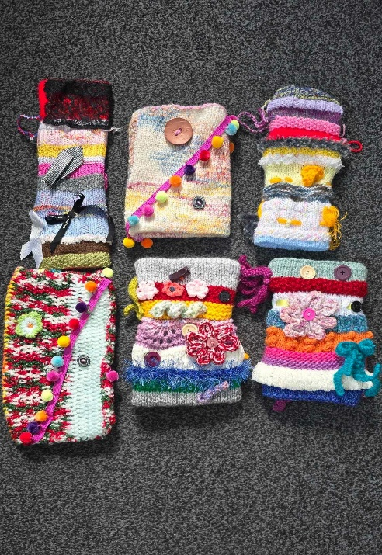**“Knit Happens”- 1.30pm – 3.30pm - Gail (Volunteer) - (The Old School Café)**

* Our “Knit Happens” sessions are for

new and experienced knitters alike.

Feel free to bring your own knitting

projects or simply turn up without so

much as a knitting needle, we will help

you to begin knitting squares to make

into a blanket. No experience is required

to join, and equally, accomplished Knitters

are welcome too. These sessions will be

held every week in our Café situated on the

ground floor of our Centre. You will still

need to book onto these sessions as there

is limited space.

**WEDNESDAY 7TH AUGUST**

*Morning –*

**Dry Brush Painting - 10am – 12pm – Olwyn – (Craft Room – Max. 14ppl)**

* A painting of fruit and paintbrushes

  Description automatically generatedIn this class you will learn an effective painting technique where small amounts of paint are applied to a brush and gently brushed back and forth across paper, without applying any water at all throughout. This gives an old traditional appearance to your paintings.

**Horticulture Group - 10am – 12pm – Joy - (Volunteer) - (Allotments)**

* You will assist in the general upkeep of our allotment, helping with digging, planting fresh bulbs, weeding, and maintaining the grounds. You will help grow fresh produce such as fruit, vegetables, and herbs as well as growing flowers, whilst learning new skills as you go. Outdoor activities are proven to help with wellbeing and mental health, so come and potter about, breathe in the fresh air and absorb some of that all-important Vitamin D.

**Beginners Recorder Group - 1.15pm - 3.30pm - Olwyn - (Continued Group)**

* Throughout this course you will learn how to read music notation and rhythm, using a recorder as an instrument to play as we learn. This can be an empowering experience as many people assume they are not capable of reading music and playing an instrument. This course aims to prove that it is entirely possible and extremely fun! There will be an opportunity to join a new recorder group in September for newcomers.

**THURSDAY 8TH AUGUST**

**(Busy Day)**

*Morning –*

**Social Day – 9.30am – 4pm – (Craft Room & Room 2, AM only - Max. 28ppl)**

**Horticulture Group - 10am – 12pm – Therese - (Volunteer) - (Allotments)**

*Afternoon -*

**Sea Glass & Pebble Art - 1.15pm - 3.30pm - Angela & Sarah (Volunteers) - (Rm 2. Max 8ppl)**

* In this class you will create wall art and greetings cards using beautiful and unique pieces of sea glass and pebbles. You will arrange and glue down your pebbles and glass to create small scale scenery/characters.

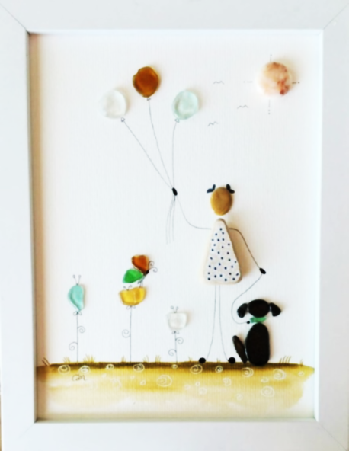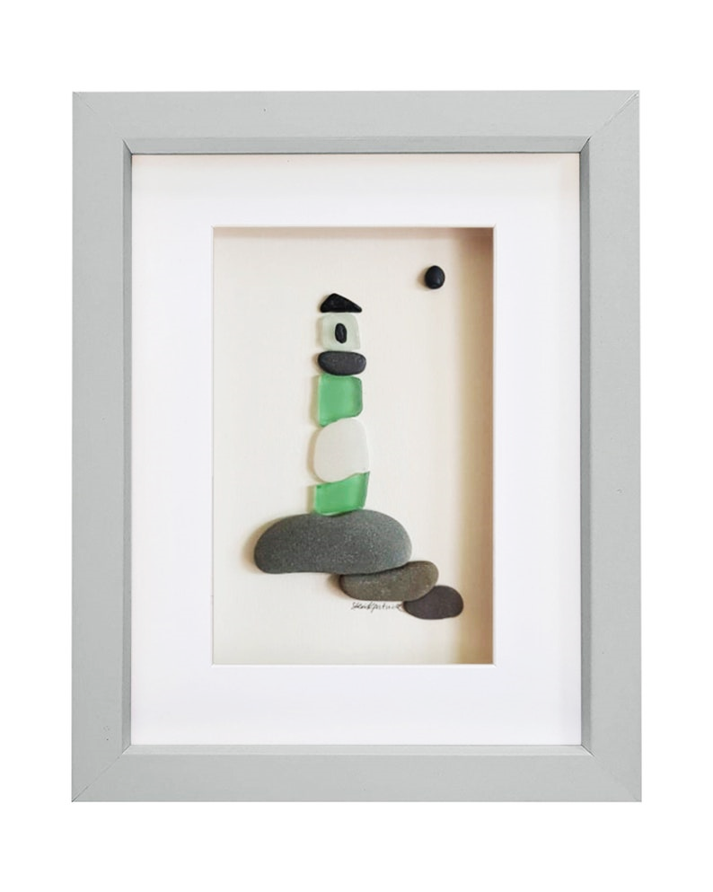

*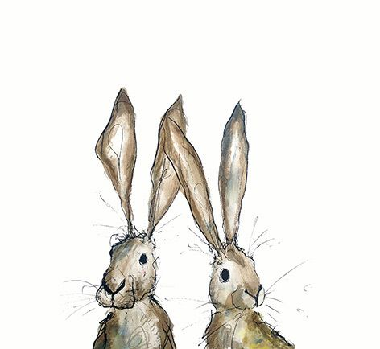***FRIDAY 9TH AUGUST**

**(Very busy day)**

*Morning –*

**One Stroke Painting “Floral Wreath” (2-Weeks) - 10am - 12pm - Olwyn - (Craft Room - Max. 14ppl)**

* One stroke painting is a technique which uses a square ended brush dipped into two colours of acrylic paint at the same time to create brushstrokes with instant highlights. Using this technique, we will paint a leafy wreath onto black card, and decorate it by applying small hand painted simple flowers. If you book onto this course, please pop the following week in your diary

*Afternoon –*

**Funky Gift Bags -****1.15pm - 3.30pm - Olwyn - (Room 2 - Max. 8ppl)**

* Using Posca paint pens we will decorate blank gift bags with a colourful doodle design. We will then embellish with a little hand lettering, and you will have the perfect, unique hand-made gift bag for any occasion.

**Walking Group – 1.30pm – 3.30pm – Nicola – (Meet in The Old School Café)**

* We will adventure out into our wonderful City, exploring the ‘nooks & crannies’ of Durham. This is a nice relaxed paced walk, with only slight inclines and as few stairs as possible (but to be expected in “Hilly” Durham) The walks are weather permitted, you will be contacted by lunchtime if the walk has been cancelled due to adverse conditions. Please bring your own water/juice bottle to hydrate or purchase a drink from our Café and wear appropriate footwear and clothing. Waterproofs and umbrellas are good to bring along, in case of a downpour whilst out on the walk or Sunscreen if it is a warm, sunny day.

**NEW! Textiles “Japanese Inspired” (4-Weeks) - 1.30pm - 3.30pm – Meg, Alison & Gail (Volunteers) - (Craft Room - Max.10ppl)**

* In this course you will learn techniques on how to make a Japanese knot bag, this is a bag that has two handles at different lengths. The longer handle slips into the short handle closing the bag and forming a knot. You may also get to make a modern take on the Japanese rice bag (Komebukuro) a traditional pouch used in Japan to carry rice offerings to the temple during religious ceremonies, or to hold gifts. You may also have the opportunity to make your own Kokeshi doll. Kokeshi dolls are mostly used as children's toys, they are also symbols of hopes for bountiful harvests, wishes for good luck and fortune If you book onto this course, pop the following 3 Fridays in your diary. **It is** **very important you turn up to your first session, with the first session being the most informative.**

**One Stroke Painting “Floral Wreath”**

**Funky Gift Bags**

**Textiles Group**

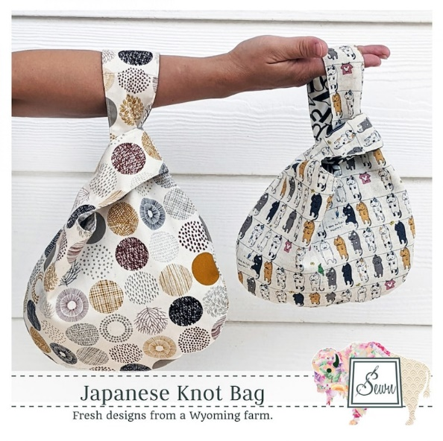**Japanese Knot Bag Japanese Rice Bag Kokeshi Doll**

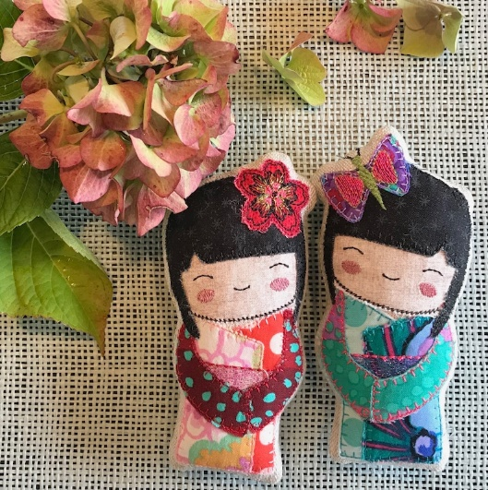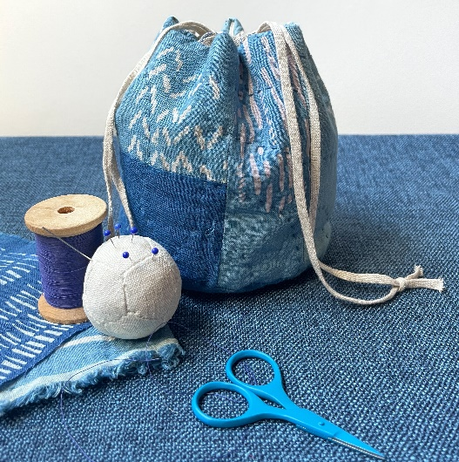

**MONDAY 12TH AUGUST**

*Afternoon -*

**Chatty Café Drop In – 1pm – 2pm – John (Volunteer) – (The Old School Café)**

* Are you feeling isolated and in need of a little chat and some friendly company? Then we welcome you to pop into The Old School Café, where one of our lovely volunteers will be there waiting. This is not counselling session, but a safe space where you can have a lovely chit chat or maybe play some board games. Hopefully this little drop in will leave you feeling a little brighter.

**Awareness to Pride: The Evolution of Autism Symbols from 1963 to TodayGilded Animal Prints - 1.15pm - 3.30pm - Olwyn – (Continued – Week 2)**

**TUESDAY 13TH AUGUST**

*Morning –*

**Social Day – 9.30am – 4pm – (Craft Room – Max. 20ppl)**

**Gardening Group – 10am – 12pm – Sandra (Volunteer) - (Meet in Craft Room)**

*Afternoon –*

**“Knit Happens” – 1.30pm – 3.30pm – Gail (Volunteer) – (The Old School Café)**

**WEDNESDAY** **14TH AUGUST**

**Awareness to Pride: The Evolution of Autism Symbols from 1963 to Today***Morning –*

**Whimsical Watercolours (2-Weeks) – 10am – 12pm – Olwyn – (Craft Room – Max. 14ppl)**

* We will add delicate watercolours to

whimsical fantasy images, which are

quite intricate, but very relaxing to paint.

If you book onto this course, please pop

the following week in your diary.

**Horticulture Group - 10am - 12pm - Joy - (Volunteer) - (Allotments)**

*Afternoon –*

**Beginners Recorder Group - 1.15pm - 3.30pm - Olwyn - (Continued Group)**

**THURSDAY 15TH AUGUST**

**(Busy day)**

*Morning –*

**Social Day - 9.30am - 4pm - (Craft Room - Max. 20ppl & Room 2, AM only Max. 8ppl)**

**Horticulture Group - 10am – 12pm – Therese - (Volunteer) - (Allotments)**

*Afternoon –*

**Sea Glass & Pebble Art - 1.15pm - 3.30pm - Angela & Sarah (Volunteers) - (Rm 2. Max 8ppl)**

**FRIDAY 1****6TH AUGUST**

**(Very busy day)**

*Morning –*

**One Stroke Painting “Floral Wreath” – 10am – 12pm – Olwyn – (Continued – Final session)**

*Afternoon –*

**“Torn” Mixed Media Collage – 1.15pm – 3.30pm – Olwyn – (Room 2 – Max. 8ppl)**

* We will create a multi – coloured landscape using torn strips of coloured paper to represent furrowed fields, combined with pastel-coloured skies.

**Walking Group – 1.30pm – 3.30pm – Nicola – (Meet in The Old School Café)**

**Textiles “Japanese Inspired” - 1.30pm - 3.30pm - Meg, Alison & Gail - (Continued - Week 2)**

**MONDAY 19TH AUGUST**

*Afternoon –*

**Awareness to Pride: The Evolution of Autism Symbols from 1963 to TodayChatty Café Drop In – 1pm – 2pm – John (Volunteer) – (The Old School Café)**

**Awareness to Pride: The Evolution of Autism Symbols from 1963 to TodayGilded Animal Prints - 1.15pm - 3.30pm - Olwyn – (Continued - Final Session)**

**TUESDAY 20TH AUGUST**

*Morning –*

**Social Day – 9.30am – 4pm – (Craft Room – Max. 20ppl)**

**Gardening Group – 10am – 12pm – Sandra (Volunteer) – (Meet in Craft Room)**

*Afternoon –*

**“Knit Happens” – 1.30pm – 3.30pm – Gail (Volunteer) - (The Old School Café)**

**WEDNESDAY 21ST AUGUST**

**Awareness to Pride: The Evolution of Autism Symbols from 1963 to Today***Morning –*

**Botanical Blackbirds – 10am – 12pm – Olwyn – (Craft Room – Max. 14ppl)**

* In this mixed media style class, we will choose

a striking, patterned paper background to add

colour and texture. We will then add hand -

drawn silhouettes of birds and lots of foliage to

create a 3 – dimensional layer. Templates for the

birds will be offered, but it will be up to you how

your botanicals surrounding the bird will bloom.

**Horticulture Group – 10am – 12pm – Joy (Volunteer) - (Allotments)**

*Afternoon –*

**Beginners Recorder Group - 1.15pm - 3.30pm - Olwyn - (Continued Group)**

**THURSDAY 22ND AUGUST**

**(Busy day)**

*Morning –*

**Social Day - 9.30am - 4pm - (Craft Room & Room 2 - AM only)**

**Horticulture Group - 10am – 12pm – Therese - (Volunteer) - (Allotments)**

**FRIDAY 23RD AUGUST**

**(Very busy day)**

*Morning –*

**Pastel Drawing - 10am - 12pm - Olwyn (Craft Room - Max. 14ppl)**

* A pastel art set and pastels

  Description automatically generated with medium confidenceThis is a very popular class, due to its sensory experience. You will build and layer colours using beautiful, soft and velvety chalk pastels, which you will then blend using your fingers giving your lovely illustration/landscape an ethereal, hazy finish.

*Afternoon –*

**Desert Island Discs -****1.15pm - 3.30pm - Olwyn (Room 2 – Max. 8ppl)**

* Back with our ever-popular class, where we will choose tracks which bring us happy memories and inspire. We will all listen to each person’s song, whilst they share why these tracks are so positive and joyful to them. If you would rather just have your song played and not discuss anything, that is fine.

**Walking Group – 1.30pm – 3.30pm – Nicola – (Meet in The Old School Café)**

**Textiles “Japanese Inspired” - 1.30pm - 3.30pm – Meg, Alison, Gail - (Continued - Week 3)**

**MONDAY 26TH AUGUST**

**CENTRE CLOSED – Bank Holiday**

**TUESDAY 27TH AUGUST**

*Morning –*

**Social Day – 9.30am – 4pm – (Craft Room – Max. 20.ppl)**

**Gardening Group – 10am – 12pm – Sandra (Volunteer) – (Meet in Craft Room)**

*Afternoon –*

**“Knit Happens” – 1.30pm – 3.30pm – Gail (volunteer) - (The Old School Café)**

**WEDNESDAY 28TH AUGUST**

**Awareness to Pride: The Evolution of Autism Symbols from 1963 to Today***Morning –*

**Funky Gift Bags – 10am – 12pm – Olwyn – (Craft Room – Max. 14ppl)**

**Horticulture Group – 10am – 12pm – Joy - (Volunteer) - (Allotments)**

*Afternoon –*

**Beginners Recorder Group - 1.15pm - 3.30pm - Olwyn - (Continued Group)**

**THURSDAY 29TH AUGUST**

**SUMMER PARTY! - 10am - 2pm - (Outside Area & Craft Room)**

* **Join us for our annual summer party! There will be games, music, food and a Tombola. This is for the Attendees and Volunteers of St. Margaret’s Centre only. Please inform us when booking, if you would like to attend.**

**FRIDAY 30TH AUGUST**

**(Very busy day)**

*Morning –*

**Botanical Blackbirds – 10am – 12pm – Olwyn - (Craft Room - Max. 14ppl)**

*Afternoon –*

**Pastel Drawing - 1.15pm - 3.30pm - Olwyn - (Room 2 - Max. 8ppl)**

**Walking Group - 1.30pm - 3pm - Nicola (Meet in The Old School Café - Max.6ppl)**

**Textiles “Japanese Inspired” - 1.30pm - 3.30pm - Meg, Alison, Gail - (Continued - Week 4)**

**Awareness to Pride: The Evolution of Autism Symbols from 1963 to TodayClasses with this symbol - are dedicated, quieter sessions. Anybody can join them, but they are designed to be inclusive of neurodivergent individuals who may struggle to access our standard sessions.**

**(Up to a Maximum of 20ppl in our Craft Room and 8ppl in Room 2)**