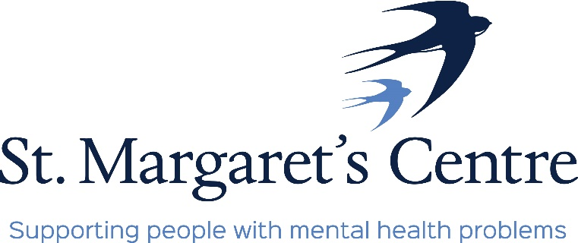

The Old School, Priory Orchard, Margery Lane, Durham, DH1 4QJ. Tel: 0191 384 8100

e-mail: enquiries@stmargaretscentre.co.uk

www.stmargaretscentre.co.uk

*Registered Charity No. 1160900*

**Job Description**

**Job Title:** Café Supervisor

**Pay Scale:** £20,258 pro-rata

**Hours:** 20 hours – Monday to Friday 9am – 1pm

**Responsible to:** Management

**Accountable to:** Board of Trustees

**General Information**

St Margaret’s Centre (SMC) [www.stmargaretscentre.co.uk](http://www.stmargaretscentre.co.uk) is a registered charity operating as an activity and training hub for adults in County Durham who need support with their mental wellbeing. The main aim of the Centre is to improve the health and wellbeing of the community of County Durham by providing a safe, therapeutic environment for people to regain their confidence, motivation and self-esteem while learning new skills and meeting new friends.

The Centre has been operating since 1991 and currently supports 200+ people. We have 6 members of staff and are overseen by a board of 9 trustees. Much of our funding comes from a contract with Durham County Council through the Durham Mental Wellbeing Alliance [https://www.durhammentalwellbeingalliance.org](https://www.durhammentalwellbeingalliance.org/), which we supplement through income-generating ventures such as our community café, workshop and craft shop, as well as fundraising, grant applications, and donations.

**Role Summary**

The Café Supervisor will be responsible for overseeing the day-to-day operation of our Community Cafe, which we aim to reopen in July/August. The post-holder will be involved from the very beginning of this exciting new community project, and will be expected to contribute positively to its development and future sustainability. The role involves ensuring the efficient running of the Café, and working alongside volunteers from within the Centre and the wider community. A positive, friendly attitude and an understanding of mental health is essential, as is a Food Safety in Catering certificate or equivalent qualification.

**Responsibilities to include:**

* Preparing good, simple food within a budget
* Maintaining accurate records in the areas of supplies, temperature requirements where required as per Environmental Health guidelines
* Supervising and training volunteers in the areas of food preparation, the use of equipment, hygiene procedures, till and card reader operation, and customer service.
* Liaising with the Volunteer Coordinator on volunteer recruitment and training needs, and rotas, as well as playing a part in monitoring and supporting volunteers to create a sense of teamwork and belonging.
* Having a friendly, patient, and understanding manner towards everyone at the centre
* Maintaining high standards of Food Hygiene and Health and Safety in the Workplace
* Reporting any concerns about the above, and any equipment in need of repair, to the Manager.
* Developing new ideas for the improvement of the café, and encouraging volunteers to play an active role in improving the space.
* Maintaining high levels of confidentiality at all times.
* Cash-handling and float management.
* Keeping up to date with training opportunities and relevant legislation
* Reviewing suppliers and prices on an ongoing basis to ensure value for money.
* Implementing strategies to reduce waste.

**Role Requirements**

* Experience within catering and customer service roles
* Experience of managing/supervising people, and preparing rotas
* Knowledge and understanding of mental health and wellbeing, learning disabilities and physical disabilities
* Patience for individuals with a range of support needs, and a friendly, non-judgemental, supportive, and motivating attitude
* A Food Safety in Catering certificate or equivalent, Allergen Awareness, and knowledge of Environmental Health reporting requirements
* Ability to handle the needs of volunteers and attendees sensitively and with compassion
* An organised and calm approach
* Excellent oral and written communication and listening skills
* Flexibility and a willingness to adapt to changing needs and environments
* A proactive approach, including an ability to work on own initiative as well as part of a team
* Working knowledge of MS Office and basic IT

Support and training will be provided, and we welcome applications from individuals from all backgrounds.

Shortlisted applicants will have the opportunity to visit the centre to discuss the role and plans for the café prior to interview.

A Disclosure and Barring Service (DBS) check will be required for this role. Please contact us to discuss any concerns you may have regarding this.

To discuss this role further, please contact [stmargarets91@hotmail.com](mailto:stmargarets91@hotmail.com)

**Closing date:** Sunday 11th June

**Interviews:** 27th and 28th June